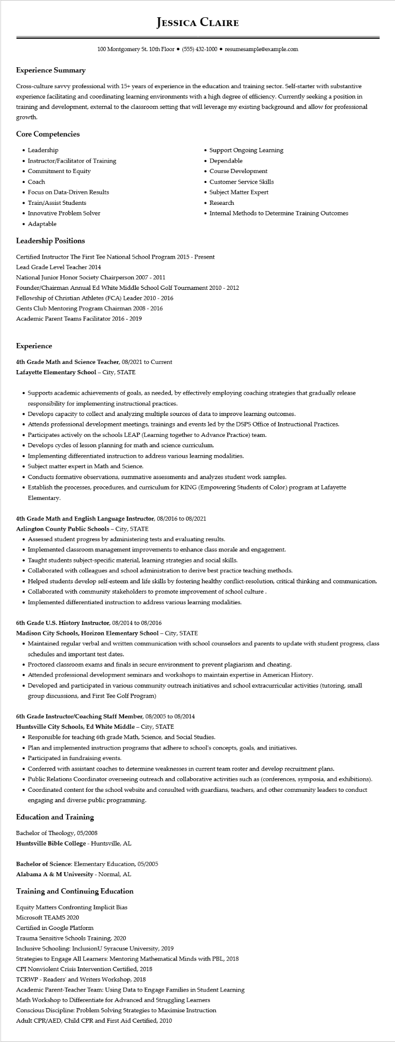

**Experience Summary**

**JESSICA CLAIRE**

100 Montgomery St. 10th Floor⚫ (555) 432-1000⚫ resumesample@example.com

Cross-culture savvy professional with 15+ years of experience in the education and training sector. Self-starter with substantive experience facilitating and coordinating learning environments with a high degree of efficiency. Currently seeking a position in training and development, external to the classroom setting that will leverage my existing background and allow for professional growth.

**Core Competencies**

• Leadership

• Instructor/Facilitator of Training

• Commitment to Equity

• Coach

• Focus on Data-Driven Results

• Train/Assist Students

• Innovative Problem Solver

• Adaptable

**Leadership Positions**

• Support Ongoing Learning

•

Dependable

• Course Development

• Customer Service Skills

• Subject Matter Expert

• Research

• Internal Methods to Determine Training Outcomes

Certified Instructor The First Tee National School Program 2015 - Present

Lead Grade Level Teacher 2014

National Junior Honor Society Chairperson 2007 - 2011

Founder/Chairman Annual Ed White Middle School Golf Tournament 2010 - 2012

Fellowship of Christian Athletes (FCA) Leader 2010 - 2016

Gents Club Mentoring Program Chairman 2008 - 2016

Academic Parent Teams Facilitator 2016 - 2019

**Experience**

4th Grade Math and Science Teacher, 08/2021 to Current

Lafayette Elementary School - City, STATE

• Supports academic achievements of goals, as needed, by effectively employing coaching strategies that gradually release responsibility for implementing instructional practices.

• Develops capacity to collect and analyzing multiple sources of data to improve learning outcomes.

• Attends professional development meetings, trainings and events led by the DSPS Office of Instructional Practices.

• Participates actively on the schools LEAP (Learning together to Advance Practice) team.

• Develops cycles of lesson planning for math and science curriculum.

• Implementing differentiated instruction to address various learning modalities.

• Subject matter expert in Math and Science.

• Conducts formative observations, summative assessments and analyzes student work samples.

• Establish the processes, procedures, and curriculum for KING (Empowering Students of Color) program at Lafayette Elementary.

**4th Grade Math and English Language Instructor, 08/2016 to 08/2021**

**Arlington County Public Schools - City, STATE**

• Assessed student progress by administering tests and evaluating results.

• Implemented classroom management improvements to enhance class morale and engagement.

•

Taught students subject-specific material, learning strategies and social skills.

• Collaborated with colleagues and school administration to derive best practice teaching methods.

• Helped students develop self-esteem and life skills by fostering healthy conflict-resolution, critical thinking and communication.

• Collaborated with community stakeholders to promote improvement of school culture.

• Implemented differentiated instruction to address various learning modalities.

**6th Grade U.S. History Instructor, 08/2014 to 08/2016**

**Madison City Schools, Horizon Elementary School - City, STATE**

• Maintained regular verbal and written communication with school counselors and parents to update with student progress, class schedules and important test dates.

• Proctored classroom exams and finals in secure environment to prevent plagiarism and cheating.

• Attended professional development seminars and workshops to maintain expertise in American History.

• Developed and participated in various community outreach initiatives and school extracurricular activities (tutoring, small group discussions, and First Tee Golf Program)

6th Grade Instructor/Coaching Staff Member, 08/2005 to 08/2014

**Huntsville City Schools, Ed White Middle - City, STATE**

• Responsible for teaching 6th grade Math, Science, and Social Studies.

• Plan and implemented instruction programs that adhere to school's concepts, goals, and initiatives.

• Participated in fundraising events.

• Conferred with assistant coaches to determine weaknesses in current team roster and develop recruitment plans.

• Public Relations Coordinator overseeing outreach and collaborative activities such as (conferences, symposia, and exhibitions).

• Coordinated content for the school website and consulted with guardians, teachers, and other community leaders to conduct engaging and diverse public programming.

**Education and Training**

Bachelor of Theology, 05/2008

**Huntsville Bible College - Huntsville, AL**

Bachelor of Science: Elementary Education, 05/2005

Alabama A & M University - Normal, AL

Training and Continuing Education

Equity Matters Confronting Implicit Bias

Microsoft TEAMS 2020

Certified in Google Platform

Trauma Sensitive Schools Training, 2020

Inclusive Schooling: InclusionU Syracuse University, 2019

Strategies to Engage All Learners: Mentoring Mathematical Minds with PBL, 2018

CPI Nonviolent Crisis Intervention Certified, 2018

TCRWP - Readers' and Writers Workshop, 2018

Academic Parent-Teacher Team: Using Data to Engage Families in Student Learning

Math Workshop to Differentiate for Advanced and Struggling Learners Conscious Discipline: Problem Solving Strategies to Maximise Instruction Adult CPR/AED, Child CPR and First Aid Certified, 2010