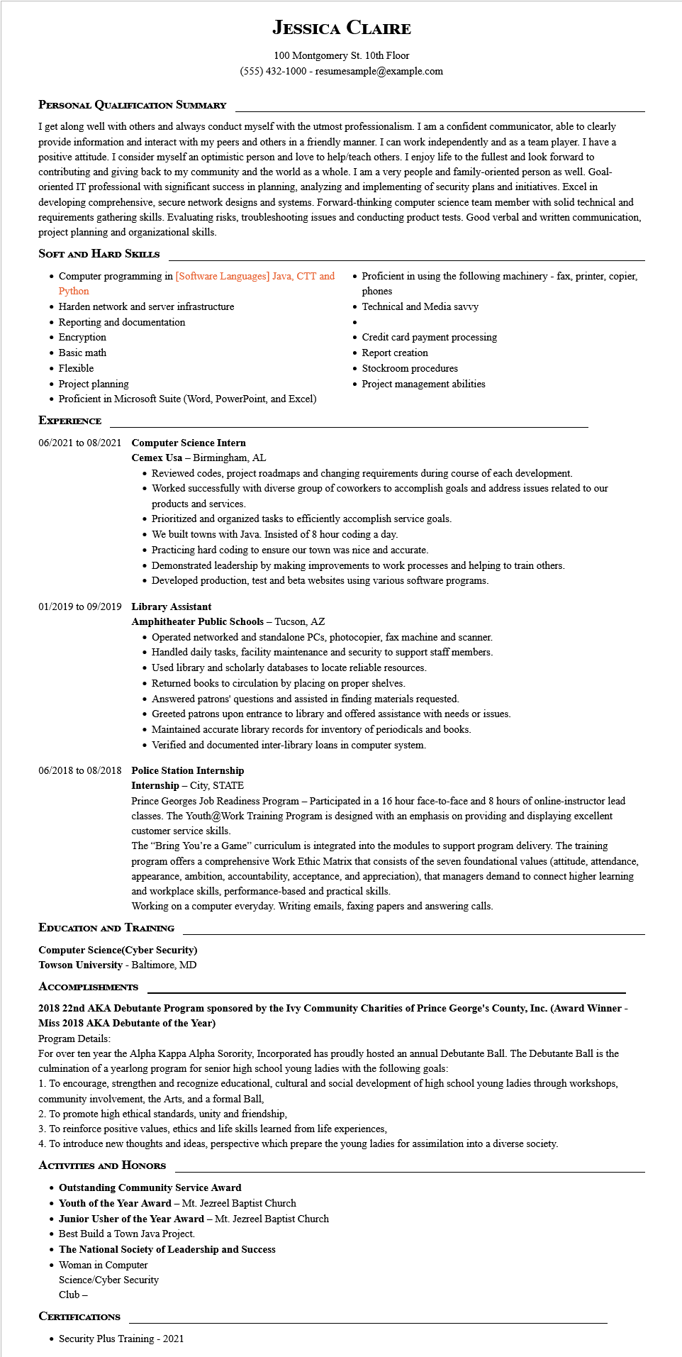

**PERSONAL QUALIFICATION SUMMARY**

**JESSICA CLAIRE**

100 Montgomery St. 10th Floor

(555) 432-1000 - resumesample@example.com

I get along well with others and always conduct myself with the utmost professionalism. I am a confident communicator, able to clearly provide information and interact with my peers and others in a friendly manner. I can work independently and as a team player. I have a positive attitude. I consider myself an optimistic person and love to help/teach others. I enjoy life to the fullest and look forward to contributing and giving back to my community and the world as a whole. I am a very people and family-oriented person as well. Goal- oriented IT professional with significant success in planning, analyzing and implementing of security plans and initiatives. Excel in developing comprehensive, secure network designs and systems. Forward-thinking computer science team member with solid technical and requirements gathering skills. Evaluating risks, troubleshooting issues and conducting product tests. Good verbal and written communication, project planning and organizational skills.

**SOFT AND HARD SKILLS**

• Computer programming in [Software Languages] Java, CTT and Python

• Harden network and server infrastructure

• Reporting and documentation

• Encryption

• Basic math

• Flexible

• Project planning

• Proficient in Microsoft Suite (Word, PowerPoint, and Excel)

**EXPERIENCE**

**06/2021 to 08/2021 Computer Science Intern**

Cemex Usa - Birmingham, AL

• Proficient in using the following machinery - fax, printer, copier, phones

Technical and Media savvy

• Credit card payment processing

• Report creation

• Stockroom procedures

• Project management abilities

• Reviewed codes, project roadmaps and changing requirements during course of each development.

• Worked successfully with diverse group of coworkers to accomplish goals and address issues related to our products and services.

• Prioritized and organized tasks to efficiently accomplish service goals.

• We built towns with Java. Insisted of 8 hour coding a day.

• Practicing hard coding to ensure our town was nice and accurate.

• Demonstrated leadership by making improvements to work processes and helping to train others.

• Developed production, test and beta websites using various software programs.

**01/2019 to 09/2019 Library Assistant**

**Amphitheater Public Schools - Tucson, AZ**

• Operated networked and standalone PCs, photocopier, fax machine and scanner.

• Handled daily tasks, facility maintenance and security to support staff members.

• Used library and scholarly databases to locate reliable resources.

• Returned books to circulation by placing on proper shelves.

• Answered patrons' questions and assisted in finding materials requested.

• Greeted patrons upon entrance to library and offered assistance with needs or issues.

• Maintained accurate library records for inventory of periodicals and books.

• Verified and documented inter-library loans in computer system.

**06/2018 to 08/2018 Police Station Internship**

**Internship - City, STATE**

Prince Georges Job Readiness Program - Participated in a 16 hour face-to-face and 8 hours of online-instructor lead classes. The Youth@Work Training Program is designed with an emphasis on providing and displaying excellent customer service skills.

The "Bring You're a Game" curriculum is integrated into the modules to support program delivery. The training program offers a comprehensive Work Ethic Matrix that consists of the seven foundational values (attitude, attendance, appearance, ambition, accountability, acceptance, and appreciation), that managers demand to connect higher learning and workplace skills, performance-based and practical skills.

Working on a computer everyday. Writing emails, faxing papers and answering calls.

**EDUCATION AND TRAINING**

**Computer Science(Cyber Security) Towson University - Baltimore, MD**

**ACCOMPLISHMENTS**

**2018 22nd AKA Debutante Program sponsored by the Ivy Community Charities of Prince George's County, Inc. (Award Winner - Miss 2018 AKA Debutante of the Year)**

Program Details:

For over ten year the Alpha Kappa Alpha Sorority, Incorporated has proudly hosted an annual Debutante Ball. The Debutante Ball is the culmination of a yearlong program for senior high school young ladies with the following goals:

1. To encourage, strengthen and recognize educational, cultural and social development of high school young ladies through workshops, community involvement, the Arts, and a formal Ball,

2. To promote high ethical standards, unity and friendship,

3. To reinforce positive values, ethics and life skills learned from life experiences,

4. To introduce new thoughts and ideas, perspective which prepare the young ladies for assimilation into a diverse society.

**ACTIVITIES AND HONORS**

**• Outstanding Community Service Award**

**Youth of the Year Award - Mt. Jezreel Baptist Church**

**• Junior Usher of the Year Award - Mt. Jezreel Baptist Church**

• Best Build a Town Java Project.

**• The National Society of Leadership and Success**

• Woman in Computer

Science/Cyber Security

Club -

**CERTIFICATIONS**

Security Plus Training - 2021