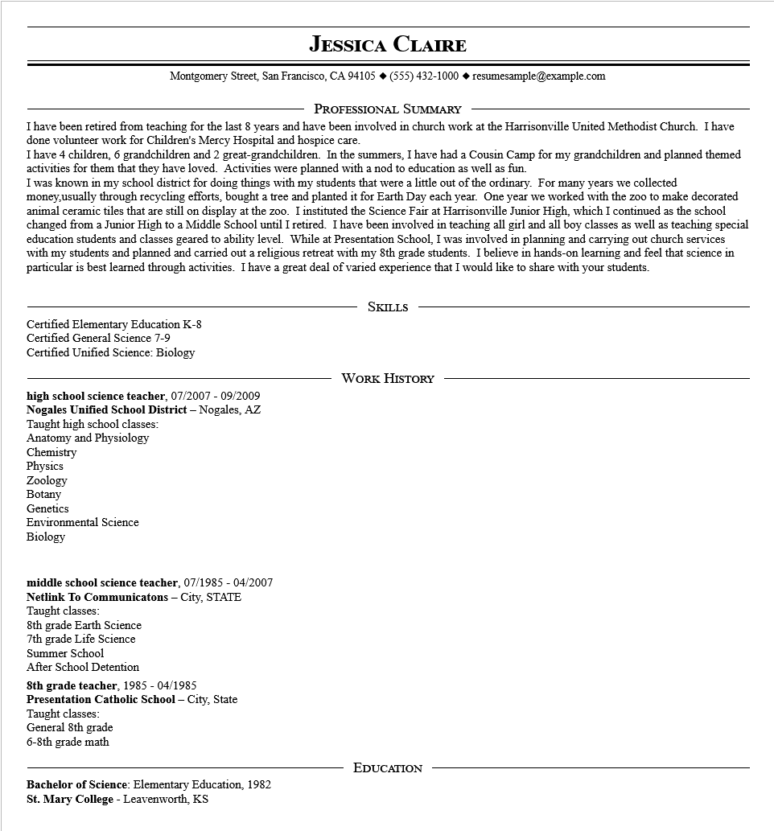

**JESSICA CLAIRE**

Montgomery Street, San Francisco, CA 94105 ♦ (555) 432-1000 resumesample@example.com

PROFESSIONAL SUMMARY

I have been retired from teaching for the last 8 years and have been involved in church work at the Harrisonville United Methodist Church. I have done volunteer work for Children's Mercy Hospital and hospice care.

I have 4 children, 6 grandchildren and 2 great-grandchildren. In the summers, I have had a Cousin Camp for my grandchildren and planned themed activities for them that they have loved. Activities were planned with a nod to education as well as fun.

I was known in my school district for doing things with my students that were a little out of the ordinary. For many years we collected money,usually through recycling efforts, bought a tree and planted it for Earth Day each year. One year we worked with the zoo to make decorated animal ceramic tiles that are still on display at the zoo. I instituted the Science Fair at Harrisonville Junior High, which I continued as the school changed from a Junior High to a Middle School until I retired. I have been involved in teaching all girl and all boy classes as well as teaching special education students and classes geared to ability level. While at Presentation School, I was involved in planning and carrying out church services with my students and planned and carried out a religious retreat with my 8th grade students. I believe in hands-on learning and feel that science in particular is best learned through activities. I have a great deal of varied experience that I would like to share with your students.

Certified Elementary Education K-8

Certified General Science 7-9

Certified Unified Science: Biology

SKILLS

high school science teacher, 07/2007 - 09/2009

**Nogales Unified School District - Nogales, AZ Taught high school classes:**

Anatomy and Physiology

WORK HISTORY

Chemistry

Physics

Zoology

Botany

Genetics

Environmental Science

Biology

middle school science teacher, 07/1985 - 04/2007

**Netlink To Communicatons - City, STATE**

Taught classes:

8th grade Earth Science

7th grade Life Science

Summer School

After School Detention

**8th grade teacher, 1985 - 04/1985**

**Presentation Catholic School - City, State**

Taught classes:

General 8th grade

6-8th grade math

Bachelor of Science: Elementary Education, 1982 St. Mary College - Leavenworth, KS

EDUCATION