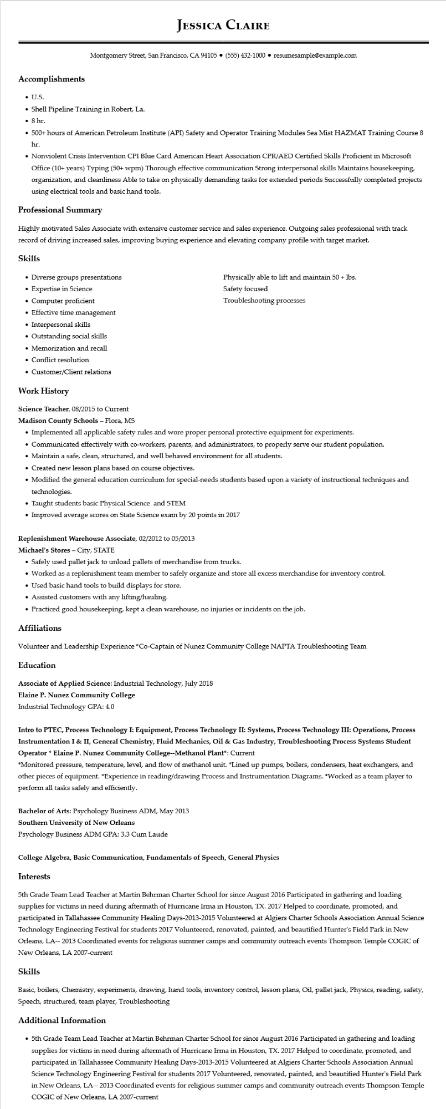

**Accomplishments**

• U.S.

**JESSICA CLAIRE**

Montgomery Street, San Francisco, CA 94105 ⚫ (555) 432-1000⚫ resumesample@example.com

• Shell Pipeline Training in Robert, La.

• 8 hr.

• 500+ hours of American Petroleum Institute (API) Safety and Operator Training Modules Sea Mist HAZMAT Training Course 8 hr.

• Nonviolent Crisis Intervention CPI Blue Card American Heart Association CPR/AED Certified Skills Proficient in Microsoft Office (10+ years) Typing (50+ wpm) Thorough effective communication Strong interpersonal skills Maintains housekeeping, organization, and cleanliness Able to take on physically demanding tasks for extended periods Successfully completed projects using electrical tools and basic hand tools.

**Professional Summary**

Highly motivated Sales Associate with extensive customer service and sales experience. Outgoing sales professional with track record of driving increased sales, improving buying experience and elevating company profile with target market.

**Skills**

• Diverse groups presentations

• Expertise in Science

• Computer proficient

• Effective time management

• Interpersonal skills

• Outstanding social skills

• Memorization and recall

• Conflict resolution

• Customer/Client relations

**Work History**

Science Teacher, 08/2015 to Current

**Madison County Schools - Flora, MS**

Physically able to lift and maintain 50 + lbs. Safety focused

Troubleshooting processes

• Implemented all applicable safety rules and wore proper personal protective equipment for experiments.

• Communicated effectively with co-workers, parents, and administrators, to properly serve our student population.

• Maintain a safe, clean, structured, and well behaved environment for all students.

• Created new lesson plans based on course objectives.

• Modified the general education curriculum for special-needs students based upon a variety of instructional techniques and technologies.

• Taught students basic Physical Science and STEM

• Improved average scores on State Science exam by 20 points in 2017

Replenishment Warehouse Associate, 02/2012 to 05/2013

**Michael's Stores - City, STATE**

• Safely used pallet jack to unload pallets of merchandise from trucks.

• Worked as a replenishment team member to safely organize and store all excess merchandise for inventory control.

• Used basic hand tools to build displays for store.

• Assisted customers with any lifting/hauling.

• Practiced good housekeeping, kept a clean warehouse, no injuries or incidents on the job.

**Affiliations**

Volunteer and Leadership Experience *Co-Captain of Nunez Community College NAPTA Troubleshooting Team Education

Associate of Applied Science: Industrial Technology, July 2018

Elaine P. Nunez Community College

Industrial Technology GPA: 4.0

**Intro to PTEC, Process Technology I: Equipment, Process Technology II: Systems, Process Technology III: Operations, Process Instrumentation I & II, General Chemistry, Fluid Mechanics, Oil & Gas Industry, Troubleshooting Process Systems Student Operator * Elaine P. Nunez Community College--Methanol Plant*: Current**

*Monitored pressure, temperature, level, and flow of methanol unit. *Lined up pumps, boilers, condensers, heat exchangers, and other pieces of equipment. *Experience in reading/drawing Process and Instrumentation Diagrams. *Worked as a team player to perform all tasks safely and efficiently.

Bachelor of Arts: Psychology Business ADM, May 2013

**Southern University of New Orleans**

Psychology Business ADM GPA: 3.3 Cum Laude

**College Algebra, Basic Communication, Fundamentals of Speech, General Physics**

**Interests**

5th Grade Team Lead Teacher at Martin Behrman Charter School for since August 2016 Participated in gathering and loading supplies for victims in need during aftermath of Hurricane Irma in Houston, TX. 2017 Helped to coordinate, promoted, and participated in Tallahassee Community Healing Days-2013-2015 Volunteered at Algiers Charter Schools Association Annual Science Technology Engineering Festival for students 2017 Volunteered, renovated, painted, and beautified Hunter's Field Park in New Orleans, LA-- 2013 Coordinated events for religious summer camps and community outreach events Thompson Temple COGIC of New Orleans, LA 2007-current

Skills

Basic, boilers, Chemistry, experiments, drawing, hand tools, inventory control, lesson plans, Oil, pallet jack, Physics, reading, safety, Speech, structured, team player, Troubleshooting

**Additional Information**

• 5th Grade Team Lead Teacher at Martin Behrman Charter School for since August 2016 Participated in gathering and loading supplies for victims in need during aftermath of Hurricane Irma in Houston, TX. 2017 Helped to coordinate, promoted, and participated in Tallahassee Community Healing Days-2013-2015 Volunteered at Algiers Charter Schools Association Annual Science Technology Engineering Festival for students 2017 Volunteered, renovated, painted, and beautified Hunter's Field Park in New Orleans, LA-2013 Coordinated events for religious summer camps and community outreach events Thompson Temple COGIC of New Orleans, LA 2007-current