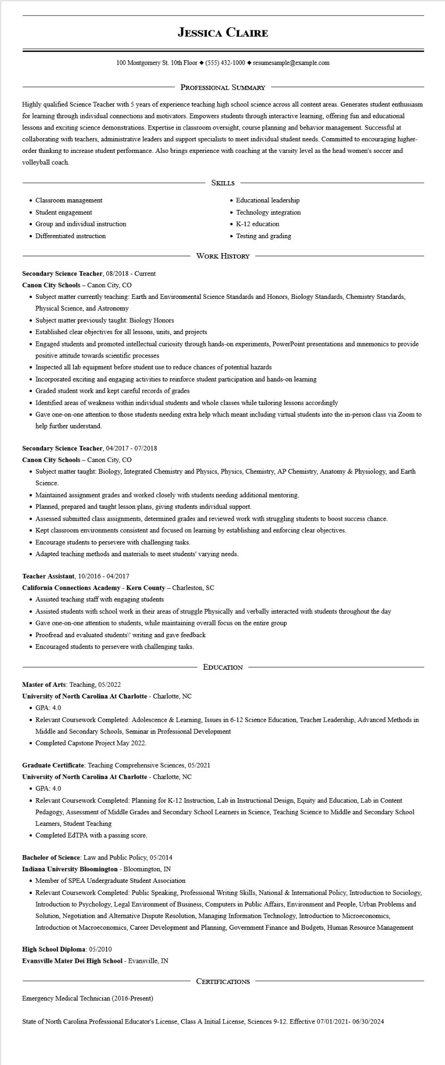

**JESSICA CLAIRE**

100 Montgomery St. 10th Floor◆ (555) 432-1000◆ resumesample@example.com

PROFESSIONAL SUMMARY

Highly qualified Science Teacher with 5 years of experience teaching high school science across all content areas. Generates student enthusiasm for learning through individual connections and motivators. Empowers students through interactive learning, offering fun and educational lessons and exciting science demonstrations. Expertise in classroom oversight, course planning and behavior management. Successful at collaborating with teachers, administrative leaders and support specialists to meet individual student needs. Committed to encouraging higher- order thinking to increase student performance. Also brings experience with coaching at the varsity level as the head women's soccer and volleyball coach.

• Classroom management

⚫ Student engagement

• Group and individual instruction

• Differentiated instruction

SKILLS

• Educational leadership

• Technology integration

• K-12 education

• Testing and grading

WORK HISTORY

**Secondary Science Teacher, 08/2018 - Current**

**Canon City Schools - Canon City, CO**

• Subject matter currently teaching: Earth and Environmental Science Standards and Honors, Biology Standards, Chemistry Standards, Physical Science, and Astronomy

• Subject matter previously taught: Biology Honors

• Established clear objectives for all lessons, units, and projects

• Engaged students and promoted intellectual curiosity through hands-on experiments, PowerPoint presentations and mnemonics to provide positive attitude towards scientific processes

• Inspected all lab equipment before student use to reduce chances of potential hazards

• Incorporated exciting and engaging activities to reinforce student participation and hands-on learning

• Graded student work and kept careful records of grades

• Identified areas of weakness within individual students and whole classes while tailoring lessons accordingly

• Gave one-on-one attention to those students needing extra help which meant including virtual students into the in-person class via Zoom to help further understand.

**Secondary Science Teacher, 04/2017-07/2018**

**Canon City Schools - Canon City, CO**

• Subject matter taught: Biology, Integrated Chemistry and Physics, Physics, Chemistry, AP Chemistry, Anatomy & Physiology, and Earth Science.

• Maintained assignment grades and worked closely with students needing additional mentoring.

• Planned, prepared and taught lesson plans, giving students individual support.

• Assessed submitted class assignments, determined grades and reviewed work with struggling students to boost success chance.

• Kept classroom environments consistent and focused on learning by establishing and enforcing clear objectives.

• Encourage students to persevere with challenging tasks.

• Adapted teaching methods and materials to meet students' varying needs.

**Teacher Assistant, 10/2016-04/2017**

**California Connections Academy - Kern County - Charleston, SC**

• Assisted teaching staff with engaging students

• Assisted students with school work in their areas of struggle Physically and verbally interacted with students throughout the day

• Gave one-on-one attention to students, while maintaining overall focus on the entire group

• Proofread and evaluated students\' writing and gave feedback

• Encouraged students to persevere with challenging tasks.

Master of Arts: Teaching, 05/2022

EDUCATION

**University of North Carolina At Charlotte - Charlotte, NC**

• GPA: 4.0

• Relevant Coursework Completed: Adolescence & Learning, Issues in 6-12 Science Education, Teacher Leadership, Advanced Methods in Middle and Secondary Schools, Seminar in Professional Development

• Completed Capstone Project May 2022.

Graduate Certificate: Teaching Comprehensive Sciences, 05/2021

**University of North Carolina At Charlotte - Charlotte, NC**

• GPA: 4.0

• Relevant Coursework Completed: Planning for K-12 Instruction, Lab in Instructional Design, Equity and Education, Lab in Content Pedagogy, Assessment of Middle Grades and Secondary School Learners in Science, Teaching Science to Middle and Secondary School Learners, Student Teaching

• Completed EdTPA with a passing score.

**Bachelor of Science: Law and Public Policy, 05/2014**

**Indiana University Bloomington - Bloomington, IN**

• Member of SPEA Undergraduate Student Association

• Relevant Coursework Completed: Public Speaking, Professional Writing Skills, National & International Policy, Introduction to Sociology, Introduction to Psychology, Legal Environment of Business, Computers in Public Affairs, Environment and People, Urban Problems and Solution, Negotiation and Alternative Dispute Resolution, Managing Information Technology, Introduction to Microeconomics, Introduction Macroeconomics, Career Development and Planning, Government Finance and Budgets, Human Resource Management

**High School Diploma: 05/2010**

**Evansville Mater Dei High School - Evansville, IN**

CERTIFICATIONS

Emergency Medical Technician (2016-Present)

State of North Carolina Professional Educator's License, Class A Initial License, Sciences 9-12. Effective 07/01/2021-06/30/2024