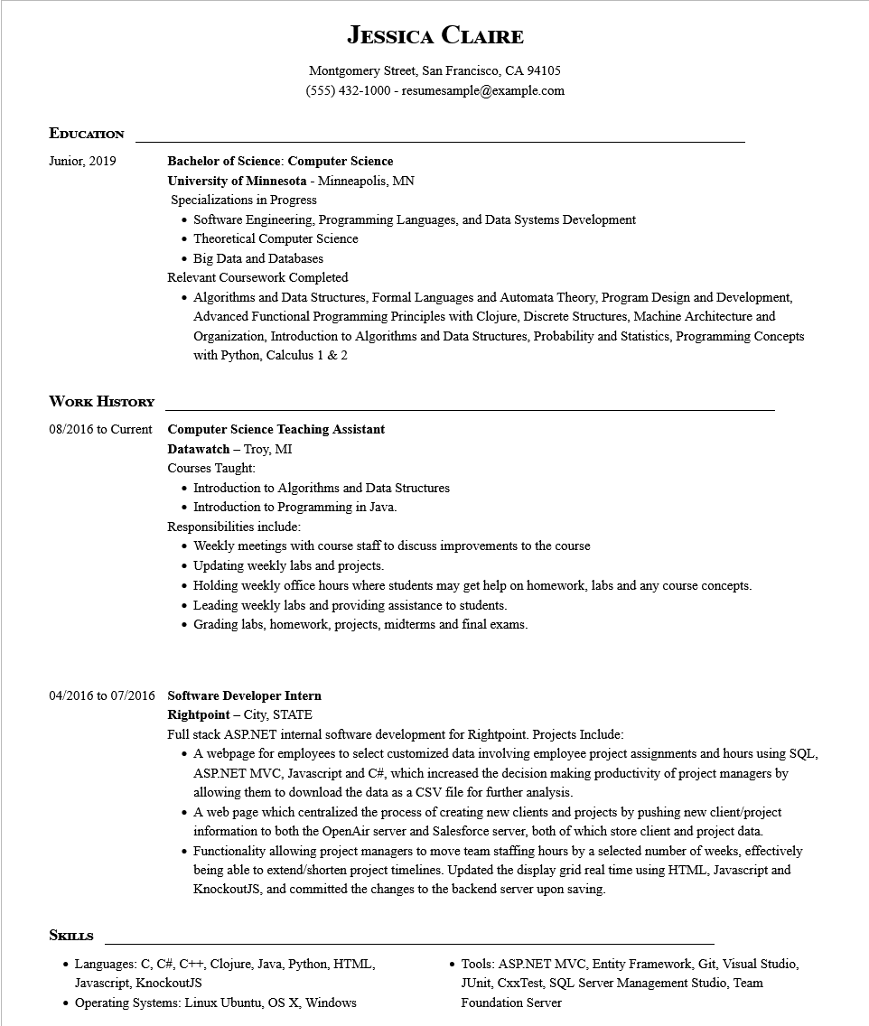

**EDUCATION**

**JESSICA CLAIRE**

Montgomery Street, San Francisco, CA 94105

(555) 432-1000 - resumesample@example.com

Junior, 2019

**WORK HISTORY**

**Bachelor of Science: Computer Science**

**University of Minnesota - Minneapolis, MN**

Specializations in Progress

• Software Engineering, Programming Languages, and Data Systems Development

• Theoretical Computer Science

• Big Data and Databases

Relevant Coursework Completed

• Algorithms and Data Structures, Formal Languages and Automata Theory, Program Design and Development, Advanced Functional Programming Principles with Clojure, Discrete Structures, Machine Architecture and Organization, Introduction to Algorithms and Data Structures, Probability and Statistics, Programming Concepts with Python, Calculus 1 & 2

**08/2016 to Current Computer Science Teaching Assistant**

**Datawatch - Troy, MI**

Courses Taught:

• Introduction to Algorithms and Data Structures

Introduction to Programming in Java.

Responsibilities include:

• Weekly meetings with course staff to discuss improvements to the course

• Updating weekly labs and projects.

• Holding weekly office hours where students may get help on homework, labs and any course concepts.

• Leading weekly labs and providing assistance to students.

Grading labs, homework, projects, midterms and final exams.

**04/2016 to 07/2016 Software Developer Intern**

**Rightpoint - City, STATE**

Full stack ASP.NET internal software development for Rightpoint. Projects Include:

• A webpage for employees to select customized data involving employee project assignments and hours using SQL, ASP.NET MVC, Javascript and C#, which increased the decision making productivity of project managers by allowing them to download the data as a CSV file for further analysis.

• A web page which centralized the process of creating new clients and projects by pushing new client/project information to both the OpenAir server and Salesforce server, both of which store client and project data.

• Functionality allowing project managers to move team staffing hours by a selected number of weeks, effectively being able to extend/shorten project timelines. Updated the display grid real time using HTML, Javascript and KnockoutJS, and committed the changes to the backend server upon saving.

**SKILLS**

• Languages: C, C#, C++, Clojure, Java, Python, HTML, Javascript, KnockoutJS

• Operating Systems: Linux Ubuntu, OS X, Windows

Tools: ASP.NET MVC, Entity Framework, Git, Visual Studio, JUnit, CxxTest, SQL Server Management Studio, Team Foundation Server