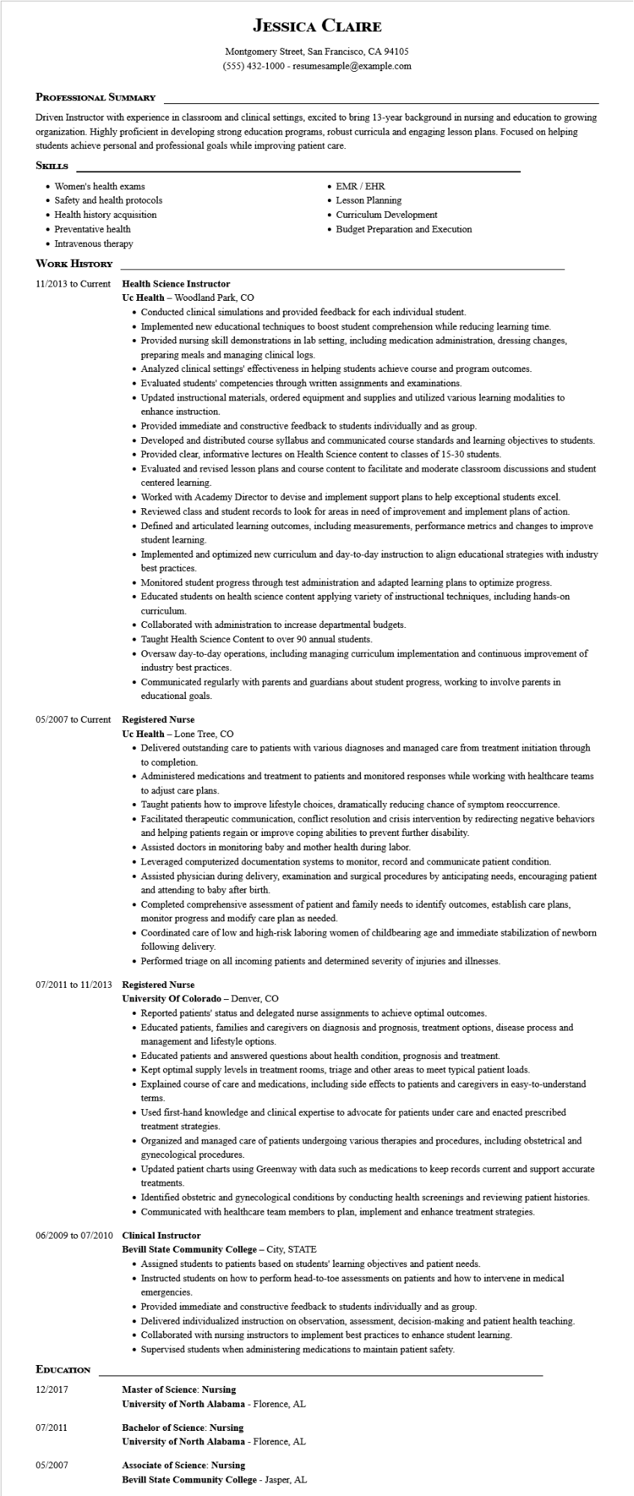

**JESSICA CLAIRE**

Montgomery Street, San Francisco, CA 94105

(555) 432-1000 - resumesample@example.com

**PROFESSIONAL SUMMARY**

Driven Instructor with experience in classroom and clinical settings, excited to bring 13-year background in nursing and education to growing organization. Highly proficient in developing strong education programs, robust curricula and engaging lesson plans. Focused on helping students achieve personal and professional goals while improving patient care.

**SKILLS**

• Women's health exams

• Safety and health protocols

• Health history acquisition

• Preventative health

• Intravenous therapy

**WORK HISTORY**

11/2013 to Current Health Science Instructor

• EMR/EHR

• Lesson Planning

• Curriculum Development

• Budget Preparation and Execution

Uc Health - Woodland Park, CO

• Conducted clinical simulations and provided feedback for each individual student.

• Implemented new educational techniques to boost student comprehension while reducing learning time.

• Provided nursing skill demonstrations in lab setting, including medication administration, dressing changes, preparing meals and managing clinical logs.

• Analyzed clinical settings' effectiveness in helping students achieve course and program outcomes.

• Evaluated students' competencies through written assignments and examinations.

• Updated instructional materials, ordered equipment and supplies and utilized various learning modalities to enhance instruction.

• Provided immediate and constructive feedback to students individually and as group.

• Developed and distributed course syllabus and communicated course standards and learning objectives to students.

• Provided clear, informative lectures on Health Science content to classes of 15-30 students.

• Evaluated and revised lesson plans and course content to facilitate and moderate classroom discussions and student centered learning.

• Worked with Academy Director to devise and implement support plans to help exceptional students excel.

• Reviewed class and student records to look for areas in need of improvement and implement plans of action.

• Defined and articulated learning outcomes, including measurements, performance metrics and changes to improve student learning.

• Implemented and optimized new curriculum and day-to-day instruction to align educational strategies with industry best practices.

• Monitored student progress through test administration and adapted learning plans to optimize progress.

• Educated students on health science content applying variety of instructional techniques, including hands-on curriculum.

• Collaborated with administration to increase departmental budgets.

• Taught Health Science Content to over 90 annual students.

• Oversaw day-to-day operations, including managing curriculum implementation and continuous improvement of industry best practices.

• Communicated regularly with parents and guardians about student progress, working to involve parents in educational goals.

**05/2007 to Current Registered Nurse**

**Uc Health - Lone Tree, CO**

• Delivered outstanding care to patients with various diagnoses and managed care from treatment initiation through to completion.

• Administered medications and treatment to patients and monitored responses while working with healthcare teams to adjust care plans.

• Taught patients how to improve lifestyle choices, dramatically reducing chance of symptom reoccurrence.

• Facilitated therapeutic communication, conflict resolution and crisis intervention by redirecting negative behaviors and helping patients regain or improve coping abilities to prevent further disability.

• Assisted doctors in monitoring baby and mother health during labor.

• Leveraged computerized documentation systems to monitor, record and communicate patient condition.

• Assisted physician during delivery, examination and surgical procedures by anticipating needs, encouraging patient and attending to baby after birth.

• Completed comprehensive assessment of patient and family needs to identify outcomes, establish care plans, monitor progress and modify care plan as needed.

• Coordinated care of low and high-risk laboring women of childbearing age and immediate stabilization of newborn following delivery.

• Performed triage on all incoming patients and determined severity of injuries and illnesses.

**07/2011 to 11/2013 Registered Nurse**

**University of Colorado - Denver, CO**

• Reported patients' status and delegated nurse assignments to achieve optimal outcomes.

• Educated patients, families and caregivers on diagnosis and prognosis, treatment options, disease process and management and lifestyle options.

• Educated patients and answered questions about health condition, prognosis and treatment.

• Kept optimal supply levels in treatment rooms, triage and other areas to meet typical patient loads.

• Explained course of care and medications, including side effects to patients and caregivers in easy-to-understand

terms.

• Used first-hand knowledge and clinical expertise to advocate for patients under care and enacted prescribed treatment strategies.

• Organized and managed care of patients undergoing various therapies and procedures, including obstetrical and gynecological procedures.

• Updated patient charts using Greenway with data such as medications to keep records current and support accurate

treatments.

• Identified obstetric and gynecological conditions by conducting health screenings and reviewing patient histories.

• Communicated with healthcare team members to plan, implement and enhance treatment strategies.

**06/2009 to 07/2010 Clinical Instructor**

**Bevill State Community College - City, STATE**

• Assigned students to patients based on students' learning objectives and patient needs.

• Instructed students on how to perform head-to-toe assessments on patients and how to intervene in medical emergencies.

• Provided immediate and constructive feedback to students individually and as group.

• Delivered individualized instruction on observation, assessment, decision-making and patient health teaching.

• Collaborated with nursing instructors to implement best practices to enhance student learning.

• Supervised students when administering medications to maintain patient safety.

**EDUCATION**

12/2017

**Master of Science: Nursing**

**University of North Alabama - Florence, AL**

07/2011

**Bachelor of Science: Nursing**

**University of North Alabama - Florence, AL**

05/2007

**Associate of Science: Nursing**

**Bevill State Community College - Jasper, AL**