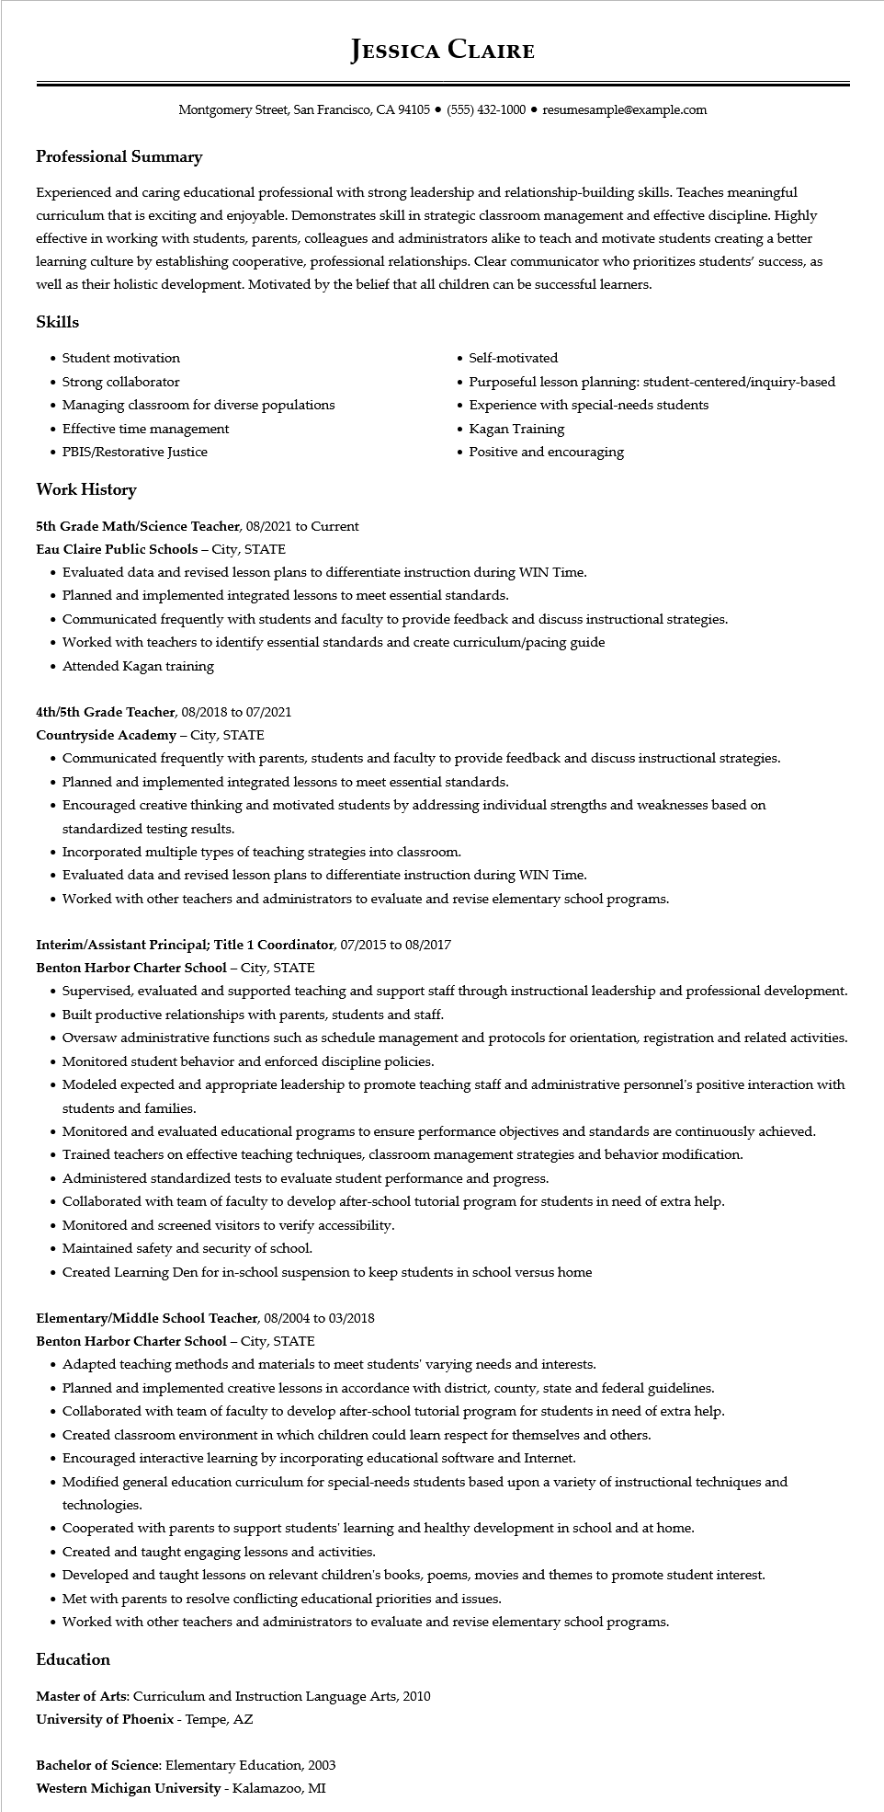

**JESSICA CLAIRE**

Montgomery Street, San Francisco, CA 94105 ⚫ (555) 432-1000⚫ resumesample@example.com

**Professional Summary**

Experienced and caring educational professional with strong leadership and relationship-building skills. Teaches meaningful curriculum that is exciting and enjoyable. Demonstrates skill in strategic classroom management and effective discipline. Highly effective in working with students, parents, colleagues and administrators alike to teach and motivate students creating a better learning culture by establishing cooperative, professional relationships. Clear communicator who prioritizes students' success, as well as their holistic development. Motivated by the belief that all children can be successful learners.

**Skills**

• Student motivation

• Strong collaborator

• Managing classroom for diverse populations

• Effective time management

• PBIS/Restorative Justice

**Work History**

5th Grade Math/Science Teacher, 08/2021 to Current

Eau Claire Public Schools - City, STATE

• Self-motivated

• Purposeful lesson planning: student-centered/inquiry-based

• Experience with special-needs students

• Kagan Training

• Positive and encouraging

• Evaluated data and revised lesson plans to differentiate instruction during WIN Time.

• Planned and implemented integrated lessons to meet essential standards.

• Communicated frequently with students and faculty to provide feedback and discuss instructional strategies.

• Worked with teachers to identify essential standards and create curriculum/pacing guide

• Attended Kagan training

4th/5th Grade Teacher, 08/2018 to 07/2021

**Countryside Academy - City, STATE**

• Communicated frequently with parents, students and faculty to provide feedback and discuss instructional strategies.

• Planned and implemented integrated lessons to meet essential standards.

• Encouraged creative thinking and motivated students by addressing individual strengths and weaknesses based on standardized testing results.

• Incorporated multiple types of teaching strategies into classroom.

• Evaluated data and revised lesson plans to differentiate instruction during WIN Time.

• Worked with other teachers and administrators to evaluate and revise elementary school programs.

**Interim/Assistant Principal; Title 1 Coordinator, 07/2015 to 08/2017**

**Benton Harbor Charter School - City, STATE**

• Supervised, evaluated and supported teaching and support staff through instructional leadership and professional development. • Built productive relationships with parents, students and staff.

• Oversaw administrative functions such as schedule management and protocols for orientation, registration and related activities. • Monitored student behavior and enforced discipline policies.

• Modeled expected and appropriate leadership to promote teaching staff and administrative personnel's positive interaction with students and families.

• Monitored and evaluated educational programs to ensure performance objectives and standards are continuously achieved.

• Trained teachers on effective teaching techniques, classroom management strategies and behavior modification.

• Administered standardized tests to evaluate student performance and progress.

• Collaborated with team of faculty to develop after-school tutorial program for students in need of extra help.

• Monitored and screened visitors to verify accessibility.

• Maintained safety and security of school.

• Created Learning Den for in-school suspension to keep students in school versus home

**Elementary/Middle School Teacher, 08/2004 to 03/2018**

Benton Harbor Charter School - City, STATE

• Adapted teaching methods and materials to meet students' varying needs and interests.

• Planned and implemented creative lessons in accordance with district, county, state and federal guidelines.

• Collaborated with team of faculty to develop after-school tutorial program for students in need of extra help.

• Created classroom environment in which children could learn respect for themselves and others.

• Encouraged interactive learning by incorporating educational software and Internet.

• Modified general education curriculum for special-needs students based upon a variety of instructional techniques and technologies.

.

Cooperated with parents to support students' learning and healthy development in school and at home.

• Created and taught engaging lessons and activities.

• Developed and taught lessons on relevant children's books, poems, movies and themes to promote student interest.

• Met with parents to resolve conflicting educational priorities and issues.

• Worked with other teachers and administrators to evaluate and revise elementary school programs.

**Education**

Master of Arts: Curriculum and Instruction Language Arts, 2010

University of Phoenix - Tempe, AZ

Bachelor of Science: Elementary Education, 2003

**Western Michigan University - Kalamazoo, MI**