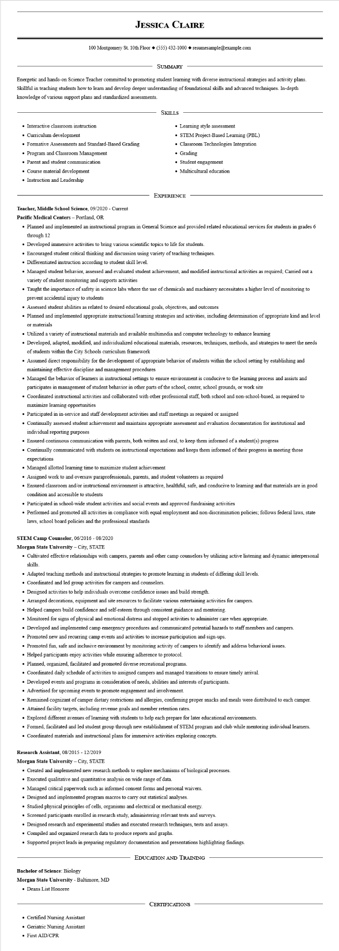

**JESSICA CLAIRE**

100 Montgomery St. 10th Floor (555) 432-1000◆ resumesample@example.com

SUMMARY

Energetic and hands-on Science Teacher committed to promoting student learning with diverse instructional strategies and activity plans. Skillful in teaching students how to learn and develop deeper understanding of foundational skills and advanced techniques. In-depth knowledge of various support plans and standardized assessments.

• Interactive classroom instruction

• Curriculum development

• Formative Assessments and Standard-Based Grading

• Program and Classroom Management

• Parent and student communication

• Course material development

• Instruction and Leadership

SKILLS

• Learning style assessment

• STEM Project-Based Learning (PBL)

• Classroom Technologies Integration

• Grading

• Student engagement

• Multicultural education

EXPERIENCE

**Teacher, Middle School Science, 09/2020 - Current**

**Pacific Medical Centers - Portland, OR**

• Planned and implemented an instructional program in General Science and provided related educational services for students in grades 6 through 12

• Developed immersive activities to bring various scientific topics to life for students.

• Encouraged student critical thinking and discussion using variety of teaching techniques.

• Differentiated instruction according to student skill level.

• Managed student behavior, assessed and evaluated student achievement, and modified instructional activities as required; Carried out a variety of student monitoring and supports activities

• Taught the importance of safety in science labs where the use of chemicals and machinery necessitates a higher level of monitoring to prevent accidental injury to students

• Assessed student abilities as related to desired educational goals, objectives, and outcomes

• Planned and implemented appropriate instructional/learning strategies and activities, including determination of appropriate kind and level or materials

• Utilized a variety of instructional materials and available multimedia and computer technology to enhance learning

• Developed, adapted, modified, and individualized educational materials, resources, techniques, methods, and strategies to meet the needs of students within the City Schools curriculum framework

• Assumed direct responsibility for the development of appropriate behavior of students within the school setting by establishing and maintaining effective discipline and management procedures

• Managed the behavior of learners in instructional settings to ensure environment is conducive to the learning process and assists and participates in management of student behavior in other parts of the school, center, school grounds, or work site

• Coordinated instructional activities and collaborated with other professional staff, both school and non-school-based, as required to maximize learning opportunities

• Participated in in-service and staff development activities and staff meetings as required or assigned

• Continually assessed student achievement and maintains appropriate assessment and evaluation documentation for institutional and individual reporting purposes

• Ensured continuous communication with parents, both written and oral, to keep them informed of a student(s) progress

• Continually communicated with students on instructional expectations and keeps them informed of their progress in meeting those expectations

• Managed allotted learning time to maximize student achievement

• Assigned work to and oversaw paraprofessionals, parents, and student volunteers as required

• Ensured classroom and/or instructional environment is attractive, healthful, safe, and conducive to learning and that materials are in good condition and accessible to students

• Participated in school-wide student activities and social events and approved fundraising activities

• Performed and promoted all activities in compliance with equal employment and non-discrimination policies; follows federal laws, state laws, school board policies and the professional standards

**STEM Camp Counselor, 06/2016 - 08/2020**

**Morgan State University - City, STATE**

• Cultivated effective relationships with campers, parents and other camp counselors by utilizing active listening and dynamic interpersonal skills.

• Adapted teaching methods and instructional strategies to promote learning in students of differing skill levels.

• Coordinated and led group activities for campers and counselors.

• Designed activities to help individuals overcome confidence issues and build strength.

• Arranged decorations, equipment and site resources to facilitate various entertaining activities for campers.

• Helped campers build confidence and self-esteem through consistent guidance and mentoring.

• Monitored for signs of physical and emotional distress and stopped activities to administer care when appropriate.

• Developed and implemented camp emergency procedures and communicated potential hazards to staff members and campers.

• Promoted new and recurring camp events and activities to increase participation and sign-ups.

• Promoted fun, safe and inclusive environment by monitoring activity of campers to identify and address behavioral issues.

• Helped participants enjoy activities while ensuring adherence to protocol.

• Planned, organized, facilitated and promoted diverse recreational programs.

• Coordinated daily schedule of activities to assigned campers and managed transitions to ensure timely arrival.

• Developed events and programs in consideration of needs, abilities and interests of participants.

• Advertised for upcoming events to promote engagement and involvement.

• Remained cognizant of camper dietary restrictions and allergies, confirming proper snacks and meals were distributed to each camper.

• Attained facility targets, including revenue goals and member retention rates.

• Explored different avenues of learning with students to help each prepare for later educational environments.

• Formed, facilitated and led student group through new establishment of STEM program and club while mentoring individual learners.

• Coordinated materials and instructional plans for immersive activities exploring concepts.

**Research Assistant, 08/2015 - 12/2019**

**Morgan State University - City, STATE**

• Created and implemented new research methods to explore mechanisms of biological processes.

• Executed qualitative and quantitative analysis on wide range of data.

• Managed critical paperwork such as informed consent forms and personal waivers.

• Designed and implemented program macros to carry out statistical analyses.

• Studied physical principles of cells, organisms and electrical or mechanical energy.

• Screened participants enrolled in research study, administering relevant tests and surveys.

• Designed research and experimental studies and executed research techniques, tests and assays.

• Compiled and organized research data to produce reports and graphs.

• Supported project leads in preparing regulatory documentation and presentations highlighting findings.

**Bachelor of Science: Biology**

**Morgan State University - Baltimore, MD**

• Deans List Honoree

• Certified Nursing Assistant

• Geriatric Nursing Assistant

• First AID/CPR

EDUCATION AND TRAINING

CERTIFICATIONS