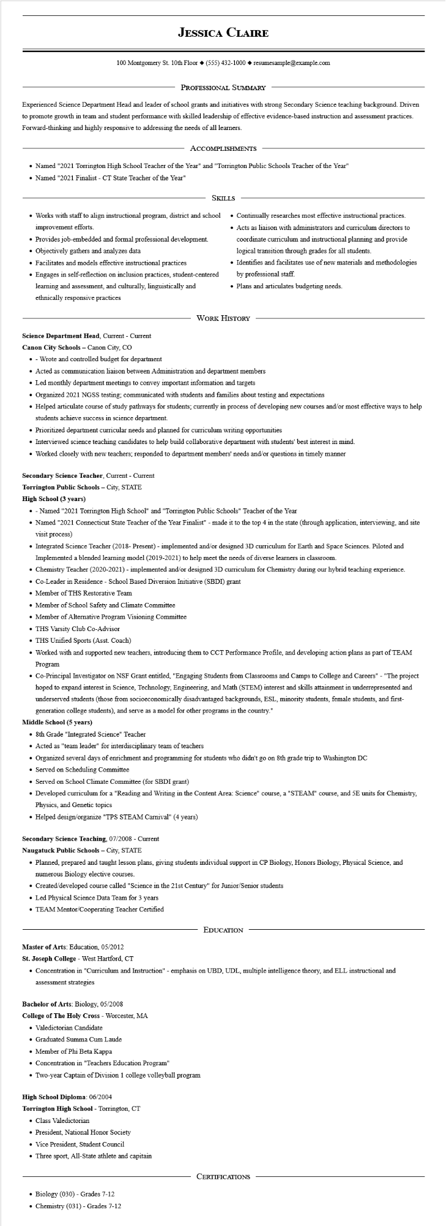

**JESSICA CLAIRE**

100 Montgomery St. 10th Floor (555) 432-1000◆ resumesample@example.com

PROFESSIONAL SUMMARY

Experienced Science Department Head and leader of school grants and initiatives with strong Secondary Science teaching background. Driven to promote growth in team and student performance with skilled leadership of effective evidence-based instruction and assessment practices. Forward-thinking and highly responsive to addressing the needs of all learners.

ACCOMPLISHMENTS

• Named "2021 Torrington High School Teacher of the Year" and "Torrington Public Schools Teacher of the Year"

• Named "2021 Finalist - CT State Teacher of the Year"

SKILLS

• Works with staff to align instructional program, district and school improvement efforts.

• Provides job-embedded and formal professional development.

• Objectively gathers and analyzes data

• Facilitates and models effective instructional practices

• Engages in self-reflection on inclusion practices, student-centered

learning and assessment, and culturally, linguistically and ethnically responsive practices

• Continually researches most effective instructional practices.

• Acts as liaison with administrators and curriculum directors to coordinate curriculum and instructional planning and provide logical transition through grades for all students.

• Identifies and facilitates use of new materials and methodologies by professional staff.

• Plans and articulates budgeting needs.

WORK HISTORY

**Science Department Head, Current - Current**

Canon City Schools - Canon City, CO

⚫ - Wrote and controlled budget for department

• Acted as communication liaison between Administration and department members

• Led monthly department meetings to convey important information and targets

• Organized 2021 NGSS testing; communicated with students and families about testing and expectations

• Helped articulate course of study pathways for students; currently in process of developing new courses and/or most effective ways to help students achieve success in science department.

• Prioritized department curricular needs and planned for curriculum writing opportunities

• Interviewed science teaching candidates to help build collaborative department with students' best interest in mind.

• Worked closely with new teachers; responded to department members' needs and/or questions in timely manner

**Secondary Science Teacher, Current - Current**

**Torrington Public Schools - City, STATE**

**High School (3 years)**

⚫ - Named "2021 Torrington High School" and "Torrington Public Schools" Teacher of the Year

• Named "2021 Connecticut State Teacher of the Year Finalist" - made it to the top 4 in the state (through application, interviewing, and site visit process)

• Integrated Science Teacher (2018- Present) - implemented and/or designed 3D curriculum for Earth and Space Sciences. Piloted and Implemented a blended learning model (2019-2021) to help meet the needs of diverse learners in classroom.

• Chemistry Teacher (2020-2021) - implemented and/or designed 3D curriculum for Chemistry during our hybrid teaching experience.

• Co-Leader in Residence School Based Diversion Initiative (SBDI) grant

• Member of THS Restorative Team

• Member of School Safety and Climate Committee

• Member of Alternative Program Visioning Committee

⚫THS Varsity Club Co-Advisor

⚫THS Unified Sports (Asst. Coach)

• Worked with and supported new teachers, introducing them to CCT Performance Profile, and developing action plans as part of TEAM Program

• Co-Principal Investigator on NSF Grant entitled, "Engaging Students from Classrooms and Camps to College and Careers" - "The project hoped to expand interest in Science, Technology, Engineering, and Math (STEM) interest and skills attainment in underrepresented and underserved students (those from socioeconomically disadvantaged backgrounds, ESL, minority students, female students, and first- generation college students), and serve as a model for other programs in the country."

**Middle School (5 years)**

• 8th Grade "Integrated Science" Teacher

• Acted as "team leader" for interdisciplinary team of teachers

• Organized several days of enrichment and programming for students who didn't go on 8th grade trip to Washington DC

• Served on Scheduling Committee

• Served on School Climate Committee (for SBDI grant)

• Developed curriculum for a "Reading and Writing in the Content Area: Science" course, a "STEAM" course, and 5E units for Chemistry, Physics, and Genetic topics

• Helped design/organize "TPS STEAM Carnival" (4 years)

**Secondary Science Teaching, 07/2008 - Current**

**Naugatuck Public Schools - City, STATE**

• Planned, prepared and taught lesson plans, giving students individual support in CP Biology, Honors Biology, Physical Science, and numerous Biology elective courses.

• Created/developed course called "Science in the 21st Century" for Junior/Senior students

• Led Physical Science Data Team for 3 years

• TEAM Mentor/Cooperating Teacher Certified

EDUCATION

Master of Arts: Education, 05/2012

St. Joseph College - West Hartford, CT

• Concentration in "Curriculum and Instruction" - emphasis on UBD, UDL, multiple intelligence theory, and ELL instructional and assessment strategies

Bachelor of Arts: Biology, 05/2008

College of The Holy Cross - Worcester, MA

• Valedictorian Candidate

• Graduated Summa Cum Laude

• Member of Phi Beta Kappa

• Concentration in "Teachers Education Program"

• Two-year Captain of Division 1 college volleyball program

**High School Diploma: 06/2004**

**Torrington High School - Torrington, CT**

• Class Valedictorian

• President, National Honor Society

• Vice President. Student Council

• Three sport, All-State athlete and capitain

CERTIFICATIONS

• Biology (030) - Grades 7-12

• Chemistry (031) Grades 7-12