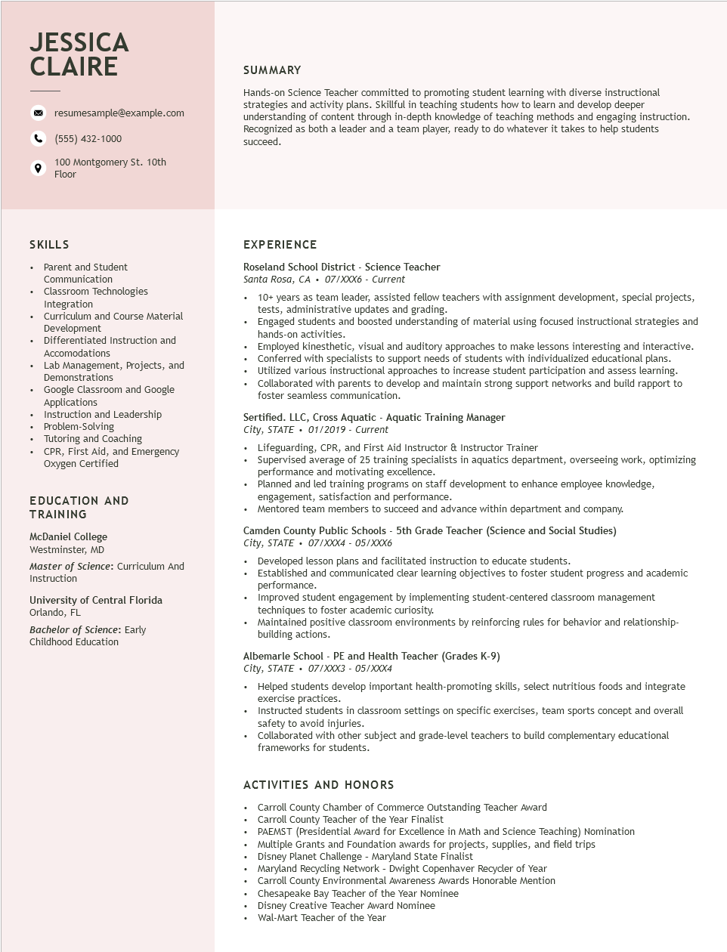

**JESSICA CLAIRE**

resumesample@example.com

(555) 432-1000

100 Montgomery St. 10th Floor

**SUMMARY**

Hands-on Science Teacher committed to promoting student learning with diverse instructional strategies and activity plans. Skillful in teaching students how to learn and develop deeper understanding of content through in-depth knowledge of teaching methods and engaging instruction. Recognized as both a leader and a team player, ready to do whatever it takes to help students succeed.

SKILLS

• Parent and Student

Communication

• Classroom Technologies

Integration

• Curriculum and Course Material

Development

•

Differentiated Instruction and Accomodations

Lab Management, Projects, and Demonstrations

Google Classroom and Google Applications

• Instruction and Leadership Problem-Solving

Tutoring and Coaching

• CPR, First Aid, and Emergency

Oxygen Certified

EDUCATION AND

TRAINING

McDaniel College

Westminster, MD

Master of Science: Curriculum And Instruction

University of Central Florida Orlando, FL

Bachelor of Science: Early Childhood Education

**EXPERIENCE**

Roseland School District - Science Teacher Santa Rosa, CA⚫ 07/XXX6 - Current

•

10+ years as team leader, assisted fellow teachers with assignment development, special projects, tests, administrative updates and grading.

Engaged students and boosted understanding of material using focused instructional strategies and hands-on activities.

Employed kinesthetic, visual and auditory approaches to make lessons interesting and interactive. Conferred with specialists to support needs of students with individualized educational plans.

• Utilized various instructional approaches to increase student participation and assess learning.

• Collaborated with parents to develop and maintain strong support networks and build rapport to foster seamless communication.

Sertified. LLC, Cross Aquatic - Aquatic Training Manager

*City, STATE 01/2019 - Current*

• Lifeguarding, CPR, and First Aid Instructor & Instructor Trainer

Supervised average of 25 training specialists in aquatics department, overseeing work, optimizing performance and motivating excellence.

Planned and led training programs on staff development to enhance employee knowledge, engagement, satisfaction and performance.

• Mentored team members to succeed and advance within department and company.

Camden County Public Schools - 5th Grade Teacher (Science and Social Studies) City, STATE. 07/XXX4 - 05/XXX6

• Developed lesson plans and facilitated instruction to educate students.

Established and communicated clear learning objectives to foster student progress and academic performance.

Improved student engagement by implementing student-centered classroom management techniques to foster academic curiosity.

• Maintained positive classroom environments by reinforcing rules for behavior and relationship- building actions.

Albemarle School - PE and Health Teacher (Grades K-9)

*City, STATE. 07/XXX3 - 05/XXX4*

• Helped students develop important health-promoting skills, select nutritious foods and integrate exercise practices.

• Instructed students in classroom settings on specific exercises, team sports concept and overall safety to avoid injuries.

• Collaborated with other subject and grade-level teachers to build complementary educational frameworks for students.

ACTIVITIES AND HONORS

Carroll County Chamber of Commerce Outstanding Teacher Award

Carroll County Teacher of the Year Finalist

• PAEMST (Presidential Award for Excellence in Math and Science Teaching) Nomination

• Multiple Grants and Foundation awards for projects, supplies, and field trips

• Disney Planet Challenge - Maryland State Finalist

Maryland Recycling Network - Dwight Copenhaver Recycler of Year

Carroll County Environmental Awareness Awards Honorable Mention

• Chesapeake Bay Teacher of the Year Nominee

• Disney Creative Teacher Award Nominee

Wal-Mart Teacher of the Year