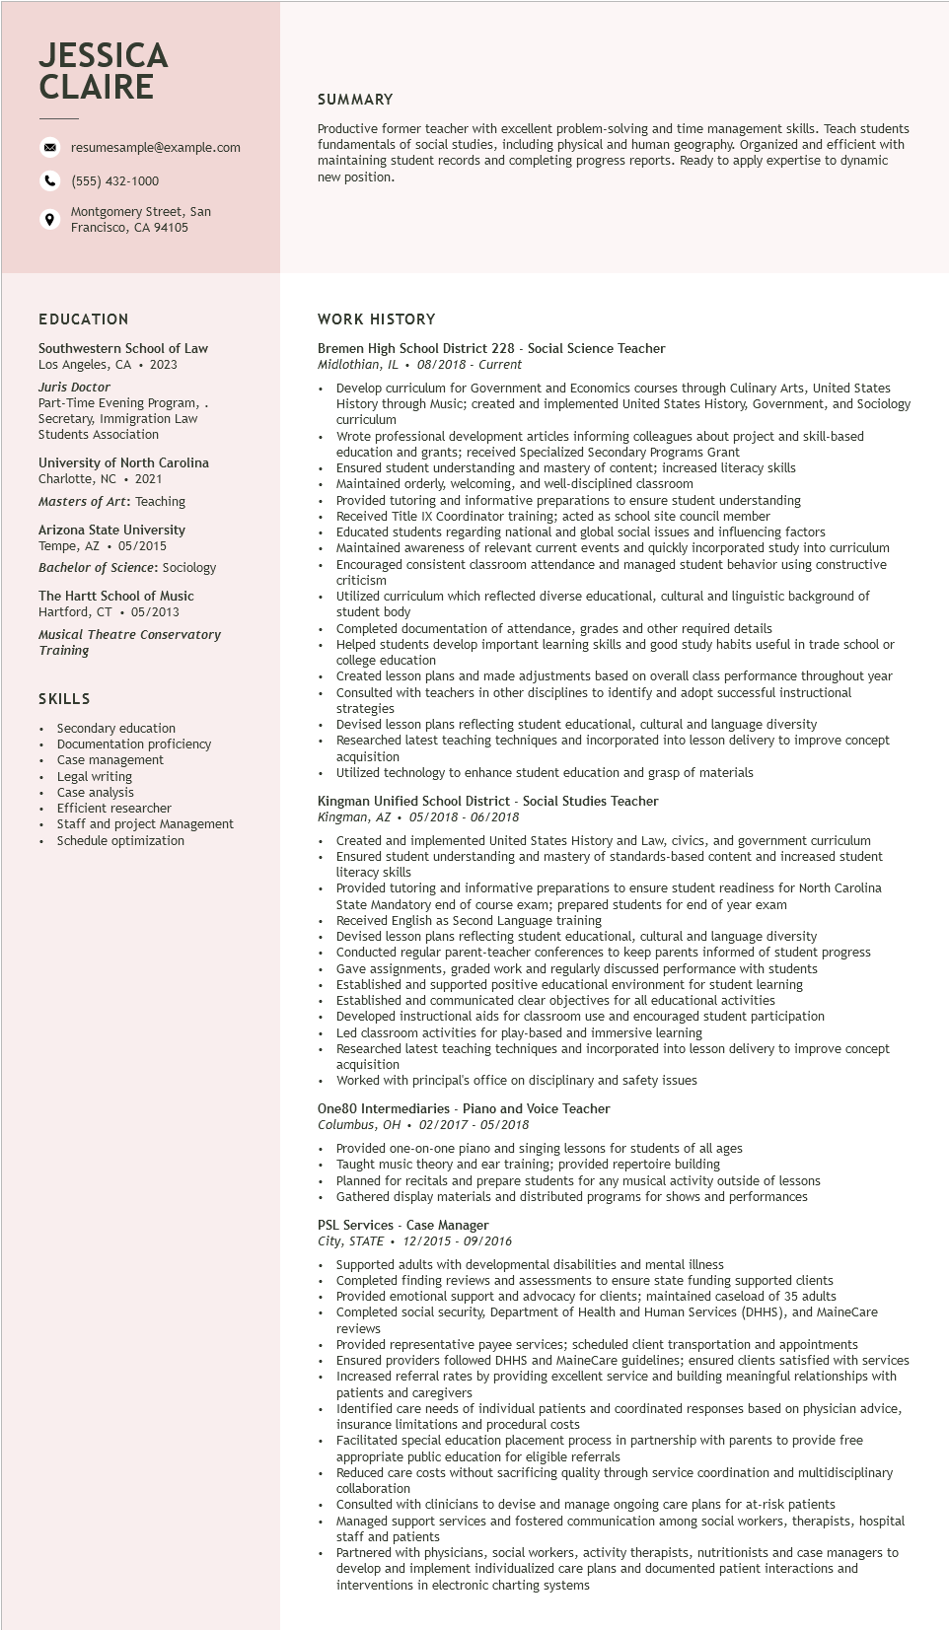

**JESSICA CLAIRE**

9

resumesample@example.com

(555) 432-1000

Montgomery Street, San Francisco, CA 94105

SUMMARY

Productive former teacher with excellent problem-solving and time management skills. Teach students fundamentals of social studies, including physical and human geography. Organized and efficient with maintaining student records and completing progress reports. Ready to apply expertise to dynamic new position.

**EDUCATION**

Southwestern School of Law Los Angeles, CA. 2023

Juris Doctor

Part-Time Evening Program, . Secretary, Immigration Law Students Association

University of North Carolina

Charlotte, NC. 2021

Masters of Art: Teaching

Arizona State University Tempe, AZ 05/2015

.

*Bachelor of Science: Sociology*

The Hartt School of Music Hartford, CT. 05/2013

Musical Theatre Conservatory Training

SKILLS

• Secondary education

• Documentation proficiency

Case management

• Legal writing

• Case analysis

•

Efficient researcher

• Staff and project Management

• Schedule optimization

**WORK HISTORY**

Bremen High School District 228 - Social Science Teacher Midlothian, IL. 08/2018 - Current

• Develop curriculum for Government and Economics courses through Culinary Arts, United States History through Music; created and implemented United States History, Government, and Sociology curriculum

Wrote professional development articles informing colleagues about project and skill-based education and grants; received Specialized Secondary Programs Grant

Ensured student understanding and mastery of content; increased literacy skills

• Maintained orderly, welcoming, and well-disciplined classroom

• Provided tutoring and informative preparations to ensure student understanding

Received Title IX Coordinator training; acted as school site council member

Educated students regarding national and global social issues and influencing factors Maintained awareness of relevant current events and quickly incorporated study into curriculum Encouraged consistent classroom attendance and managed student behavior using constructive criticism

Utilized curriculum which reflected diverse educational, cultural and linguistic background of student body Student

Completed documentation of attendance, grades and other required details

Helped students develop important learning skills and good study habits useful in trade school or college education

college

Created lesson plans and made adjustments based on overall class performance throughout year Consulted with teachers in other disciplines to identify and adopt successful instructional strategies

Devised lesson plans reflecting student educational, cultural and language diversity

Researched latest teaching techniques and incorporated into lesson delivery to improve concept acquisition

Utilized technology to enhance student education and grasp of materials

Kingman Unified School District - Social Studies Teacher

Kingman, AZ 05/2018 - 06/2018

Created and implemented United States History and Law, civics, and government curriculum Ensured student understanding and mastery of standards-based content and increased student literacy skills

• Provided tutoring and informative preparations to ensure student readiness for North Carolina State Mandatory end of course exam; prepared students for end of year exam Received English as Second Language training

Devised lesson plans reflecting student educational, cultural and language diversity Conducted regular parent-teacher conferences to keep parents informed of student progress Gave assignments, graded work and regularly discussed performance with students Established and supported positive educational environment for student learning Established and communicated clear objectives for all educational activities

Developed instructional aids for classroom use and encouraged student participation

Led classroom activities for play-based and immersive learning

Researched latest teaching techniques and incorporated into lesson delivery to improve concept acquisition

Worked with principal's office on disciplinary and safety issues

One80 Intermediaries - Piano and Voice Teacher

Columbus, OH. 02/2017 - 05/2018

Provided one-on-one piano and singing lessons for students of all ages

Taught music theory and ear training; provided repertoire building

Planned for recitals and prepare students for any musical activity outside of lessons Gathered display materials and distributed programs for shows and performances

PSL Services - Case Manager

*City, STATE 12/2015-09/2016*

Supported adults with developmental disabilities and mental illness

Completed finding reviews and assessments to ensure state funding supported clients Provided emotional support and advocacy for clients; maintained caseload of 35 adults Completed social security, Department of Health and Human Services (DHHS), and MaineCare reviews

Provided representative payee services; scheduled client transportation and appointments Ensured providers followed DHHS and MaineCare guidelines; ensured clients satisfied with services Increased referral rates by providing excellent service and building meaningful relationships with

patients and caregivers

Identified care needs of individual patients and coordinated responses based on physician advice, insurance limitations and procedural costs

• Facilitated special education placement process in partnership with parents to provide free appropriate public education for eligible referrals

Reduced care costs without sacrificing quality through service coordination and multidisciplinary collaboration

Consulted with clinicians to devise and manage ongoing care plans for at-risk patients

• Managed support services and fostered communication among social workers, therapists, hospital staff and patients

Partnered with physicians, social workers, activity therapists, nutritionists and case managers to develop and implement individualized care plans and documented patient interactions and interventions in electronic charting systems