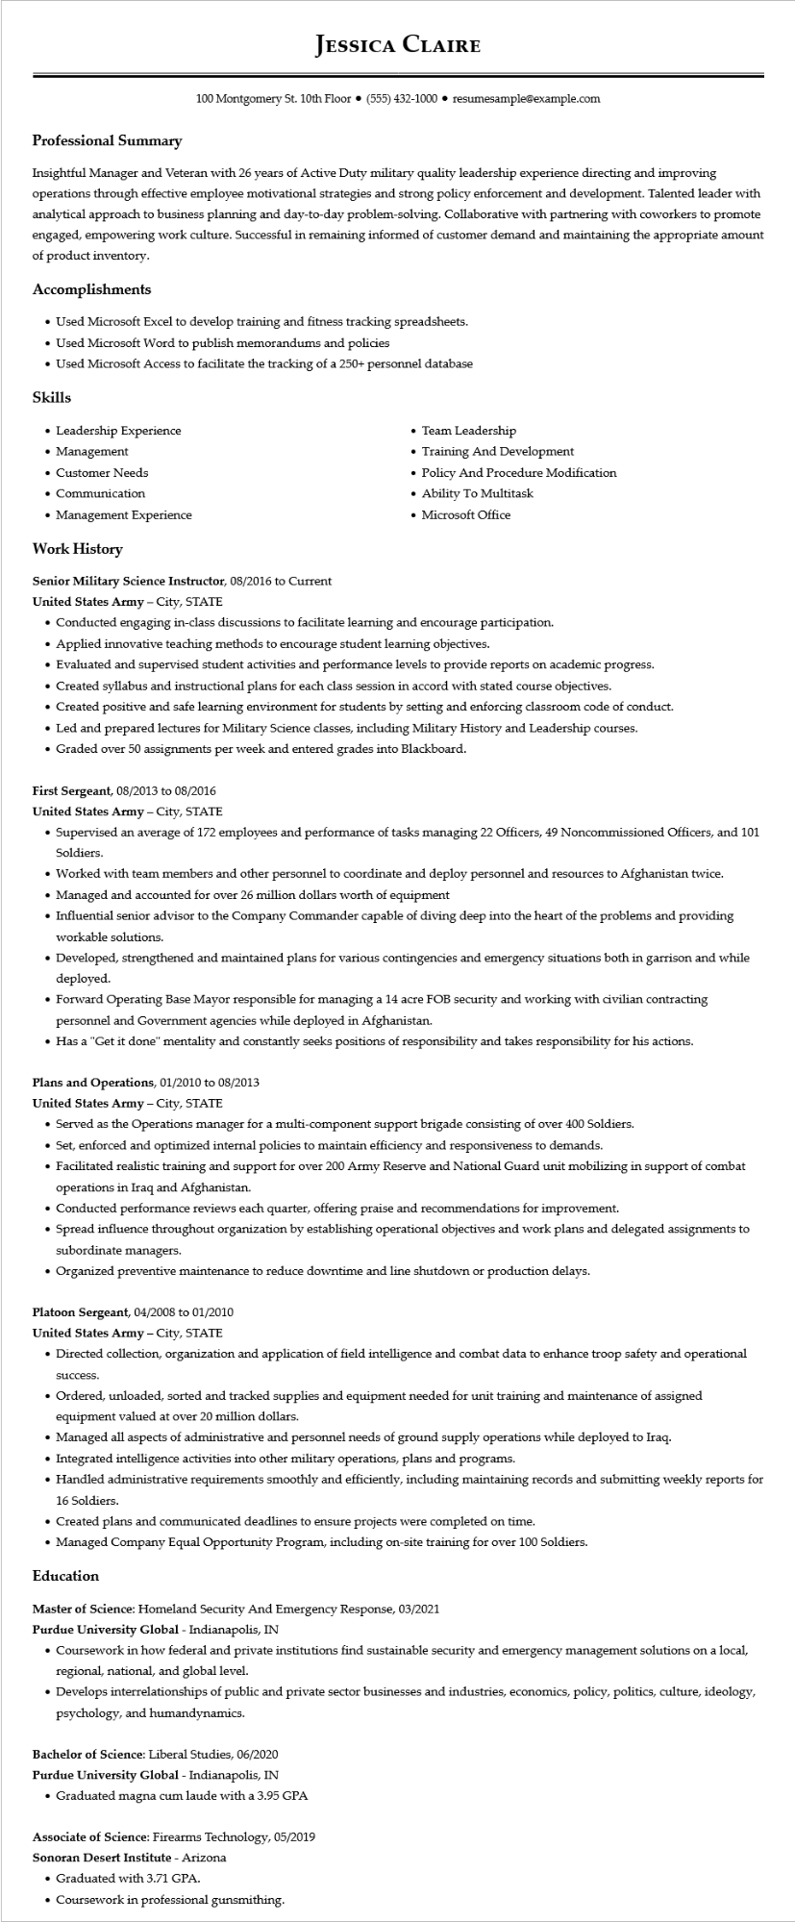

**Professional Summary**

**JESSICA CLAIRE**

100 Montgomery St. 10th Floor⚫ (555) 432-1000⚫ resumesample@example.com

Insightful Manager and Veteran with 26 years of Active Duty military quality leadership experience directing and improving operations through effective employee motivational strategies and strong policy enforcement and development. Talented leader with analytical approach to business planning and day-to-day problem-solving. Collaborative with partnering with coworkers to promote engaged, empowering work culture. Successful in remaining informed of customer demand and maintaining the appropriate amount of product inventory.

**Accomplishments**

• Used Microsoft Excel to develop training and fitness tracking spreadsheets.

• Used Microsoft Word to publish memorandums and policies

• Used Microsoft Access to facilitate the tracking of a 250+ personnel database

**Skills**

• Leadership Experience

• Management

• Customer Needs

• Communication

• Management Experience

**Work History**

Senior Military Science Instructor, 08/2016 to Current

**United States Army - City, STATE**

• Team Leadership

• Training And Development

• Policy And Procedure Modification

• Ability To Multitask

• Microsoft Office

• Conducted engaging in-class discussions to facilitate learning and encourage participation.

• Applied innovative teaching methods to encourage student learning objectives.

• Evaluated and supervised student activities and performance levels to provide reports on academic progress.

• Created syllabus and instructional plans for each class session in accord with stated course objectives.

• Created positive and safe learning environment for students by setting and enforcing classroom code of conduct.

• Led and prepared lectures for Military Science classes, including Military History and Leadership courses.

• Graded over 50 assignments per week and entered grades into Blackboard.

First Sergeant, 08/2013 to 08/2016

United States Army - City, STATE

• Supervised an average of 172 employees and performance of tasks managing 22 Officers, 49 Noncommissioned Officers, and 101 Soldiers.

• Worked with team members and other personnel to coordinate and deploy personnel and resources to Afghanistan twice.

• Managed and accounted for over 26 million dollars worth of equipment

• Influential senior advisor to the Company Commander capable of diving deep into the heart of the problems and providing workable solutions.

• Developed, strengthened and maintained plans for various contingencies and emergency situations both in garrison and while deployed.

• Forward Operating Base Mayor responsible for managing a 14 acre FOB security and working with civilian contracting personnel and Government agencies while deployed in Afghanistan.

• Has a "Get it done" mentality and constantly seeks positions of responsibility and takes responsibility for his actions.

**Plans and Operations, 01/2010 to 08/2013**

United States Army - City, STATE

• Served as the Operations manager for a multi-component support brigade consisting of over 400 Soldiers.

• Set, enforced and optimized internal policies to maintain efficiency and responsiveness to demands.

• Facilitated realistic training and support for over 200 Army Reserve and National Guard unit mobilizing in support of combat operations in Iraq and Afghanistan.

• Conducted performance reviews each quarter, offering praise and recommendations for improvement.

• Spread influence throughout organization by establishing operational objectives and work plans and delegated assignments to subordinate managers.

• Organized preventive maintenance to reduce downtime and line shutdown or production delays.

Platoon Sergeant, 04/2008 to 01/2010

United States Army - City, STATE

• Directed collection, organization and application of field intelligence and combat data to enhance troop safety and operational

success.

• Ordered, unloaded, sorted and tracked supplies and equipment needed for unit training and maintenance of assigned equipment valued at over 20 million dollars.

• Managed all aspects of administrative and personnel needs of ground supply operations while deployed to Iraq.

• Integrated intelligence activities into other military operations, plans and programs.

• Handled administrative requirements smoothly and efficiently, including maintaining records and submitting weekly reports for 16 Soldiers.

• Created plans and communicated deadlines to ensure projects were completed on time.

• Managed Company Equal Opportunity Program, including on-site training for over 100 Soldiers.

**Education**

Master of Science: Homeland Security And Emergency Response, 03/2021

Purdue University Global - Indianapolis, IN

• Coursework in how federal and private institutions find sustainable security and emergency management solutions on a local, regional, national, and global level.

• Develops interrelationships of public and private sector businesses and industries, economics, policy, politics, culture, ideology, psychology, and humandynamics.

Bachelor of Science: Liberal Studies, 06/2020

Purdue University Global - Indianapolis, IN

• Graduated magna cum laude with a 3.95 GPA

Associate of Science: Firearms Technology, 05/2019 Sonoran Desert Institute - Arizona

• Graduated with 3.71 GPA.

• Coursework in professional gunsmithing.