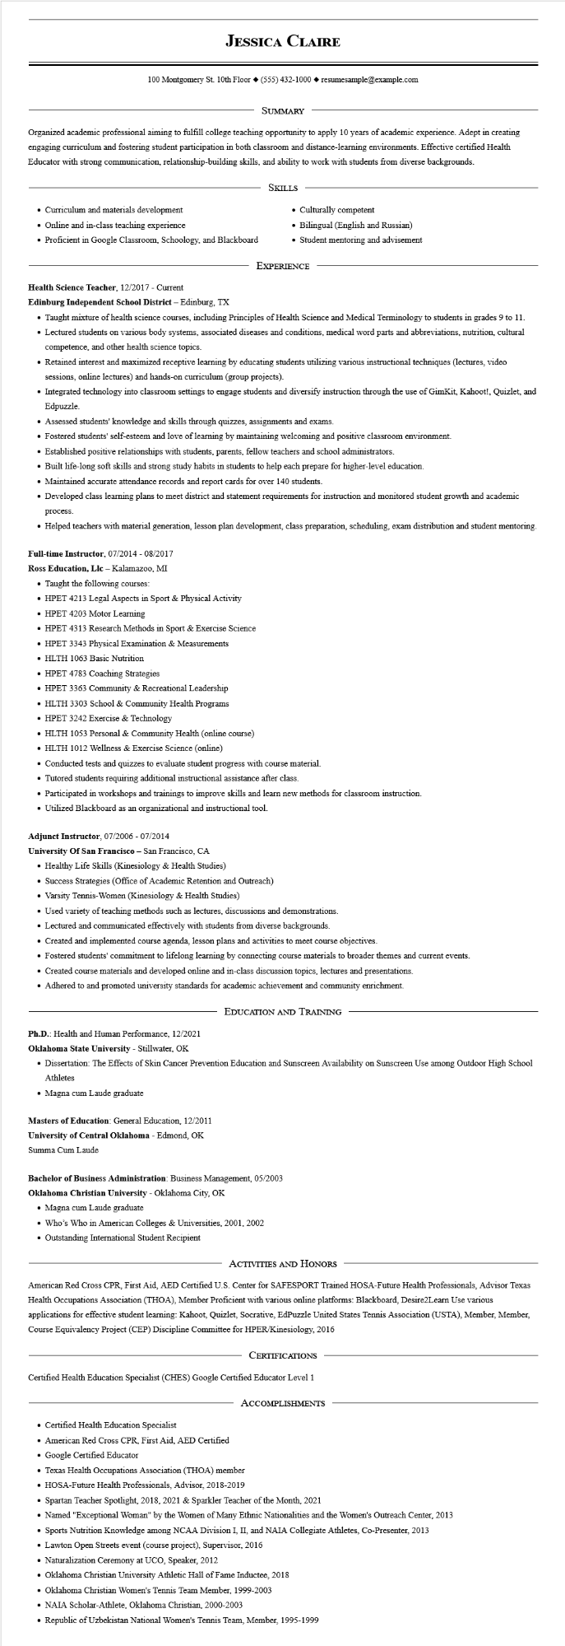

**JESSICA CLAIRE**

100 Montgomery St. 10th Floor◆ (555) 432-1000◆ resumesample@example.com

SUMMARY

Organized academic professional aiming to fulfill college teaching opportunity to apply 10 years of academic experience. Adept in creating engaging curriculum and fostering student participation in both classroom and distance-learning environments. Effective certified Health Educator with strong communication, relationship-building skills, and ability to work with students from diverse backgrounds.

• Curriculum and materials development

• Online and in-class teaching experience

• Proficient in Google Classroom, Schoology, and Blackboard

SKILLS

• Culturally competent

• Bilingual (English and Russian)

• Student mentoring and advisement

EXPERIENCE

**Health Science Teacher, 12/2017 - Current**

**Edinburg Independent School District - Edinburg, TX**

• Taught mixture of health science courses, including Principles of Health Science and Medical Terminology to students in grades 9 to 11. • Lectured students on various body systems, associated diseases and conditions, medical word parts and abbreviations, nutrition, cultural competence, and other health science topics.

• Retained interest and maximized receptive learning by educating students utilizing various instructional techniques (lectures, video sessions, online lectures) and hands-on curriculum (group projects).

• Integrated technology into classroom settings to engage students and diversify instruction through the use of GimKit, Kahoot!, Quizlet, and Edpuzzle.

• Assessed students' knowledge and skills through quizzes, assignments and exams.

• Fostered students' self-esteem and love of learning by maintaining welcoming and positive classroom environment.

• Established positive relationships with students, parents, fellow teachers and school administrators.

• Built life-long soft skills and strong study habits in students to help each prepare for higher-level education.

• Maintained accurate attendance records and report cards for over 140 students.

• Developed class learning plans to meet district and statement requirements for instruction and monitored student growth and academic process.

• Helped teachers with material generation, lesson plan development, class preparation, scheduling, exam distribution and student mentoring.

Full-time Instructor, 07/2014 - 08/2017

**Ross Education, Llc - Kalamazoo, MI**

• Taught the following courses:

• HPET 4213 Legal Aspects in Sport & Physical Activity

• HPET 4203 Motor Learning

• HPET 4313 Research Methods in Sport & Exercise Science

• HPET 3343 Physical Examination & Measurements

• HLTH 1063 Basic Nutrition

⚫ HPET 4783 Coaching Strategies

• HPET 3363 Community & Recreational Leadership

⚫HLTH 3303 School & Community Health Programs

• HPET 3242 Exercise & Technology

• HLTH 1053 Personal & Community Health (online course)

• HLTH 1012 Wellness & Exercise Science (online)

• Conducted tests and quizzes to evaluate student progress with course material.

• Tutored students requiring additional instructional assistance after class.

• Participated in workshops and trainings to improve skills and learn new methods for classroom instruction.

• Utilized Blackboard as an organizational and instructional tool.

Adjunct Instructor, 07/2006 - 07/2014

**University of San Francisco - San Francisco, CA**

• Healthy Life Skills (Kinesiology & Health Studies)

• Success Strategies (Office of Academic Retention and Outreach)

• Varsity Tennis-Women (Kinesiology & Health Studies)

• Used variety of teaching methods such as lectures, discussions and demonstrations.

• Lectured and communicated effectively with students from diverse backgrounds.

• Created and implemented course agenda, lesson plans and activities to meet course objectives.

• Fostered students' commitment to lifelong learning by connecting course materials to broader themes and current events.

• Created course materials and developed online and in-class discussion topics, lectures and presentations.

• Adhered to and promoted university standards for academic achievement and community enrichment.

EDUCATION AND TRAINING

Ph.D.: Health and Human Performance, 12/2021

Oklahoma State University - Stillwater, OK

• Dissertation: The Effects of Skin Cancer Prevention Education and Sunscreen Availability on Sunscreen Use among Outdoor High School Athletes

• Magna cum Laude graduate

**Masters of Education: General Education, 12/2011**

**University of Central Oklahoma - Edmond, OK**

Summa Cum Laude

**Bachelor of Business Administration: Business Management, 05/2003**

**Oklahoma Christian University - Oklahoma City, OK**

• Magna cum Laude graduate

• Who's Who in American Colleges & Universities, 2001, 2002

• Outstanding International Student Recipient

ACTIVITIES AND HONORS

American Red Cross CPR, First Aid, AED Certified U.S. Center for SAFESPORT Trained HOSA-Future Health Professionals, Advisor Texas Health Occupations Association (THOA), Member Proficient with various online platforms: Blackboard, Desire2Learn Use various applications for effective student learning: Kahoot, Quizlet, Socrative, EdPuzzle United States Tennis Association (USTA), Member, Member, Course Equivalency Project (CEP) Discipline Committee for HPER/Kinesiology, 2016

CERTIFICATIONS

Certified Health Education Specialist (CHES) Google Certified Educator Level 1

ACCOMPLISHMENTS

• Certified Health Education Specialist

• American Red Cross CPR, First Aid, AED Certified

• Google Certified Educator

• Texas Health Occupations Association (THOA) member

• HOSA-Future Health Professionals, Advisor, 2018-2019

• Spartan Teacher Spotlight, 2018, 2021 & Sparkler Teacher of the Month, 2021

• Named "Exceptional Woman" by the Women of Many Ethnic Nationalities and the Women's Outreach Center, 2013

• Sports Nutrition Knowledge among NCAA Division I, II, and NAIA Collegiate Athletes, Co-Presenter, 2013

• Lawton Open Streets event (course project), Supervisor, 2016

• Naturalization Ceremony at UCO, Speaker, 2012

• Oklahoma Christian University Athletic Hall of Fame Inductee, 2018

• Oklahoma Christian Women's Tennis Team Member, 1999-2003

• NAIA Scholar-Athlete, Oklahoma Christian, 2000-2003

• Republic of Uzbekistan National Women's Tennis Team, Member, 1995-1999