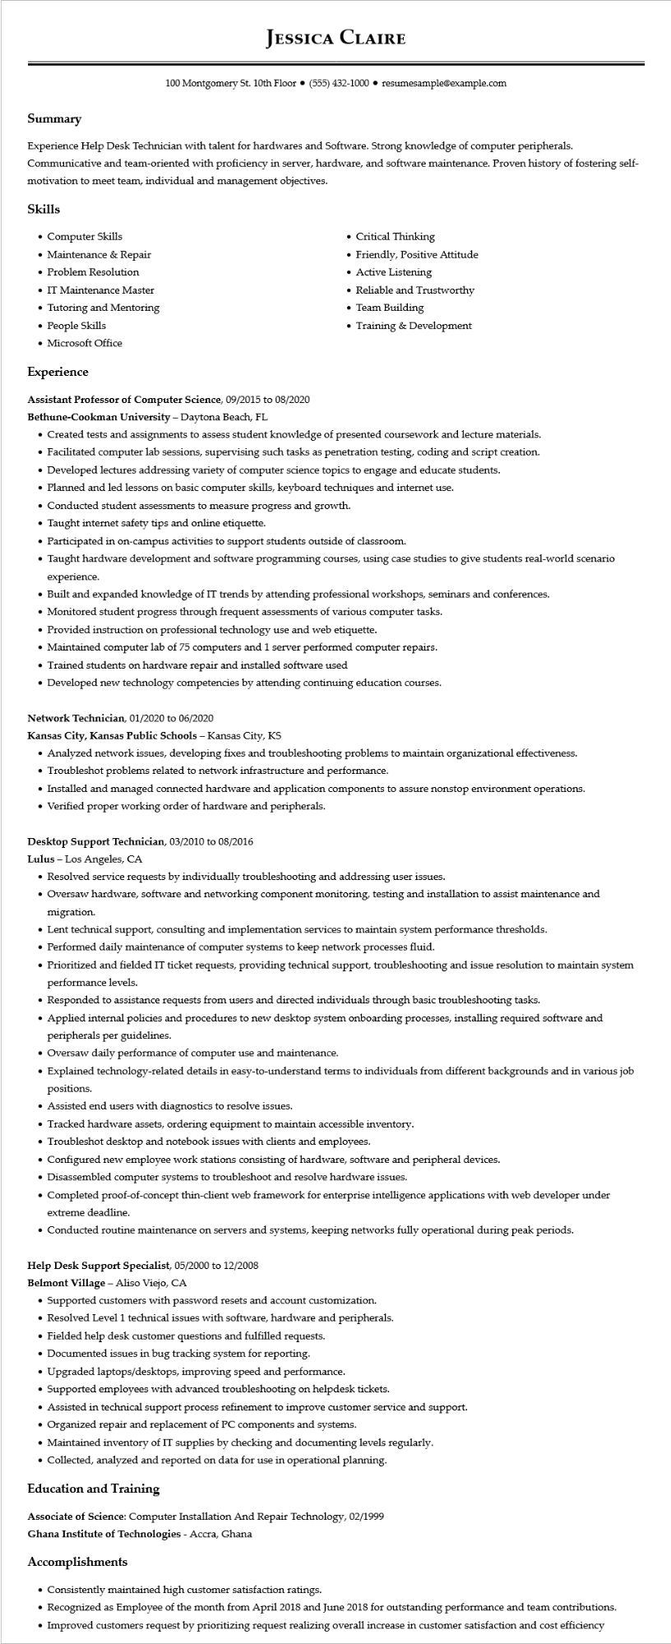

**JESSICA CLAIRE**

100 Montgomery St. 10th Floor ⚫ (555) 432-1000⚫ resumesample@example.com

**Summary**

Experience Help Desk Technician with talent for hardwares and Software. Strong knowledge of computer peripherals. Communicative and team-oriented with proficiency in server, hardware, and software maintenance. Proven history of fostering self- motivation to meet team, individual and management objectives.

**Skills**

• Computer Skills

• Maintenance & Repair

• Problem Resolution

• IT Maintenance Master

• Tutoring and Mentoring • People Skills

• Microsoft Office

**Experience**

**Assistant Professor of Computer Science, 09/2015 to 08/2020**

Bethune-Cookman University - Daytona Beach, FL

• Critical Thinking

• Friendly, Positive Attitude

• Active Listening

• Reliable and Trustworthy

• Team Building

• Training & Development

• Created tests and assignments to assess student knowledge of presented coursework and lecture materials.

• Facilitated computer lab sessions, supervising such tasks as penetration testing, coding and script creation.

• Developed lectures addressing variety of computer science topics to engage and educate students.

• Planned and led lessons on basic computer skills, keyboard techniques and internet use.

• Conducted student assessments to measure progress and growth.

• Taught internet safety tips and online etiquette.

• Participated in on-campus activities to support students outside of classroom.

• Taught hardware development and software programming courses, using case studies to give students real-world scenario experience.

• Built and expanded knowledge of IT trends by attending professional workshops, seminars and conferences.

• Monitored student progress through frequent assessments of various computer tasks.

• Provided instruction on professional technology use and web etiquette.

• Maintained computer lab of 75 computers and 1 server performed computer repairs.

• Trained students on hardware repair and installed software used

• Developed new technology competencies by attending continuing education courses.

Network Technician, 01/2020 to 06/2020

**Kansas City, Kansas Public Schools - Kansas City, KS**

• Analyzed network issues, developing fixes and troubleshooting problems to maintain organizational effectiveness.

• Troubleshot problems related to network infrastructure and performance.

• Installed and managed connected hardware and application components to assure nonstop environment operations.

• Verified proper working order of hardware and peripherals.

**Desktop Support Technician, 03/2010 to 08/2016**

Lulus - Los Angeles, CA

• Resolved service requests by individually troubleshooting and addressing user issues.

• Oversaw hardware, software and networking component monitoring, testing and installation to assist maintenance and migration.

• Lent technical support, consulting and implementation services to maintain system performance thresholds.

• Performed daily maintenance of computer systems to keep network processes fluid.

• Prioritized and fielded IT ticket requests, providing technical support, troubleshooting and issue resolution to maintain system performance levels.

• Responded to assistance requests from users and directed individuals through basic troubleshooting tasks.

• Applied internal policies and procedures to new desktop system onboarding processes, installing required software and peripherals per guidelines.

• Oversaw daily performance of computer use and maintenance.

• Explained technology-related details in easy-to-understand terms to individuals from different backgrounds and in various job positions.

• Assisted end users with diagnostics to resolve issues.

• Tracked hardware assets, ordering equipment to maintain accessible inventory.

• Troubleshot desktop and notebook issues with clients and employees.

Configured new employee work stations consisting of hardware, software and peripheral devices.

• Disassembled computer systems to troubleshoot and resolve hardware issues.

• Completed proof-of-concept thin-client web framework for enterprise intelligence applications with web developer under extreme deadline.

• Conducted routine maintenance on servers and systems, keeping networks fully operational during peak periods.

Help Desk Support Specialist, 05/2000 to 12/2008

**Belmont Village - Aliso Viejo, CA**

• Supported customers with password resets and account customization.

• Resolved Level 1 technical issues with software, hardware and peripherals.

• Fielded help desk customer questions and fulfilled requests.

• Documented issues in bug tracking system for reporting.

·

Upgraded laptops/desktops, improving speed and performance.

• Supported employees with advanced troubleshooting on helpdesk tickets.

• Assisted in technical support process refinement to improve customer service and support.

• Organized repair and replacement of PC components and systems.

• Maintained inventory of IT supplies by checking and documenting levels regularly.

• Collected, analyzed and reported on data for use in operational planning.

**Education and Training**

Associate of Science: Computer Installation And Repair Technology, 02/1999

Ghana Institute of Technologies - Accra, Ghana

**Accomplishments**

• Consistently maintained high customer satisfaction ratings.

• Recognized as Employee of the month from April 2018 and June 2018 for outstanding performance and team contributions.

• Improved customers request by prioritizing request realizing overall increase in customer satisfaction and cost efficiency