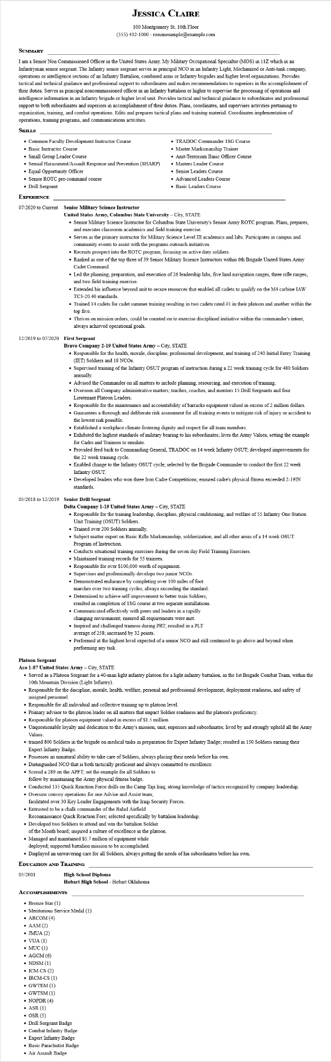

**JESSICA CLAIRE**

100 Montgomery St. 10th Floor

(555) 432-1000 - resumesample@example.com

**SUMMARY**

I am Senior Non Commissioned Officer in the United States Army. My Military Occupational Specialtie (MOS) in 11Z which in an Infantryman senior sergeant. The Infantry senior sergeant serves as principal NCO in an Infantry Light, Mechanized or Anti-tank company, operations or intelligence sections of an Infantry Battalion, combined arms or Infantry brigades and higher level organizations. Provides tactical and technical guidance and professional support to subordinates and makes recommendations to superiors in the accomplishment of their duties. Serves as principal noncommissioned officer in an Infantry battalion or higher to supervise the processing of operations and intelligence information in an Infantry brigade or higher level unit. Provides tactical and technical guidance to subordinates and professional support to both subordinates and superiors in accomplishment of their duties. Plans, coordinates, and supervises activities pertaining to organization, training, and combat operations. Edits and prepares tactical plans and training material. Coordinates implementation of operations, training programs, and communications activities.

**SKILLS**

• Common Faculty Development Instructor Course

• Basic Instructor Course

• Small Group Leader Course

• Sexual Harassment/Assault Response and Prevention (SHARP)

• Equal Opportunity Officer

• Senior ROTC pre-command course

• Drill Sergeant

**EXPERIENCE**

**07/2020 to Current Senior Military Science Instructor**

• TRADOC Commander 1SG Course

• Master Marksmanship Trainer

• Anit-Terrorism Basic Officer Course

• Masters Leader Course

• Senior Leaders Course

• Advanced Leaders Course

• Basic Leaders Course

**United States Army, Columbus State University - City, STATE**

• Senior Military Science Instructor for Columbus State University's Senior Army ROTC program. Plans, prepares, and executes classroom academics and field training exercise.

• Serves as the primary instructor for Military Science Level III academics and labs. Participates in campus and community events to assist with the programs outreach initiatives.

• Recruits prospect into the ROTC program, focusing on active duty soldiers.

• Ranked as one of the top three of 39 Senior Military Science Instructors within 6th Brigade United States Army Cadet Command.

• Led the planning, preparation, and execution of 26 leadership labs, five land navigation ranges, three rifle ranges, and two field training exercise.

• Extended his influence beyond unit to secure resources that enabled all cadets to qualify on the M4 carbine IAW TC3-20.40 standards.

• Trained 14 cadets for cadet summer training resulting in two cadets rated #1 in their platoon and another within the top five.

• Thrives on mission orders; could be counted on to exercise disciplined initiative within the commander's intent, always achieved operational goals.

**12/2019 to 07/2020 First Sergeant**

**Bravo Company 2-19 United States Army - City, STATE**

• Responsible for the health, morale, discipline, professional development, and training of 240 Initial Entry Training (IET) Soldiers and 18 NCOs.

• Supervised training of the Infantry OSUT program of instruction during a 22 week training cycle for 480 Soldiers annually.

• Advised the Commander on all matters to include planning, resourcing, and execution of training.

• Overseen all Company administrative matters; teaches, coaches, and mentors 15 Drill Sergeants and four Lieutenant Platoon Leaders.

• Responsible for the maintenance and accountability of barracks equipment valued in excess of 2 million dollars.

• Guarantees a thorough and deliberate risk assessment for all training events to mitigate risk of injury or accident to the lowest risk possible.

• Established a workplace climate fostering dignity and respect for all team members.

• Exhibited the highest standards of military bearing to his subordinates; lives the Army Values, setting the example for Cadre and Trainees to emulate.

• Provided feed back to Commanding General, TRADOC on 14 week Infantry OSUT; developed improvements for the 22 week training cycle.

• Enabled change to the Infantry OSUT cycle; selected by the Brigade Commander to conduct the first 22 week Infantry OSUT.

• Developed leaders who won three Iron Cadre Competitions; ensured cadre's physical fitness exceeded 2-19IN standards.

**05/2018 to 12/2019 Senior Drill Sergeant**

**Delta Company 1-19 United States Army - City, STATE**

• Responsible for the training leadership, discipline, physical conditioning, and welfare of 55 Infantry One Station Unit Training (OSUT) Soldiers.

• Trained over 200 Soldiers annually.

• Subject matter expert on Basic Rifle Marksmanship, soldierization, and all other areas of a 14 week OSUT Program of Instruction.

• Conducts situational training exercises during the seven day Field Training Exercises.

• Maintained training records for 55 trainees.

• Responsible for over $100,000 worth of equipment.

• Supervises and professionally develops two junior NCOs.

• Demonstrated endurance by completing over 100 miles of foot marches over two training cycles; always exceeding the standard.

• Determined to achieve self-improvement to better train Soldiers; resulted in completion of 1SG course at two separate installations. • Communicated effectively with peers and leaders in a rapidly changing environment; ensured all requirements were met.

• Inspired and challenged trainees during PRT; resulted in a PLT

average of 258; increased by 32 points.

• Performed at the highest level expected of a senior NCO and still continued to go above and beyond when performing any task.

**Platoon Sergeant**

**Aco 1-87 United States Army - City, STATE**

• Served as a Platoon Sergeant for a 40-man light infantry platoon for a light infantry battalion, in the 1st Brigade Combat Team, within the 10th Mountain Division (Light Infantry).

• Responsible for the discipline, morale, health, welfare, personal and professional development, deployment readiness, and safety of assigned personnel.

• Responsible for all individual and collective training up to platoon level.

• Primary advisor to the platoon leader on all matters that impact Soldier readiness and the platoon's proficiency.

• Responsible for platoon equipment valued in excess of $1.5 million.

• Unquestionable loyalty and dedication to the Army's mission, unit, superiors and subordinates; lived by and strongly upheld all the Army Values.

⚫ trained 800 Soldiers in the brigade on medical tasks in preparation for Expert Infantry Badge; resulted in 150 Soldiers earning their Expert Infantry Badge.

• Possesses an unnatural ability to take care of Soldiers, always placing their needs before his own.

• Distinguished NCO that is both tactically proficient and always committed to excellence.

Scored a 289 on the APFT; set the example for all Soldiers to

follow by maintaining the Army physical fitness badge.

• Conducted 135 Quick Reaction Force drills on the Camp Taji Iraq; strong knowledge of tactics recognized by company leadership.

• Oversaw convoy operations for one Advise and Assist team;

facilitated over 30 Key Leader Engagements with the Iraqi Security Forces.

• Entrusted to be a chalk commander of the Balad Airfield

Reconnaissance Quick Reaction Fore; selected specifically by battalion leadership.

• Developed two Soldiers to attend and win the battalion Soldier

of the Month board; inspired a culture of excellence in the platoon.

• Managed and maintained $5.7 million of equipment while

deployed; supported battalion mission to be accomplished.

• Displayed an unwavering care for all Soldiers, always putting the needs of his subordinates before his own.

**EDUCATION AND TRAINING**

05/2001

**High School Diploma**

**Hobart High School - Hobart Oklahoma**

**ACCOMPLISHMENTS**

• Bronze Star (1)

• Meritorious Service Medal (1)

• ARCOM (4)

• AAM (2)

• JMUA (2)

•VUA(1)

• MUC (1)

• AGCM (6)

• NDSM (1)

• ICM-CS (2)

• IRCM-CS (1)

• GWTEM (1)

• GWTSM (1)

• NOPDR (4)

• ASR (1)

• OSR (5)

• Drill Sergeant Badge

• Combat Infantry Badge

• Expert Infantry Badge

• Basic Parachutist Badge

• Air Assault Badge