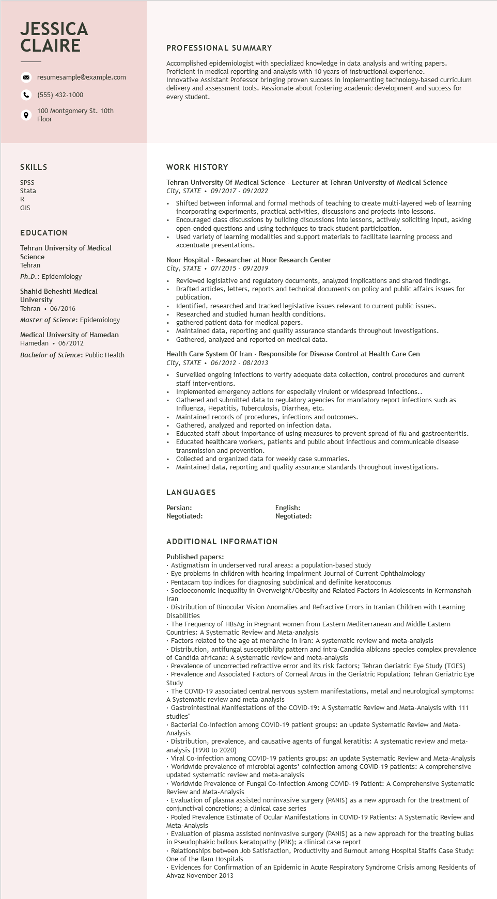

**JESSICA CLAIRE**

resumesample@example.com

(555) 432-1000

100 Montgomery St. 10th Floor

**PROFESSIONAL SUMMARY**

Accomplished epidemiologist with specialized knowledge in data analysis and writing papers. Proficient in medical reporting and analysis with 10 years of instructional experience.

Innovative Assistant Professor bringing proven success in implementing technology-based curriculum delivery and assessment tools. Passionate about fostering academic development and success for every student.

SKILLS

SPSS Statal R

GIS

EDUCATION

**Tehran University of Medical**

Science

Tehran

Ph.D.: Epidemiology

Shahid Beheshti Medical

University

Tehran. 06/2016

Master of Science: Epidemiology

Medical University of Hamedan Hamedan⚫ 06/2012

Bachelor of Science: Public Health

WORK HISTORY

Tehran University Of Medical Science - Lecturer at Tehran University of Medical Science City, STATE 09/2017 - 09/2022

.

Shifted between informal and formal methods of teaching to create multi-layered web of learning incorporating experiments, practical activities, discussions and projects into lessons.

• Encouraged class discussions by building discussions into lessons, actively soliciting input, asking open-ended questions and using techniques to track student participation.

.

Used variety of learning modalities and support materials to facilitate learning process and accentuate presentations.

Noor Hospital Researcher at Noor Research Center

*City, STATE*

07/2015-09/2019

Reviewed legislative and regulatory documents, analyzed implications and shared findings. Drafted articles, letters, reports and technical documents on policy and public affairs issues for publication.

Identified, researched and tracked legislative issues relevant to current public issues. Researched and studied human health conditions.

gathered patient data for medical papers.

Maintained data, reporting and quality assurance standards throughout investigations.

Gathered, analyzed and reported on medical data.

Health Care System Of Iran - Responsible for Disease Control at Health Care Cen City, STATE. 06/2012-08/2013

.

Surveilled ongoing infections to verify adequate data collection, control procedures and current staff interventions.

Implemented emergency actions for especially virulent or widespread infections..

Gathered and submitted data to regulatory agencies for mandatory report infections such as Influenza, Hepatitis, Tuberculosis, Diarrhea, etc.

Maintained records of procedures, infections and outcomes.

Gathered, analyzed and reported on infection data.

Educated staff about importance of using measures to prevent spread of flu and gastroenteritis. Educated healthcare workers, patients and public about infectious and communicable disease transmission and prevention.

Collected and organized data for weekly case summaries.

Maintained data, reporting and quality assurance standards throughout investigations.

LANGUAGES

Persian:

Negotiated:

ADDITIONAL INFORMATION

Published papers:

English: Negotiated:

• Astigmatism in underserved rural areas: a population-based study

• Eye problems in children with hearing impairment Journal of Current Ophthalmology

• Pentacam top indices for diagnosing subclinical and definite keratoconus

• Socioeconomic Inequality in Overweight/Obesity and Related Factors in Adolescents in Kermanshah- Iran

• Distribution of Binocular Vision Anomalies and Refractive Errors in Iranian Children with Learning Disabilities

• The Frequency of HBsAg in Pregnant women from Eastern Mediterranean and Middle Eastern Countries: A Systematic Review and Meta-analysis

• Factors related to the age at menarche in Iran: A systematic review and meta-analysis

Distribution, antifungal susceptibility pattern and intra-Candida albicans species complex prevalence of Candida africana: A systematic review and meta-analysis

• Prevalence of uncorrected refractive error and its risk factors; Tehran Geriatric Eye Study (TGES)

. Prevalence and Associated Factors of Corneal Arcus i the Geriatric Population; Tehran Geriatric Eye Study

• The COVID-19 associated central nervous system manifestations, metal and neurological symptoms: A Systematic review and meta-analysis

• Gastrointestinal Manifestations of the COVID-19: A Systematic Review and Meta-Analysis with 111 studies"

• Bacterial Co-infection among COVID-19 patient groups: an update Systematic Review and Meta- Analysis Analysis

•Distribution, prevalence, and causative agents of fungal keratitis: A systematic review and meta- analysis (1990 to 2020)

• Viral Co-infection among COVID-19 patients groups: an update Systematic Review and Meta-Analysis • Worldwide prevalence of microbial agents' coinfection among COVID-19 patients: A comprehensive updated systematic review and meta-analysis

upuated

• Worldwide Prevalence of Fungal Co-infection Among COVID-19 Patient: A Comprehensive Systematic Review and Meta-Analysis

Evaluation of plasma assisted noninvasive surgery (PANIS) as a new approach for the treatment of conjunctival concretions; a clinical case series

conjunctival concre

• Pooled Prevalence Estimate of Ocular Manifestations in COVID-19 Patients: A Systematic Review and Meta-Analysis

• Evaluation of plasma assisted noninvasive surgery (PANIS) as a new approach for the treating bullas in Pseudophakic bullous keratopathy (PBK); a clinical case report

• Relationships between Job Satisfaction, Productivity and Burnout among Hospital Staffs Case Study: One of the Ilam Hospitals

• Evidences for Confirmation of an Epidemic in Acute Respiratory Syndrome Crisis among Residents of Ahvaz November 2013