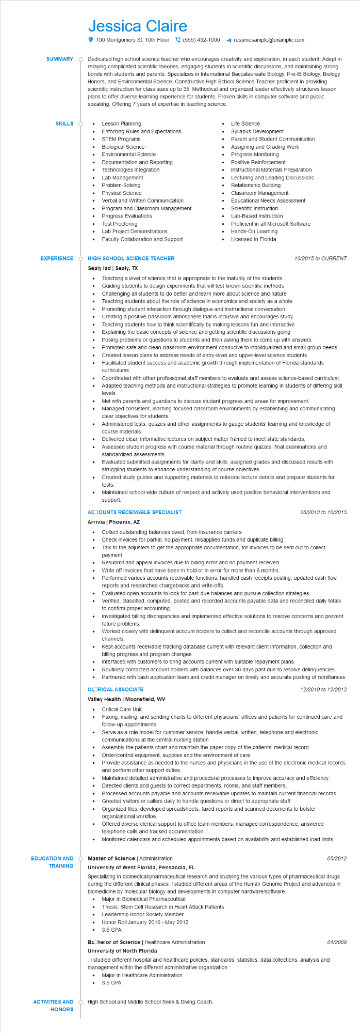

**SUMMARY**

**SKILLS**

Jessica Claire

100 Montgomery St. 10th Floor (555) 432-1000

resumesample@example.com

Dedicated high school science teacher who encourages creativity and exploration, in each student. Adept in relaying complicated scientific theories, engaging students in scientific discussions, and maintaining strong bonds with students and parents. Specializes in International Baccalaureate Biology, Pre-IB Biology, Biology Honors, and Environmental Science. Constructive High School Science Teacher proficient in providing scientific instruction for class sizes up to 35. Methodical and organized leader effectively structures lesson plans to offer diverse learning experience for students. Proven skills in computer software and public speaking. Offering 7 years of expertise in teaching science.

• Lesson Planning

Enforcing Rules and Expectations

•

STEM Programs

Biological Science

•

Environmental Science

•

Life Science

Syllabus Development

Parent and Student Communication Assigning and Grading Work

**EXPERIENCE**

•

Progress Monitoring

Documentation and Reporting

Positive Reinforcement

Technologies Integration

•

Lab Management

Problem-Solving

Instructional Materials Preparation

Lecturing and Leading Discussions

Relationship Building

Classroom Management

•

Physical Science

Verbal and Written Communication

• Progress Evaluations

Educational Needs Assessment

Program and Classroom Management

•

Scientific Instruction

•

Lab-Based Instruction

•

Test Proctoring

Proficient in all Microsoft Software

Lab Project Demonstrations

Hands-On Learning

•

Faculty Collaboration and Support

•

Licensed in Florida

**HIGH SCHOOL SCIENCE TEACHER**

**Sealy Isd | Sealy, TX**

•

•

•

·

•

Teaching a level of science that is appropriate to the maturity of the students Guiding students to design experiments that will test known scientific methods Challenging all students to do better and learn more about science and nature Teaching students about the role of science in economics and society as a whole Promoting student interaction through dialogue and instructional conversation Creating a positive classroom atmosphere that is inclusive and encourages study Teaching students how to think scientifically by making lessons fun and interactive Explaining the basic concepts of science and getting scientific discussions going

*10/2015 to CURRENT*

Posing problems or questions to students and then asking them to come up with answers.

Promoted safe and clean classroom environment conducive to individualized and small group needs.

• Created lesson plans to address needs of entry-level and upper-level science students. Facilitated student success and academic growth through implementation of Florida standards curriculums.

•

•

Coordinated with other professional staff members to evaluate and assess science-based curriculum. Adapted teaching methods and instructional strategies to promote learning in students of differing skill levels.

Met with parents and guardians to discuss student progress and areas for improvement.

Managed consistent, learning-focused classroom environments by establishing and communicating clear objectives for students.

Administered tests, quizzes and other assignments to gauge students' learning and knowledge of course materials.

•

Delivered clear, informative lectures on subject matter framed to meet state standards.

•

•

Assessed student progress with course material through routine quizzes, final examinations and standardized assessments.

Evaluated submitted assignments for clarity and skills, assigned grades and discussed results with struggling students to enhance understanding of course objectives.

Created study guides and supporting materials to reiterate lecture details and prepare students for tests.

Maintained school-wide culture of respect and actively used positive behavioral interventions and support.

**ACCOUNTS RECEIVABLE SPECIALIST**

**Arrivia | Phoenix, AZ**

Collect outstanding balances owed, from insurance carriers

• Check invoices for partial, no payment, misapplied funds and duplicate billing

•

•

*06/2013 to 10/2015*

Talk to the adjusters to get the appropriate documentation, for invoices to be sent out to collect payment

Resubmit and appeal invoices due to billing error and no payment received

Write off invoices that have been in hold or in error for more than 6 months.

Performed various accounts receivable functions, handled cash receipts posting, updated cash flow reports and researched chargebacks and write-offs.

Evaluated open accounts to look for past-due balances and pursue collection strategies.

Verified, classified, computed, posted and recorded accounts payable data and reconciled daily totals to confirm proper accounting.

Investigated billing discrepancies and implemented effective solutions to resolve concerns and prevent future problems.

Worked closely with delinquent account holders to collect and reconcile accounts through approved channels.

Kept accounts receivable tracking database current with relevant client information, collection and billing progress and program changes.

Interfaced with customers to bring accounts current with suitable repayment plans.

• Routinely contacted account holders with balances over 30 days past due to resolve delinquencies.

· Partnered with cash application team and credit manager on timely and accurate posting of remittances.

**CLORICAL ASSOCIATE**

**Valley Health | Moorefield, WV**

• Critical Care Unit

12/2010 to 12/2013

Faxing, mailing, and sending charts to different physicians' offices and patients for continued care and follow-up appointments

Serve as a role model for customer service; handle verbal, written, telephone and electronic

communications at the central nursing station

Assembly the patients chart and maintain the paper copy of the patients' medical record

•

Order/control equipment, supplies and the environment of care

Provide assistance as needed to the nurses and physicians in the use of the electronic medical records and perform other support duties.

Maintained detailed administrative and procedural processes to improve accuracy and efficiency.

•

Directed clients and guests to correct departments, rooms, and staff members.

Processed accounts payable and accounts receivable updates to maintain current financial records. Greeted visitors or callers daily to handle questions or direct to appropriate staff.

•

Organized files, developed spreadsheets, faxed reports and scanned documents to bolster organizational workflow.

•

Offered diverse clerical support to office team members, managed correspondence, answered telephone calls and tracked documentation.

•

Monitored calendars and scheduled appointments based on availability and established load limits.

05/2012

**EDUCATION AND**

Master of Science | Administration

**TRAINING**

University of West Florida, Pensacola, FL

**ACTIVITIES AND**

**HONORS**

Specializing in biomedical/pharmaceutical research and studying the various types of pharmaceutical drugs during the different clinical phases. I studied different areas of the Human Genome Project and advances in biomedicine by molecular biology and developments in computer hardware/software.

•

Major in Biomedical Pharmaceutical

Thesis: Stem Cell Research in Heart Attack Patients

Leadership Honor Society Member

Honor Roll January 2010 - May 2012

• 3.6 GPA

Bachelor of Science | Healthcare Administration

**University of North Florida**

. I studied different hospital and healthcare policies, standards, statistics, data collections, analysis and

management within the different administrative organization.

•

Major in Healthcare Administration

3.5 GPA

High School and Middle School Swim & Diving Coach.

*04/2009*