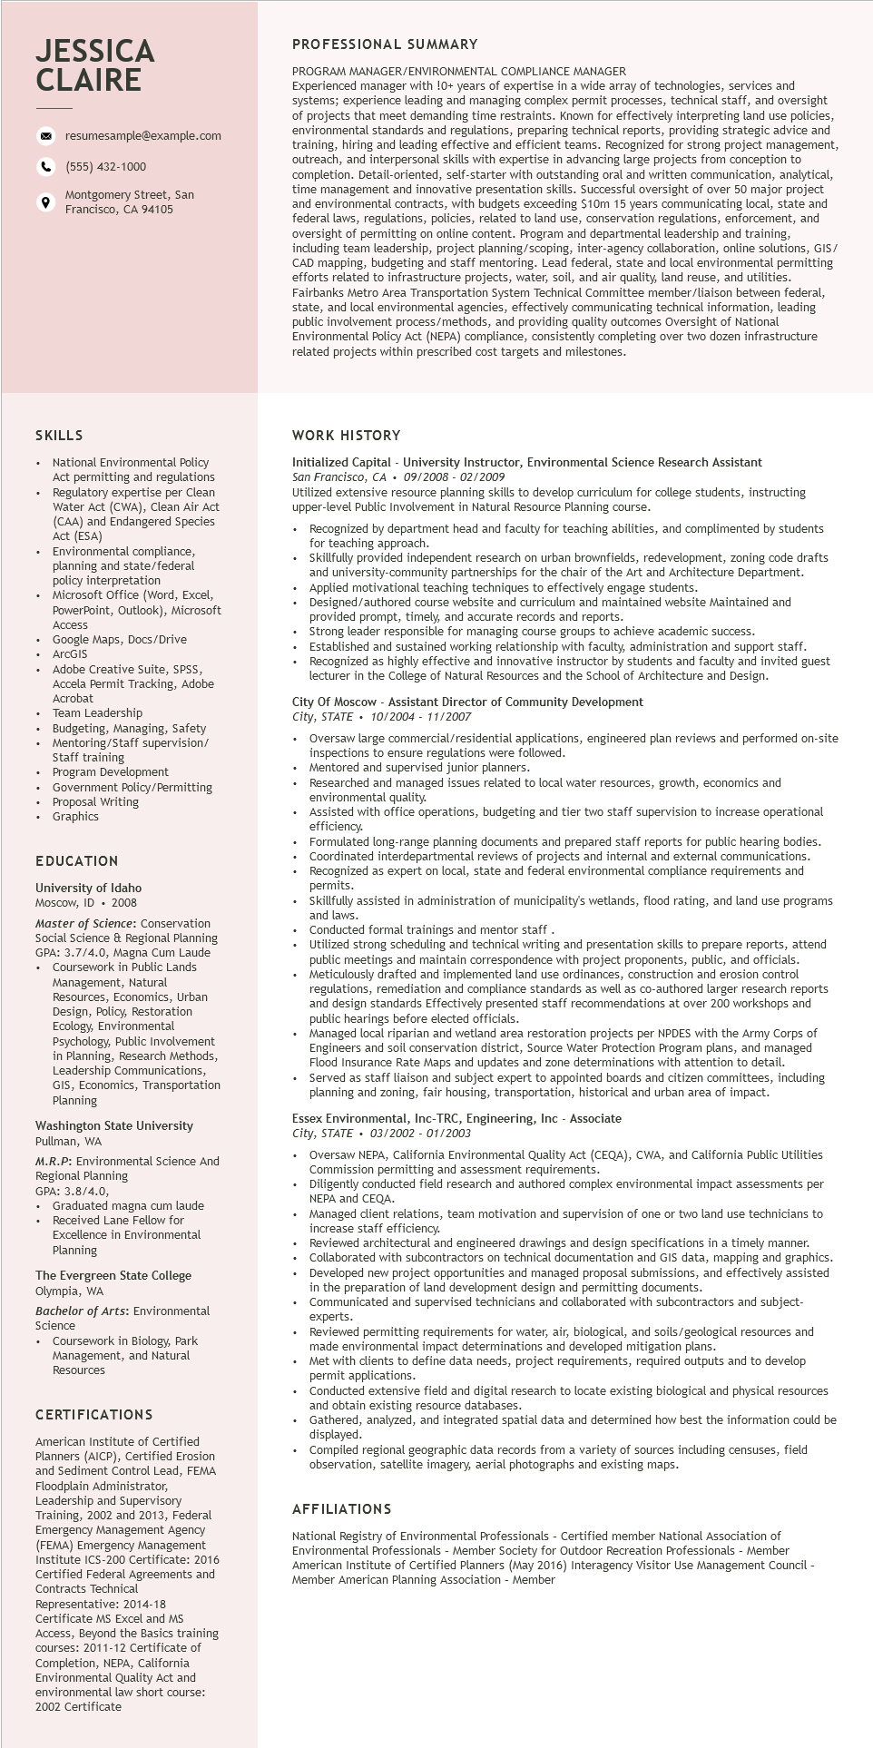

**JESSICA CLAIRE**

9

resumesample@example.com

(555) 432-1000

Montgomery Street, San Francisco, CA 94105

PROFESSIONAL SUMMARY

PROGRAM MANAGER/ENVIRONMENTAL COMPLIANCE MANAGER

Experienced manager with !0+ years of expertise in a wide array of technologies, services and systems; experience leading and managing complex permit processes, technical staff, and oversight of f projects that meet demanding time restraints. Known for effectively interpreting land use policies, environmental standards and regulations, preparing technical reports, providing strategic advice and training, hiring and leading effective and efficient ient teams. Recognized for strong project management, outreach, and interpersonal skills with expertise in advancing large projects from conception to completion. Detail-oriented, self-starter with outstanding oral and written itten communication, analytical, time management and innovative presentation skills. Successful oversight of over 50 major project and environmental contracts, with budgets exceeding $10m 15 years communicating local, state and federal I laws, regulations, policies, related to land use, conservation regulations, enforcement, and oversight of permitting rmitting on online content. Program and departmental leadership and training including team team leadership, project planning/scoping, inter-agency collaboration, online solutions, GIS/ CAD mapping, budgeting and staff mentoring. Lead federal, state and local environmental permitting efforts related to infrastructure projects, water, soil, and air quality, land reuse, and utilities. Fairbanks Metro Area Transportation System Technical Committee member/liaison between federal, state, and local environmental agencies, effectively communicating technical information, leading public involvement process/methods, and providing quality outcomes Oversight of National Environmental Policy Act (NEPA) compliance, consistently completing over two dozen infrastructure related projects within prescribed cost targets and milestones.

includ

SKILLS

• National Environmental Policy Act permitting and regulations

• Regulatory expertise per Clean Water Act (CWA), Clean Air Act (CAA) and Endangered Species ACL (ESA)

Environmental compliance, planning and state/federal policy interpretation

Microsoft Office (Word, Excel,

PowerPoint, Outlook), Microsoft

Access Access

Google Maps, Docs/Drive

ArcGIS ArcGIS

Adobe Creative Suite, SPSS,

Accela Permit Tracking, Adobe Acrobat

Team Leadership

Budgeting, Managing, Safety Mentoring/Staff supervision/ Staff training Program Development

Government Policy/Permitting Proposal Writing

• Graphics

EDUCATION

University of Idaho

Moscow, ID. 2008

Master of Science: Conservation Social Science & Regional Planning GPA: 3.7/4.0, Magna Cum Laude • Coursework in Public Lands Management, Natural Resources, Economics, Urban Design, Policy, Restoration Ecology, Environmental Psychology, Public Involvement

in Planning, Research Methods, Leadership Communications, GIS, Economics, Transportation Planning

Washington State University Pullman, WA

M.R.P: Environmental Science And

Regional Planning

GPA: 3.8/4.0,

Graduated magna cum laude Received Lane Fellow for Excellence in Environmental Planning

The Evergreen State College Olympia, WA

Bachelor of Arts: Environmental Science

• Coursework in Biology, Park Management, and Natural Resources

CERTIFICATIONS

American Institute of Certified Planners (AICP), Certified Erosion and Sediment Control Lead, FEMA Floodplain Administrator, Leadership and Supervisory

Training,

2002 and 2013, Federal

Emergency Management Agency (FEMA) Emergency Management Institute ICS-200 Certificate: 2016 Certified Federal Agreements and

Contracts Technical

Representative: 2014-18

Certificate MS Excel and MS

Access, Beyond the Basics training

courses: 2011-12 Certificate of

Completion, NEPA, California

Environmental Quality Act and

environmental law short course: 2002 Certificate

WORK HISTORY

**Initialized Capital - University Instructor, Environmental Science Research Assistant San Francisco, CA 09/2008- 02/2009**

Utilized extensive resource planning skills to develop curriculum for college students, instructing upper-level Public Involvement in Natural Resource Planning course.

Recognized by department head and faculty for teaching abilities, and complimented by students for teaching approach.

• Skillfully provided independent research on urban brownfields, redevelopment, zoning code drafts and university-community partnerships for the chair of the Art and Architecture Department. Applied motivational teaching techniques to effectively engage students. Designed/authored course website and curriculum and maintained website Maintained and provided prompt, timely, and accurate records and reports.

Strong leader responsible for managing course groups to achieve academic success.

Established and sustained working relationship with faculty, administration and support staff. Recognized as highly effective and innovative instructor by students and faculty and invited guest lecturer in the College of Natural Resources and the School of Architecture and Design.

City of Moscow - Assistant Director of Community Development

*City, STATE*

10/2004 - 11/2007

Oversaw large commercial/residential applications, engineered plan reviews and performed on-site inspections to ensure regulations were followed.

Mentored and supervised junior planners.

Researched and managed issues related to local water resources, growth, economics and environmental quality.

Assisted with office operations, budgeting and tier two staff supervision to increase operational efficiency.

Formulated long-range planning documents and prepared staff reports for public hearing bodies. Coordinated interdepartmental reviews of projects and internal and external communications. Recognized as expert on local, state and federal environmental compliance requirements and Dermits. permits.

Skillfully assisted in administration of municipality's wetlands, flood rating, and land use programs and laws.

Conducted formal trainings and mentor staff.

Utilized strong scheduling and technical writing and presentation skills to prepare reports, attend public meetings and maintain correspondence with project proponents, public, and officials. Meticulously drafted and implemented land use ordinances, construction and erosion control regulations, remediation and compliance standards as well as co-authored larger research reports and design standards Effectively presented staff recommendations at over 200 workshops and public hearings before elected officials.

Managed local riparian and wetland area restoration projects per NPDES with the Army Corps of Engineers and soil conservation district, Source Water Protection Program plans, and managed Flood Insurance Rate Maps and updates and zone determinations with attention to detail.

• Served as staff liaison and subject expert to appointed boards and citizen committees, including planning and zoning, fair housing, transportation, historical and urban area of impact.

**Essex Environmental, Inc-TRC, Engineering, Inc - Associate**

*City, STATE*

03/2002 - 01/2003

Oversaw NEPA, California Environmental Quality Act (CEQA), CWA, and California Public Utilities Commission permitting and assessment requirements.

Diligently conducted field research and authored complex environmental impact assessments per NEPA and CEQA.

client relations, team motivation and supervision of one or two land use technicians to Managed increase staff efficiency.

Reviewed architectural and engineered drawings and design specifications in a timely manner. Collaborated with subcontractors on technical documentation and GIS data, mapping and graphics.

• Developed new project opportunities and managed proposal submissions, and effectively assisted in the preparation of land development design and permitting documents.

Communicated and supervised technicians and collaborated with subcontractors and subject- experts.

Reviewed permitting requirements for water, air, biological, and soils/geological resources and made environmental impact determinations and developed mitigation plans.

Met with clients to define data needs, project requirements, required outputs and to develop permit applications.

Conducted extensive field and digital research to locate existing biological and physical resources and obtain existing resource databases.

Gathered, analyzed, and integrated spatial data and determined how best the information could be displayed.

Compiled regional geographic data records from a variety of sources including censuses, field observation, satellite imagery, aerial photographs and existing maps.

AFFILIATIONS

National Registry of Environmental Professionals - Certified member National Association of Environmental Professionals - Member Society for Outdoor Recreation Professionals - Member American Institute of Certified Planners (May 2016) Interagency Visitor Use Management Council - Member American Planning Association - Member