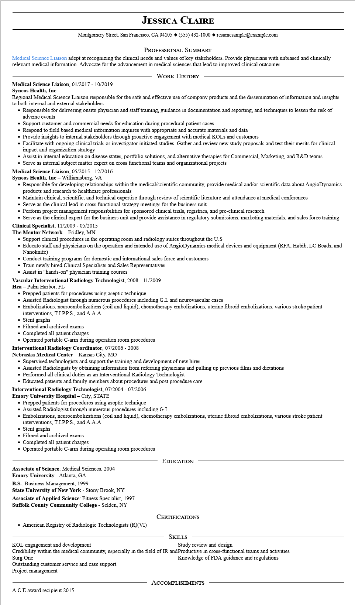

**JESSICA CLAIRE**

Montgomery Street, San Francisco, CA 94105 ♦ (555) 432-1000 resumesample@example.com

PROFESSIONAL SUMMARY

Medical Science Liaison adept at recognizing the clinical needs and values of key stakeholders. Provide physicians with unbiased and clinically relevant medical information. Advocate for the advancement in medical sciences that lead to improved clinical outcomes.

WORK HISTORY

Medical Science Liaison, 01/2017 - 10/2019

**Syneos Health, Inc**

Regional Medical Science Liaison responsible for the safe and effective use of company products and the dissemination of information and insights to both internal and external stakeholders.

• Responsible for delivering onsite physician and staff training, guidance in documentation and reporting, and techniques to lessen the risk of adverse events

• Support customer and commercial needs for education during procedural patient cases

• Respond to field based medical information inquires with appropriate and accurate materials and data

• Provide insights to internal stakeholders through proactive engagement with medical KOLs and customers

• Facilitate with ongoing clinical trials or investigator initiated studies. Gather and review new study proposals and test their merits for clinical impact and organization strategy

• Assist in internal education on disease states, portfolio solutions, and alternative therapies for Commercial, Marketing, and R&D teams

• Serve as internal subject matter expert on cross functional teams and organizational projects

Medical Science Liaison, 05/2015 - 12/2016

**Syneos Health, Inc - Williamsburg, VA**

• Responsible for developing relationships within the medical/scientific community, provide medical and/or scientific data about AngioDynamics products and research to healthcare professionals

• Maintain clinical, scientific, and technical expertise through review of scientific literature and attendance at medical conferences

• Serve as the clinical lead in cross functional strategy meetings for the business unit

• Perform project management responsibilities for sponsored clinical trials, registries, and pre-clinical research

• Serve as the clinical expert for the business unit and provide assistance in regulatory submissions, marketing materials, and sales force training Clinical Specialist, 11/2009 - 05/2015

**The Mentor Network - Fridley, MN**

• Support clinical procedures in the operating room and radiology suites throughout the U.S

• Educate staff and physicians on the operation and intended use of AngioDynamics medical devices and equipment (RFA, Habib, LC Beads, and Nanoknife)

• Conduct training programs for domestic and international sales force and customers

• Train newly hired Clinical Specialists and Sales Representatives

• Assist in "hands-on" physician training courses

**Vascular Interventional Radiology Technologist, 2008 - 11/2009**

Hca - Palm Harbor, FL

• Prepped patients for procedures using aseptic technique

• Assisted Radiologist through numerous procedures including G.I. and neurovascular cases

• Embolizations, neuroembolizations (coil and liquid), chemotherapy embolizations, uterine fibroid embolizations, various stroke patient interventions, T.I.P.P.S., and A.A.A

• Stent graphs

Filmed and archived exams.

• Completed all patient charges

• Operated portable C-arm during operation room procedures

**Interventional Radiology Coordinator, 07/2006 - 2008**

**Nebraska Medical Center - Kansas City, MO**

• Supervised technologists and support the training and development of new hires

• Assisted Radiologists by obtaining information from referring physicians and pulling up previous films and dictations

• Performed all clinical duties as an Interventional Radiology Technologist

• Educated patients and family members about procedures and post procedure care

**Interventional Radiology Technologist, 07/2004 - 07/2006**

**Emory University Hospital - City, STATE**

• Prepped patients for procedures using aseptic technique

• Assisted Radiologist through numerous procedures including G.I

• Embolizations, neuroembolizations (coil and liquid), chemotherapy embolizations, uterine fibroid embolizations, various stroke patient interventions, T.I.P.P.S., and A.A.A

• Stent graphs

Filmed and archived exams

• Completed all patient charges

• Operated portable C-arm during operating room procedures

**Associate of Science: Medical Sciences, 2004**

Emory University - Atlanta, GA

B.S.: Business Management, 1999

**State University of New York - Stony Brook, NY**

Associate of Applied Science: Fitness Specialist, 1997 Suffolk County Community College - Selden, NY

EDUCATION

CERTIFICATIONS

• American Registry of Radiologic Technologists (R)(VI)

SKILLS

KOL engagement and development

Study review and design

Credibility within the medical community, especially in the field of IR and Productive in cross-functional teams and activities

Surg Onc

Knowledge of FDA guidance and regulations

Outstanding customer service and case support

Project management

A.C.E award recipient 2015

ACCOMPLISHMENTS