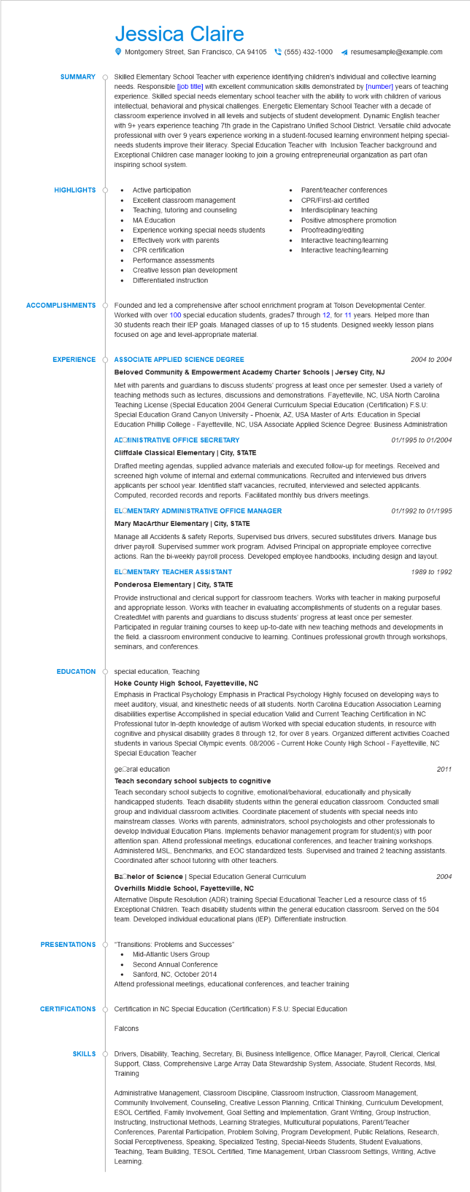

**SUMMARY**

Jessica Claire

Montgomery Street, San Francisco, CA 94105(555) 432-1000

resumesample@example.com

Skilled Elementary School Teacher with experience identifying children's individual and collective learning needs. Responsible [job title] with excellent communication skills demonstrated by [number] years of teaching experience. Skilled special needs elementary school teacher with the ability to work with children of various intellectual, behavioral and physical challenges. Energetic Elementary School Teacher with a decade of classroom experience involved in all levels and subjects of student development. Dynamic English teacher with 9+ years experience teaching 7th grade in the Capistrano Unified School District. Versatile child advocate professional with over 9 years experience working in a student-focused learning environment helping special- needs students improve their literacy. Special Education Teacher with Inclusion Teacher background and Exceptional Children case manager looking to join a growing entrepreneurial organization as part ofan inspiring school system.

**HIGHLIGHTS**

•

Active participation

•

Excellent classroom management

• Parent/teacher conferences

•

CPR/First-aid certified

Teaching, tutoring and counseling

MA Education

Experience working special needs students

Interdisciplinary teaching

Positive atmosphere promotion

Proofreading/editing

•

Effectively work with parents

•

Interactive teaching/learning

CPR certification

Interactive teaching/learning

Performance assessments

Creative lesson plan development

Differentiated instruction

**ACCOMPLISHMENTS**

Founded and led a comprehensive after school enrichment program at Tolson Developmental Center. Worked with over 100 special education students, grades7 through 12, for 11 years. Helped more than 30 students reach their IEP goals. Managed classes of up to 15 students. Designed weekly lesson plans focused on age and level-appropriate material.

**EXPERIENCE**

EDUCATION

**ASSOCIATE APPLIED SCIENCE DEGREE**

**Beloved Community & Empowerment Academy Charter Schools | Jersey City, NJ**

2004 to 2004

Met with parents and guardians to discuss students' progress at least once per semester. Used a variety of teaching methods such as lectures, discussions and demonstrations. Fayetteville, NC, USA North Carolina Teaching License (Special Education 2004 General Curriculum Special Education (Certification) F.S.U: Special Education Grand Canyon University - Phoenix, AZ, USA Master of Arts: Education in Special Education Phillip College - Fayetteville, NC, USA Associate Applied Science Degree: Business Administration

**ACOMINISTRATIVE OFFICE SECRETARY**

Cliffdale Classical Elementary | City, STATE

01/1995 to 01/2004

Drafted meeting agendas, supplied advance materials and executed follow-up for meetings. Received and screened high volume of internal and external communications. Recruited and interviewed bus drivers applicants per school year. Identified staff vacancies, recruited, interviewed and selected applicants. Computed, recorded records and reports. Facilitated monthly bus drivers meetings.

**ELOMENTARY ADMINISTRATIVE OFFICE MANAGER**

**Mary MacArthur Elementary | City, STATE**

01/1992 to 01/1995

Manage all Accidents & safety Reports, Supervised bus drivers, secured substitutes drivers. Manage bus driver payroll. Supervised summer work program. Advised Principal on appropriate employee corrective actions. Ran the bi-weekly payroll process. Developed employee handbooks, including design and layout.

**ELOMENTARY TEACHER ASSISTANT**

**Ponderosa Elementary | City, STATE**

1989 to 1992

Provide instructional and clerical support for classroom teachers. Works with teacher in making purposeful and appropriate lesson. Works with teacher in evaluating accomplishments of students on a regular bases. CreatedMet with parents and guardians to discuss students' progress at least once per semester. Participated in regular training courses to keep up-to-date with new teaching methods and developments in the field. a classroom environment conducive to learning. Continues professional growth through workshops, seminars, and conferences.

special education, Teaching

**Hoke County High School, Fayetteville, NC**

Emphasis in Practical Psychology Emphasis in Practical Psychology Highly focused on developing ways to meet auditory, visual, and kinesthetic needs of all students. North Carolina Education Association Learning disabilities expertise Accomplished in special education Valid and Current Teaching Certification in NC Professional tutor In-depth knowledge of autism Worked with special education students, in resource with cognitive and physical disability grades 8 through 12, for over 8 years. Organized different activities Coached students in various Special Olympic events. 08/2006 - Current Hoke County High School - Fayetteville, NC Special Education Teacher

geCeral education

2011

**Teach secondary school subjects to cognitive**

Teach secondary school subjects to cognitive, emotional/behavioral, educationally and physically handicapped students. Teach disability students within the general education classroom. Conducted small group and individual classroom activities. Coordinate placement of students with special needs into mainstream classes. Works with parents, administrators, school psychologists and other professionals to develop Individual Education Plans. Implements behavior management program for student(s) with poor attention span. Attend professional meetings, educational conferences, and teacher training workshops. Administered MSL, Benchmarks, and EOC standardized tests. Supervised and trained 2 teaching assistants. Coordinated after school tutoring with other teachers.

2004

Bachelor of Science | Special Education General Curriculum

**Overhills Middle School, Fayetteville, NC**

Alternative Dispute Resolution (ADR) training Special Educational Teacher Led a resource class of 15 Exceptional Children. Teach disability students within the general education classroom. Served on the 504 team. Developed individual educational plans (IEP). Differentiate instruction.

**PRESENTATIONS**

"Transitions: Problems and Successes"

•

Mid-Atlantic Users Group

Second Annual Conference

• Sanford, NC, October 2014

Attend professional meetings, educational conferences, and teacher training

CERTIFICATIONS O Certification in NC Special Education (Certification) F.S.U: Special Education

Falcons

**SKILLS**

Drivers, Disability, Teaching, Secretary, Bi, Business Intelligence, Office Manager, Payroll, Clerical, Clerical Support, Class, Comprehensive Large Array Data Stewardship System, Associate, Student Records, Msl, Training

Administrative Management, Classroom Discipline, Classroom Instruction, Classroom Management, Community Involvement, Counseling, Creative Lesson Planning, Critical Thinking, Curriculum Development, ESOL Certified, Family Involvement, Goal Setting and Implementation, Grant Writing, Group Instruction, Instructing, Instructional Methods, Learning Strategies, Multicultural populations, Parent/Teacher Conferences, Parental Participation, Problem Solving, Program Development, Public Relations, Research, Social Perceptiveness, Speaking, Specialized Testing, Special-Needs Students, Student Evaluations, Teaching, Team Building, TESOL Certified, Time Management, Urban Classroom Settings, Writing, Active Learning