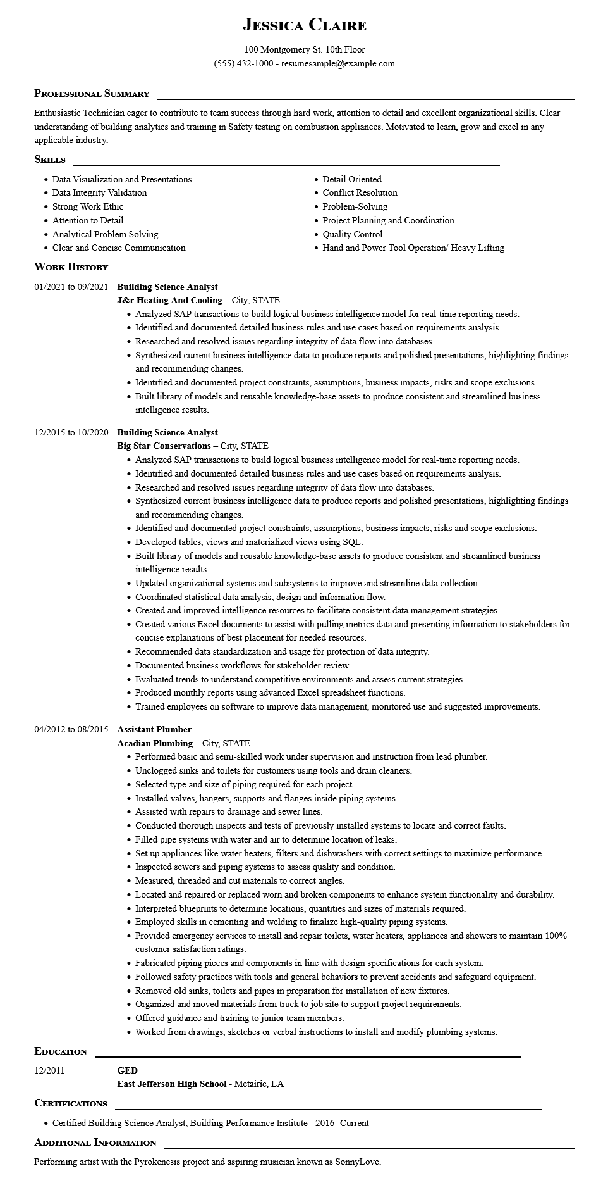

**JESSICA CLAIRE**

100 Montgomery St. 10th Floor (555) 432-1000 - resumesample@example.com

**PROFESSIONAL SUMMARY**

Enthusiastic Technician eager to contribute to team success through hard work, attention to detail and excellent organizational skills. Clear understanding of building analytics and training in Safety testing on combustion appliances. Motivated to learn, grow and excel in any applicable industry.

**SKILLS**

• Data Visualization and Presentations

• Data Integrity Validation

• Strong Work Ethic

• Attention to Detail

• Analytical Problem Solving

• Clear and Concise Communication

**WORK HISTORY**

**01/2021 to 09/2021 Building Science Analyst**

J&r Heating And Cooling - City, STATE

• Detail Oriented

• Conflict Resolution

• Problem-Solving

• Project Planning and Coordination

• Quality Control

• Hand and Power Tool Operation/ Heavy Lifting

• Analyzed SAP transactions to build logical business intelligence model for real-time reporting needs.

• Identified and documented detailed business rules and use cases based on requirements analysis.

• Researched and resolved issues regarding integrity of data flow into databases.

• Synthesized current business intelligence data to produce reports and polished presentations, highlighting findings and recommending changes.

• Identified and documented project constraints, assumptions, business impacts, risks and scope exclusions.

• Built library of models and reusable knowledge-base assets to produce consistent and streamlined business intelligence results.

12/2015 to 10/2020 Building Science Analyst

**Big Star Conservations - City, STATE**

• Analyzed SAP transactions to build logical business intelligence model for real-time reporting needs.

• Identified and documented detailed business rules and use cases based on requirements analysis.

• Researched and resolved issues regarding integrity of data flow into databases.

• Synthesized current business intelligence data to produce reports and polished presentations, highlighting findings and recommending changes.

• Identified and documented project constraints, assumptions, business impacts, risks and scope exclusions.

• Developed tables, views and materialized views using SQL.

• Built library of models and reusable knowledge-base assets to produce consistent and streamlined business intelligence results.

• Updated organizational systems and subsystems to improve and streamline data collection.

• Coordinated statistical data analysis, design and information flow.

• Created and improved intelligence resources to facilitate consistent data management strategies.

• Created various Excel documents to assist with pulling metrics data and presenting information to stakeholders for concise explanations of best placement for needed resources.

• Recommended data standardization and usage for protection of data integrity.

• Documented business workflows for stakeholder review.

• Evaluated trends to understand competitive environments and assess current strategies.

• Produced monthly reports using advanced Excel spreadsheet functions.

• Trained employees on software to improve data management, monitored use and suggested improvements.

**04/2012 to 08/2015 Assistant Plumber**

**EDUCATION**

**Acadian Plumbing - City, STATE**

• Performed basic and semi-skilled work under supervision and instruction from lead plumber.

• Unclogged sinks and toilets for customers using tools and drain cleaners.

• Selected type and size of piping required for each project.

• Installed valves, hangers, supports and flanges inside piping systems.

• Assisted with repairs to drainage and sewer lines.

• Conducted thorough inspects and tests of previously installed systems to locate and correct faults.

• Filled pipe systems with water and air to determine location of leaks.

• Set up appliances like water heaters, filters and dishwashers with correct settings to maximize performance.

• Inspected sewers and piping systems to assess quality and condition.

• Measured, threaded and cut materials to correct angles.

• Located and repaired or replaced worn and broken components to enhance system functionality and durability.

• Interpreted blueprints to determine locations, quantities and sizes of materials required.

• Employed skills in cementing and welding to finalize high-quality piping systems.

• Provided emergency services to install and repair toilets, water heaters, appliances and showers to maintain 100% customer satisfaction ratings.

• Fabricated piping pieces and components in line with design specifications for each system.

• Followed safety practices with tools and general behaviors to prevent accidents and safeguard equipment.

• Removed old sinks, toilets and pipes in preparation for installation of new fixtures.

• Organized and moved materials from truck to job site to support project requirements.

• Offered guidance and training to junior team members.

• Worked from drawings, sketches or verbal instructions to install and modify plumbing systems.

12/2011

**GED**

**CERTIFICATIONS**

**East Jefferson High School - Metairie, LA**

• Certified Building Science Analyst, Building Performance Institute - 2016- Current ADDITIONAL INFORMATION

Performing artist with the Pyrokenesis project and aspiring musician known as SonnyLove.