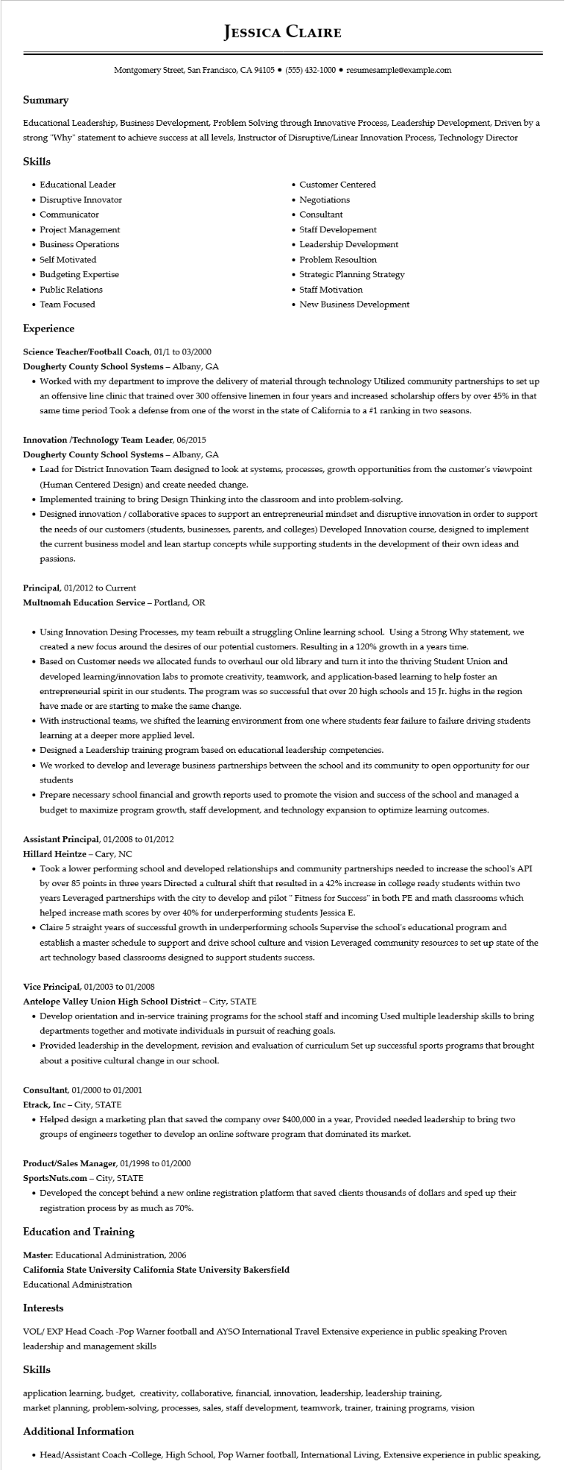

**JESSICA CLAIRE**

Montgomery Street, San Francisco, CA 94105⚫ (555) 432-1000⚫ resumesample@example.com

**Summary**

Educational Leadership, Business Development, Problem Solving through Innovative Process, Leadership Development, Driven by a strong "Why" statement to achieve success at all levels, Instructor of Disruptive/Linear Innovation Process, Technology Director

Skills

• Educational Leader

• Disruptive Innovator

• Communicator

• Project Management

• Business Operations

• Self Motivated

• Budgeting Expertise

• Public Relations

• Team Focused

**Experience**

• Customer Centered

• Negotiations

• Consultant

• Staff Developement

• Leadership Development

• Problem Resoultion

• Strategic Planning Strategy

• Staff Motivation

• New Business Development

Science Teacher/Football Coach, 01/1 to 03/2000

**Dougherty County School Systems - Albany, GA**

• Worked with my department to improve the delivery of material through technology Utilized community partnerships to set up an offensive line clinic that trained over 300 offensive linemen in four years and increased scholarship offers by over 45% in that same time period Took a defense from one of the worst in the state of California to a #1 ranking in two seasons.

**Innovation/Technology Team Leader, 06/2015**

**Dougherty County School Systems - Albany, GA**

• Lead for District Innovation Team designed to look at systems, processes, growth opportunities from the customer's viewpoint (Human Centered Design) and create needed change.

• Implemented training to bring Design Thinking into the classroom and into problem-solving.

• Designed innovation/collaborative spaces to support an entrepreneurial mindset and disruptive innovation in order to support the needs of our customers (students, businesses, parents, and colleges) Developed Innovation course, designed to implement the current business model and lean startup concepts while supporting students in the development of their own ideas and passions.

Principal, 01/2012 to Current

Multnomah Education Service - Portland, OR

• Using Innovation Desing Processes, my team rebuilt a struggling Online learning school. Using a Strong Why statement, we created a new focus around the desires of our potential customers. Resulting in a 120% growth in a years time.

• Based on Customer needs we allocated funds to overhaul our old library and turn it into the thriving Student Union and developed learning/innovation labs to promote creativity, teamwork, and application-based learning to help foster an entrepreneurial spirit in our students. The program was so successful that over 20 high schools and 15 Jr. highs in the region have made or are starting to make the same change.

• With instructional teams, we shifted the learning environment from one where students fear failure to failure driving students learning at a deeper more applied level.

• Designed a Leadership training program based on educational leadership competencies.

• We worked to develop and leverage business partnerships between the school and its community to open opportunity for our students

• Prepare necessary school financial and growth reports used to promote the vision and success of the school and managed a budget to maximize program growth, staff development, and technology expansion to optimize learning outcomes.

Assistant Principal, 01/2008 to 01/2012

Hillard Heintze - Cary, NC

• Took a lower performing school and developed relationships and community partnerships needed to increase the school's API by over 85 points in three years Directed a cultural shift that resulted in a 42% increase in college ready students within two years Leveraged partnerships with the city to develop and pilot " Fitness for Success" in both PE and math classrooms which helped increase math scores by over 40% for underperforming students Jessica E.

• Claire 5 straight years of successful growth in underperforming schools Supervise the school's educational program and establish a master schedule to support and drive school culture and vision Leveraged community resources to set up state of the art technology based classrooms designed to support students success.

Vice Principal, 01/2003 to 01/2008

**Antelope Valley Union High School District - City, STATE**

• Develop orientation and in-service training programs for the school staff and incoming Used multiple leadership skills to bring departments together and motivate individuals in pursuit of reaching goals.

• Provided leadership in the development, revision and evaluation of curriculum Set up successful sports programs that brought about a positive cultural change in our school.

**Consultant, 01/2000 to 01/2001**

Etrack, Inc - City, STATE

• Helped design a marketing plan that saved the company over $400,000 in a year, Provided needed leadership to bring two groups of engineers together to develop an online software program that dominated its market.

**Product/Sales Manager, 01/1998 to 01/2000**

SportsNuts.com - City, STATE

• Developed the concept behind a new online registration platform that saved clients thousands of dollars and sped up their registration process by as much as 70%.

**Education and Training**

Master: Educational Administration, 2006

**California State University California State University Bakersfield**

Educational Administration

**Interests**

VOL/EXP Head Coach -Pop Warner football and AYSO International Travel Extensive experience in public speaking Proven leadership and management skills

**Skills**

application learning, budget, creativity, collaborative, financial, innovation, leadership, leadership training, market planning, problem-solving, processes, sales, staff development, teamwork, trainer, training programs, vision

**Additional Information**

• Head/Assistant Coach -College, High School, Pop Warner football, International Living, Extensive experience in public speaking,