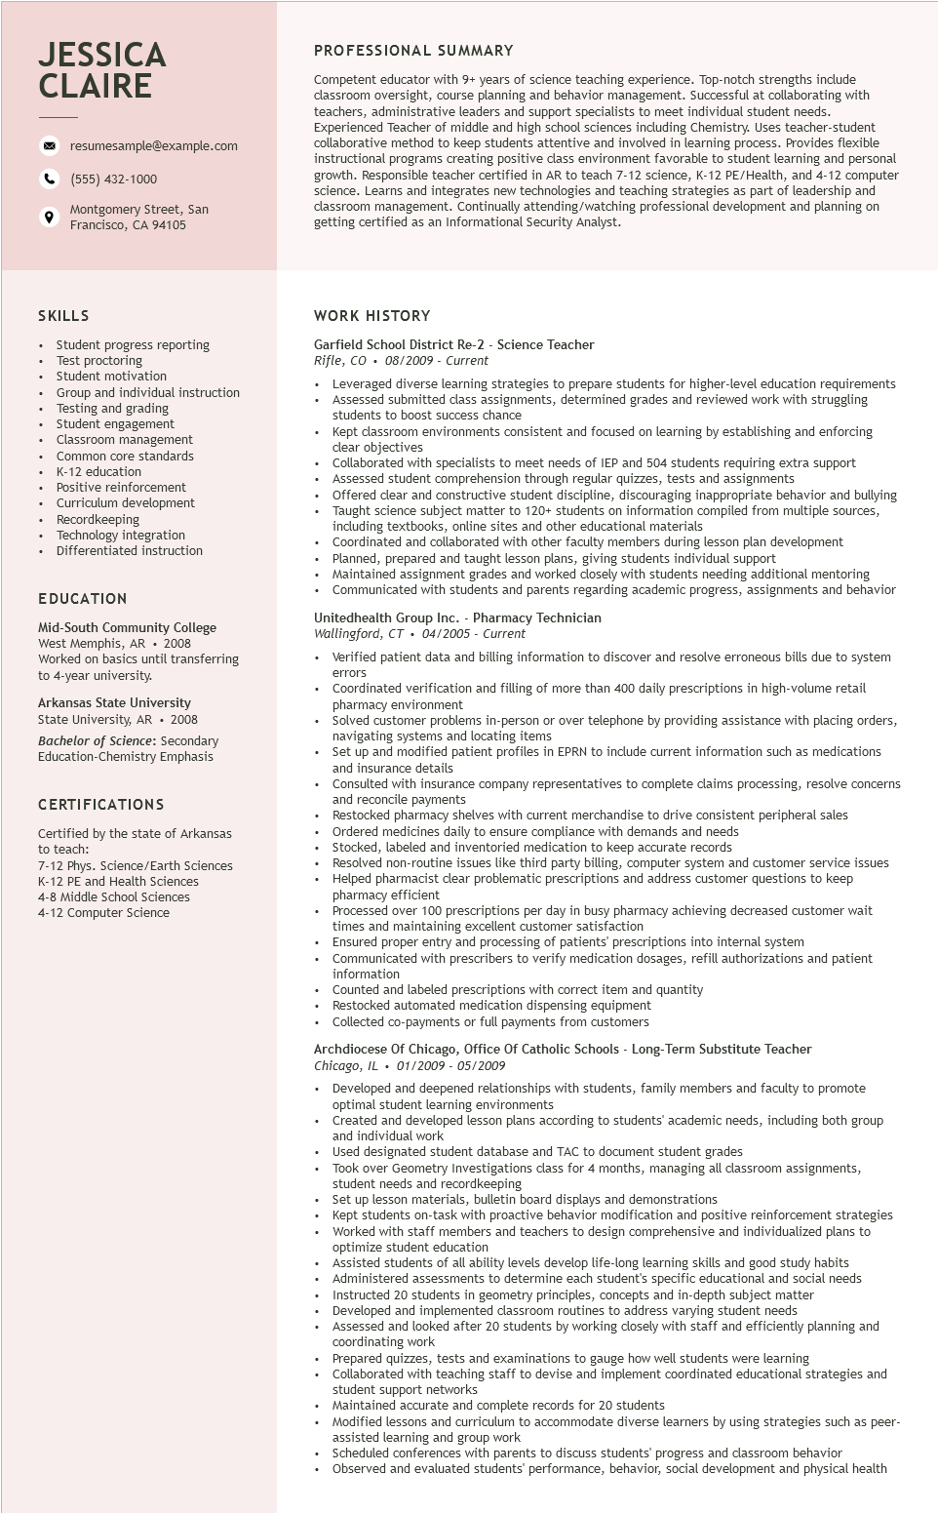

**JESSICA CLAIRE**

9

resumesample@example.com

(555) 432-1000

Montgomery Street, San

Francisco, CA 94105

PROFESSIONAL SUMMARY

Competent educator with 9+ years of science teaching experience. Top-notch strengths include classroom oversight, course planning and behavior management. Successful at collaborating with teachers, administrative leaders and support specialists to meet individual student needs. Experienced Teacher of middle and high school sciences including Chemistry. Uses teacher-student collaborative method to keep students attentive and involved in learning process. Provides flexible instructional I programs creating positive class environment favorable to student learning and personal growth. Responsible teacher certified in AR to teach 7-12 science, K-12 PE/Health, and 4-12 computer science. Learns and integrates new technologies and teaching strategies as part of leadership and classroom management. Continually attending/watching professional development and planning on getting certified as an Informational Security Analyst.

SKILLS

Student progress reporting

Test proctoring

Student motivation

Group and individual instruction

Testing and grading

Student engagement

Classroom management

Common core standards

K-12 education

Positive reinforcement Curriculum development Recordkeeping

• Technology integration Differentiated instruction

EDUCATION

Mid-South Community College

West Memphis, AR. 2008

Worked on basics until transferring

to 4-year university.

**Arkansas State University**

State University, AR. 2008

Bachelor of Science: Secondary Education-Chemistry Emphasis

**CERTIFICATIONS**

Certified by the state of Arkansas to teach:

7-12 Phys. Science/Earth Sciences K-12 PE and Health Sciences 4-8 Middle School Sciences

4-12 Computer Science

WORK HISTORY

Garfield School District Re-2 - Science Teacher

Rifle, CO 08/2009 - Current

• Leveraged diverse learning strategies to prepare students for higher-level education requirements Assessed submitted class assignments, determined grades and reviewed work with struggling students to boost success chance

Kept classroom environments consistent and focused on learning by establishing and enforcing clear objectives

Collaborated with specialists to meet needs of IEP and 504 students requiring extra support Assessed student comprehension through regular quizzes, tests and assignments

Offered clear and constructive student discipline, discouraging inappropriate behavior and bullying Taught science subject matter to 120+ students on information compiled from multiple sources, including textbooks, online sites and other educational materials

Coordinated and collaborated with other faculty members during lesson plan development Planned, prepared and taught lesson plans, giving students individual support

Maintained assignment grades and worked closely with students needing additional mentoring Communicated with students and parents regarding academic progress, assignments and behavior

Unitedhealth Group Inc. - Pharmacy Technician

*Wallingford, CT 04/2005 Current*

•

Verified patient data and billing information to discover and resolve erroneous bills due to system

errors

Coordinated verification and filling of more than 400 daily prescriptions in high-volume retail pharmacy environment

Solved customer problems in-person or over telephone by providing assistance with placing orders, navigating systems and locating items

Set up and modified patient profiles in EPRN to include current information such as medications and insurance details

Consulted with insurance company representatives to complete claims processing, resolve concerns and reconcile payment payments

Restock

Restocked pharmacy shelves with current merchandise to drive consistent peripheral sales Ordered medicines daily to ensure compliance with demands and needs

Stocked, labeled and inventoried medication to keep accurate records

Resolved non-routine issues like third party billing, computer system and customer service issues Helped pharmacist clear problematic prescriptions and address customer questions to keep pharmacy efficient

Processed over 100 prescriptions per day in busy pharmacy achieving decreased customer wait times and maintaining excellent customer satisfaction

Ensured proper entry and processing of patients' prescriptions into internal system

Communicated with prescribers to verify medication dosages, refill authorizations and patient information

Counted and labeled prescriptions with correct item and quantity

Restocked automated medication dispensing equipment

Collected co-payments or full payments from customers

Archdiocese Of Chicago, Office Of Catholic Schools - Long-Term Substitute Teacher Chicago, IL 01/2009 - 05/2009

• Developed and deepened relationships with students, family members and faculty to promote optimal student learning environments

Created and developed lesson plans according to students' academic needs, including both group and individual work

Used designated student database and TAC to document student grades

Took over Geometry Investigations class for 4 months, managing all classroom assignments, student needs and recordkeeping

Set up lesson mate Set up lesson materials, bulletin board displays and demonstrations

Kept students on-task with proactive behavior modification and positive reinforcement strategies Worked with staff members and teachers to design comprehensive and individualized plans to optimize student education

Assisted students of all ability levels develop life-long learning skills and good study habits Administered assessments to determine each student's specific educational and social needs Instructed 20 students in geometry principles, concepts and in-depth subject matter Developed and implemented classroom routines to address varying student needs

Assessed and I looked after 20 students by working closely with staff and efficiently planning and coordinating work

Prepared quizzes, tests and examinations to gauge how well students were learning

Collaborated with teaching staff to devise and implement coordinated educational strategies and student support networks

Maintained accurate and complete records for 20 students

Modified lessons and curriculum to accommodate diverse learners by using strategies such as peer- assisted learning and group work

Scheduled conferences with parents to discuss students' progress and classroom behavior

Observed and evaluated students' performance, behavior, social development and physical health