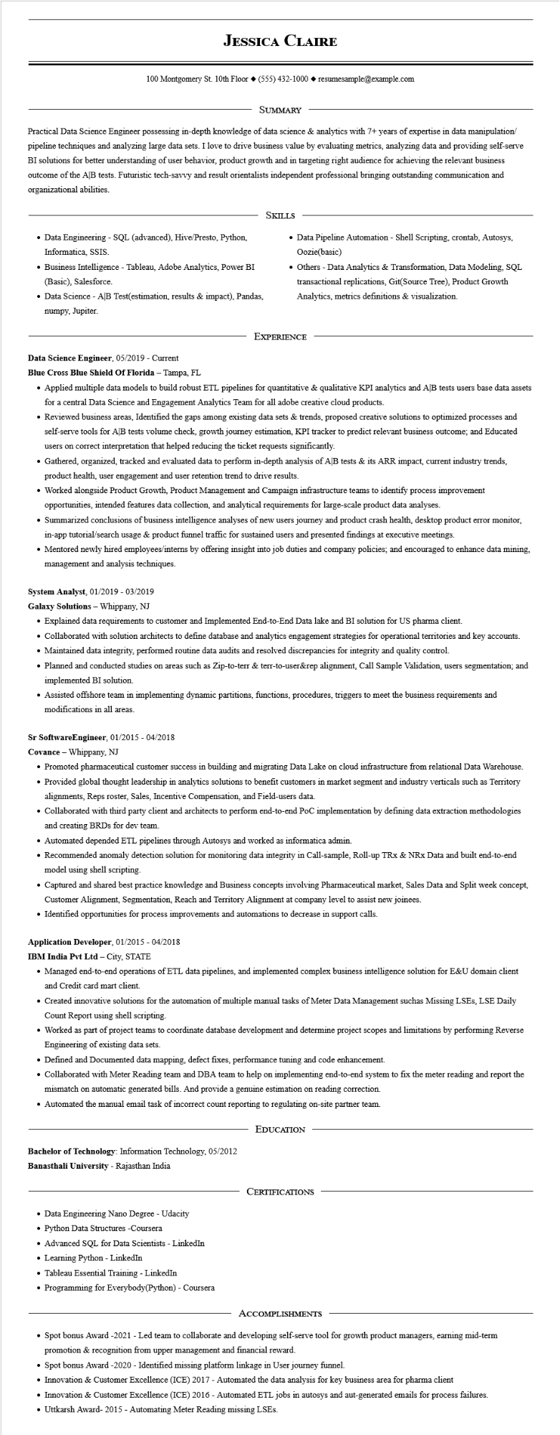

**JESSICA CLAIRE**

100 Montgomery St. 10th Floor (555) 432-1000◆ resumesample@example.com

SUMMARY

Practical Data Science Engineer possessing in-depth knowledge of data science & analytics with 7+ years of expertise in data manipulation/ pipeline techniques and analyzing large data sets. I love to drive business value by evaluating metrics, analyzing data and providing self-serve BI solutions for better understanding of user behavior, product growth and in targeting right audience for achieving the relevant business outcome of the AB tests. Futuristic tech-savvy and result orientalists independent professional bringing outstanding communication and organizational abilities.

• Data Engineering - SQL (advanced), Hive/Presto, Python, Informatica, SSIS.

• Business Intelligence - Tableau, Adobe Analytics, Power BI (Basic), Salesforce.

• Data Science - AB Test(estimation, results & impact), Pandas, numpy, Jupiter.

SKILLS

• Data Pipeline Automation - Shell Scripting, crontab, Autosys, Oozie(basic)

• Others - Data Analytics & Transformation, Data Modeling, SQL transactional replications, Git(Source Tree), Product Growth Analytics, metrics definitions & visualization.

Data Science Engineer, 05/2019 - Current

EXPERIENCE

**Blue Cross Blue Shield Of Florida - Tampa, FL**

• Applied multiple data models to build robust ETL pipelines for quantitative & qualitative KPI analytics and AB tests users base data assets for a central Data Science and Engagement Analytics Team for all adobe creative cloud products.

• Reviewed business areas, Identified the gaps among existing data sets & trends, proposed creative solutions to optimized processes and self-serve tools for AB tests volume check, growth journey estimation, KPI tracker to predict relevant business outcome; and Educated users on correct interpretation that helped reducing the ticket requests significantly.

• Gathered, organized, tracked and evaluated data to perform in-depth analysis of AB tests & its ARR impact, current industry trends, product health, user engagement and user retention trend to drive results.

• Worked alongside Product Growth, Product Management and Campaign infrastructure teams to identify process improvement opportunities, intended features data collection, and analytical requirements for large-scale product data analyses.

• Summarized conclusions of business intelligence analyses of new users journey and product crash health, desktop product error monitor,

in-app tutorial/search usage & product funnel traffic for sustained users and presented findings at executive meetings.

• Mentored newly hired employees/interns by offering insight into job duties and company policies; and encouraged to enhance data mining, management and analysis techniques.

**System Analyst, 01/2019-03/2019**

**Galaxy Solutions - Whippany, NJ**

• Explained data requirements to customer and Implemented End-to-End Data lake and BI solution for US pharma client.

• Collaborated with solution architects to define database and analytics engagement strategies for operational territories and key accounts.

• Maintained data integrity, performed routine data audits and resolved discrepancies for integrity and quality control.

• Planned and conducted studies on areas such as Zip-to-terr & terr-to-user&rep alignment, Call Sample Validation, users segmentation; and implemented BI solution.

• Assisted offshore team in implementing dynamic partitions, functions, procedures, triggers to meet the business requirements and modifications in all areas.

Sr Software Engineer, 01/2015 - 04/2018

Covance Whippany, NJ

• Promoted pharmaceutical customer success in building and migrating Data Lake on cloud infrastructure from relational Data Warehouse. • Provided global thought leadership in analytics solutions to benefit customers in market segment and industry verticals such as Territory alignments, Reps roster, Sales, Incentive Compensation, and Field-users data.

• Collaborated with third party client and architects to perform end-to-end PoC implementation by defining data extraction methodologies and creating BRDs for dev team.

• Automated depended ETL pipelines through Autosys and worked as informatica admin.

• Recommended anomaly detection solution for monitoring data integrity in Call-sample, Roll-up TRX & NRx Data and built end-to-end model using shell scripting.

• Captured and shared best practice knowledge and Business concepts involving Pharmaceutical market, Sales Data and Split week concept, Customer Alignment, Segmentation, Reach and Territory Alignment at company level to assist new joinees.

• Identified opportunities for process improvements and automations to decrease in support calls.

**Application Developer, 01/2015 - 04/2018**

IBM India Pvt Ltd - City, STATE

• Managed end-to-end operations of ETL data pipelines, and implemented complex business intelligence solution for E&U domain client and Credit card mart client.

• Created innovative solutions for the automation of multiple manual tasks of Meter Data Management suchas Missing LSES, LSE Daily Count Report using shell scripting.

• Worked as part of project teams to coordinate database development and determine project scopes and limitations by performing Reverse Engineering of existing data sets.

• Defined and Documented data mapping, defect fixes, performance tuning and code enhancement.

• Collaborated with Meter Reading team and DBA team to help on implementing end-to-end system to fix the meter reading and report the mismatch on automatic generated bills. And provide a genuine estimation on reading correction.

• Automated the manual email task of incorrect count reporting to regulating on-site partner team.

EDUCATION

Bachelor of Technology: Information Technology, 05/2012

**Banasthali University - Rajasthan India**

• Data Engineering Nano Degree - Udacity

• Python Data Structures -Coursera

• Advanced SQL for Data Scientists - LinkedIn

• Learning Python - LinkedIn

• Tableau Essential Training - LinkedIn

• Programming for Everybody(Python) - Coursera

CERTIFICATIONS

ACCOMPLISHMENTS

• Spot bonus Award -2021 - Led team to collaborate and developing self-serve tool for growth product managers, earning mid-term promotion & recognition from upper management and financial reward.

• Spot bonus Award -2020 - Identified missing platform linkage in User journey funnel.

• Innovation & Customer Excellence (ICE) 2017 - Automated the data analysis for key business area for pharma client

• Innovation & Customer Excellence (ICE) 2016 - Automated ETL jobs in autosys and aut-generated emails for process failures.

• Uttkarsh Award- 2015 - Automating Meter Reading missing LSES.