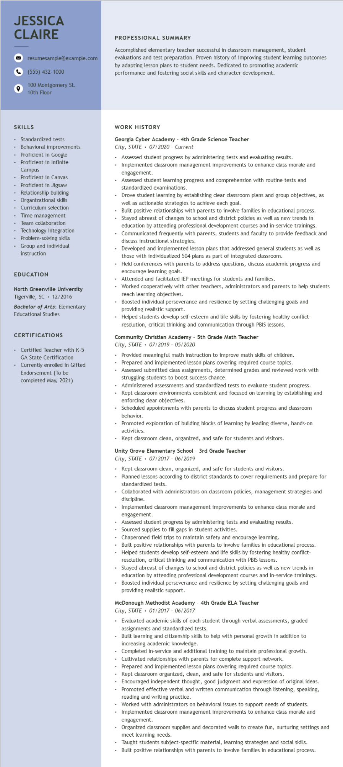

**JESSICA CLAIRE**

resumesample@example.com

(555) 432-1000

100 Montgomery St. 10th Floor

**PROFESSIONAL SUMMARY**

Accomplished elementary teacher successful in classroom management, student evaluations and test preparation. Proven history of improving student learning outcomes by adapting lesson plans to student needs. Dedicated to promoting academic performance and fostering social skills and character development.

**SKILLS**

• Standardized tests

• Behavioral improvements

• Proficient in Google

• Proficient in Infinite Campus

Proficient in Canvas • Proficient in Jigsaw • Relationship building

• Organizational skills Curriculum selection Time management Team collaboration

• Technology integration

• Problem-solving skills

• Group and individual instruction

EDUCATION

North Greenville University Tigerville, SC 12/2016

Bachelor of Arts: Elementary Educational Studies

**CERTIFICATIONS**

• Certified Teacher with K-5 GA State Certification

• Currently enrolled in Gifted Endorsement (To be completed May, 2021)

**WORK HISTORY**

**Georgia Cyber Academy - 4th Grade Science Teacher**

*City, STATE 07/2020 Current*

• Assessed student progress by administering tests and evaluating results.

• Implemented classroom management improvements to enhance class morale and engagement.

Assessed student learning progress and comprehension with routine tests and standardized examinations.

Drove student learning by establishing clear classroom plans and group objectives, as well as actionable strategies to achieve each goal.

• Built positive relationships with parents to involve families in educational process. Stayed abreast of changes to school and district policies as well as new trends in education by attending professional development courses and in-service trainings. Communicated frequently with parents, students and faculty to provide feedback and discuss instructional strategies.

Developed and implemented lesson plans that addressed general students as well as those with individualized 504 plans as part of integrated classroom.

Held conferences with parents to address questions, discuss academic progress and encourage learning goals.

Attended and facilitated IEP meetings for students and families.

Worked cooperatively with other teachers, administrators and parents to help students reach learning objectives.

• Boosted individual perseverance and resilience by setting challenging goals and providing realistic support.

Helped students develop self-esteem and life skills by fostering healthy conflict- resolution, critical thinking and communication through PBIS lessons.

**Community Christian Academy - 5th Grade Math Teacher City, STATE 07/2019- 05/2020**

Provided meaningful math instruction to improve math skills of children. Prepared and implemented lesson plans covering required course topics.

• Assessed submitted class assignments, determined grades and reviewed work with struggling students to boost success chance.

Administered assessments and standardized tests to evaluate student progress. Kept classroom environments consistent and focused on learning by establishing and enforcing clear objectives.

• Scheduled appointments with parents to discuss student progress and classroom behavior.

Promoted exploration of building blocks of learning by leading diverse, hands-on activities.

• Kept classroom clean, organized, and safe for students and visitors.

**Unity Grove Elementary School - 3rd Grade Teacher**

*City, STATE*

*07/2017 - 06/2019*

⚫ Kept classroom clean, organized, and safe for students and visitors.

• Planned lessons according to district standards to cover requirements and prepare for standardized tests.

+

Collaborated with administrators on classroom policies, management strategies and discipline.

• Implemented classroom management improvements to enhance class morale and engagement.

Assessed student progress by administering tests and evaluating results.

• Sourced supplies to fill gaps in student activities.

Chaperoned field trips to maintain safety and encourage learning.

Built positive relationships with parents to involve families in educational process. • Helped students develop self-esteem and life skills by fostering healthy conflict- resolution, critical thinking and communication with PBIS lessons.

• Stayed abreast of changes to school and district policies as well as new trends in education by attending professional development courses and in-service trainings.

⚫ Boosted individual perseverance and resilience by setting challenging goals and providing realistic support.

**McDonough Methodist Academy - 4th Grade ELA Teacher**

*City, STATE 01/2017 - 06/2017*

• Evaluated academic skills of each student through verbal assessments, graded assignments and standardized tests.

Built learning and citizenship skills to help with personal growth in addition to

increasing academic knowledge.

Completed in-service and additional training to maintain professional growth. Cultivated relationships with parents for complete support network. Prepared and implemented lesson plans covering required course topics.

• Kept classroom organized, clean, and safe for students and visitors.

• Encouraged independent thought, good judgment and expression of original ideas. Promoted effective verbal and written communication through listening, speaking, reading and writing practice.

• Worked with administrators on behavioral issues to support needs of students.

• Implemented classroom management improvements to enhance class morale and engagement.

•

Organized classroom supplies and decorated walls to create fun, nurturing settings and meet learning needs.

• Taught students subject-specific material, learning strategies and social skills. Built positive relationships with parents to involve families in educational process.