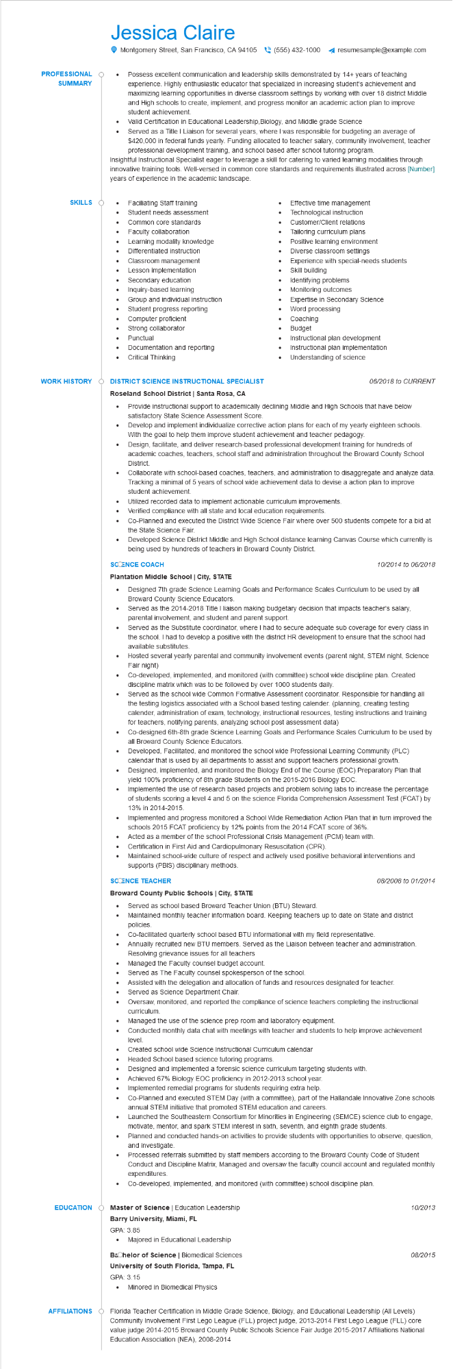

**PROFESSIONAL**

**SUMMARY**

**SKILLS**

Jessica Claire

•

Montgomery Street, San Francisco, CA 94105(555) 432-1000 ◄ resumesample@example.com

Possess excellent communication and leadership skills demonstrated by 14+ years of teaching experience. Highly enthusiastic educator that specialized in increasing student's achievement and maximizing learning opportunities in diverse classroom settings by working with over 18 district Middle and High schools to create, implement, and progress monitor an academic action plan to improve student achievement.

Valid Certification in Educational Leadership, Biology, and Middle grade Science

Served as a Title I Liaison for several years, where I was responsible for budgeting an average of $420,000 in federal funds yearly. Funding allocated to teacher salary, community involvement, teacher professional development training, and school based after school tutoring program.

Insightful Instructional Specialist eager to leverage a skill for catering to varied learning modalities through innovative training tools. Well-versed in common core standards and requirements illustrated across [Number] years of experience in the academic landscape.

Faciliating Staff training

Student needs assessment

Common core standards

Effective time management

Technological instruction

•

Faculty collaboration

•

•

Learning modality knowledge

Differentiated instruction

•

Classroom management

•

Lesson implementation

Secondary education

•

Inquiry-based learning

Group and individual instruction

Student progress reporting

Computer proficient

Strong collaborator

Punctual

•

Documentation and reporting

Critical Thinking

**WORK HISTORY**

**DISTRICT SCIENCE INSTRUCTIONAL SPECIALIST Roseland School District | Santa Rosa, CA**

•

•

Customer/Client relations

Tailoring curriculum plans Positive learning environment

Diverse classroom settings

Experience with special-needs students

Skill building

Identifying problems

Monitoring outcomes

Expertise in Secondary Science

Word processing

Coaching

•

Budget

•

Instructional plan development

Instructional plan implementation

Understanding of science

*06/2018 to CURRENT*

Provide instructional support to academically declining Middle and High Schools that have below satisfactory State Science Assessment Score.

Develop and implement individualize corrective action plans for each of my yearly eighteen schools. With the goal to help them improve student achievement and teacher pedagogy.

Design, facilitate, and deliver research-based professional development training for hundreds of academic coaches, teachers, school staff and administration throughout the Broward County School District.

Collaborate with school-based coaches, teachers, and administration to disaggregate and analyze data. Tracking a minimal of 5 years of school wide achievement data to devise a action plan to improve student achievement.

Utilized recorded data to implement actionable curriculum improvements.

Verified compliance with all state and local education requirements.

Co-Planned and executed the District Wide Science Fair where over 500 students compete for a bid at the State Science Fair.

Developed Science District Middle and High School distance learning Canvas Course which currently is being used by hundreds of teachers in Broward County District.

**SCCENCE COACH**

**Plantation Middle School | City, STATE**

*10/2014 to 06/2018*

• Designed 7th grade Science Learning Goals and Performance Scales Curriculum to be used by all Broward County Science Educators.

•

•

Served as the 2014-2018 Title I liaison making budgetary decision that impacts teacher's salary, parental involvement, and student and parent support.

Served as the Substitute coordinator, where I had to secure adequate sub coverage for every class in the school. I had to develop a positive with the district HR development to ensure that the school had available substitutes.

Hosted several yearly parental and community involvement events (parent night, STEM night, Science Fair night)

Co-developed, implemented, and monitored (with committee) school wide discipline plan. Created discipline matrix which was to be followed by over 1000 students daily.

Served as the school wide Common Formative Assessment coordinator. Responsible for handling all the testing logistics associated with a School based testing calender. (planning, creating testing calender, administration of exam, technology, instructional resources, testing instructions and training for teachers, notifying parents, analyzing school post assessment data)

Co-designed 6th-8th grade Science Learning Goals and Performance Scales Curriculum to be used by all Broward County Science Educators.

Developed, Facilitated, and monitored the school wide Professional Learning Community (PLC) calendar that is used by all departments to assist and support teachers professional growth. Designed, implemented, and monitored the Biology End of the Course (EOC) Preparatory Plan that yield 100% proficiency of 8th grade Students on the 2015-2016 Biology EOC.

Implemented the use of research based projects and problem solving labs to increase the percentage of students scoring a level 4 and 5 on the science Florida Comprehension Assessment Test (FCAT) by 13% in 2014-2015.

Implemented and progress monitored a School Wide Remediation Action Plan that in turn improved the schools 2015 FCAT proficiency by 12% points from the 2014 FCAT score of 36%.

Acted as a member of the school Professional Crisis Management (PCM) team with.

• Certification in First Aid and Cardiopulmonary Resuscitation (CPR).

· Maintained school-wide culture of respect and actively used positive behavioral interventions and supports (PBIS) disciplinary methods.

**SCŒENCE TEACHER**

**Broward County Public Schools | City, STATE**

• Served as school based Broward Teacher Union (BTU) Steward.

*08/2008 to 01/2014*

Maintained monthly teacher information board. Keeping teachers up to date on State and district policies.

Co-facilitated quarterly school based BTU informational with my field representative.

Annually recruited new BTU members. Served as the Liaison between teacher and administration. Resolving grievance issues for all teachers

Managed the Faculty counsel budget account.

• Served as The Faculty counsel spokesperson of the school.

• Served as Science Department Chair.

Assisted with the delegation and allocation of funds and resources designated for teacher.

Oversaw, monitored, and reported the compliance of science teachers completing the instructional curriculum.

Managed the use of the science prep room and laboratory equipment.

•

Conducted monthly data chat with meetings with teacher and students to help improve achievement level.

......

Created school wide Science Instructional Curriculum calendar

Headed School based science tutoring programs.

Designed and implemented a forensic science curriculum targeting students with.

Achieved 67% Biology EOC proficiency in 2012-2013 school year.

Implemented remedial programs for students requiring extra help.

Co-Planned and executed STEM Day (with a committee), part of the Hallandale Innovative Zone schools annual STEM initiative that promoted STEM education and careers.

•

•

Launched the Southeastern Consortium for Minorities in Engineering (SEMCE) science club to engage, motivate, mentor, and spark STEM interest in sixth, seventh, and eighth grade students. Planned and conducted hands-on activities to provide students with opportunities to observe, question, and investigate.

•

Processed referrals submitted by staff members according to the Broward County Code of Student Conduct and Discipline Matrix, Managed and oversaw the faculty council account and regulated monthly expenditures.

Co-developed, implemented, and monitored (with committee) school discipline plan.

EDUCATION Master of Science | Education Leadership

Barry University, Miami, FL

GPA: 3.85

• Majored in Educational Leadership

**Bachelor of Science | Biomedical Sciences University of South Florida, Tampa, FL**

GPA: 3.15

• Minored in Biomedical Physics

10/2013

*08/2015*

AFFILIATIONS Florida Teacher Certification in Middle Grade Science, Biology, and Educational Leadership (All Levels)

Community Involvement First Lego League (FLL) project judge, 2013-2014 First Lego League (FLL) core value judge 2014-2015 Broward County Public Schools Science Fair Judge 2015-2017 Affiliations National Education Association (NEA), 2008-2014