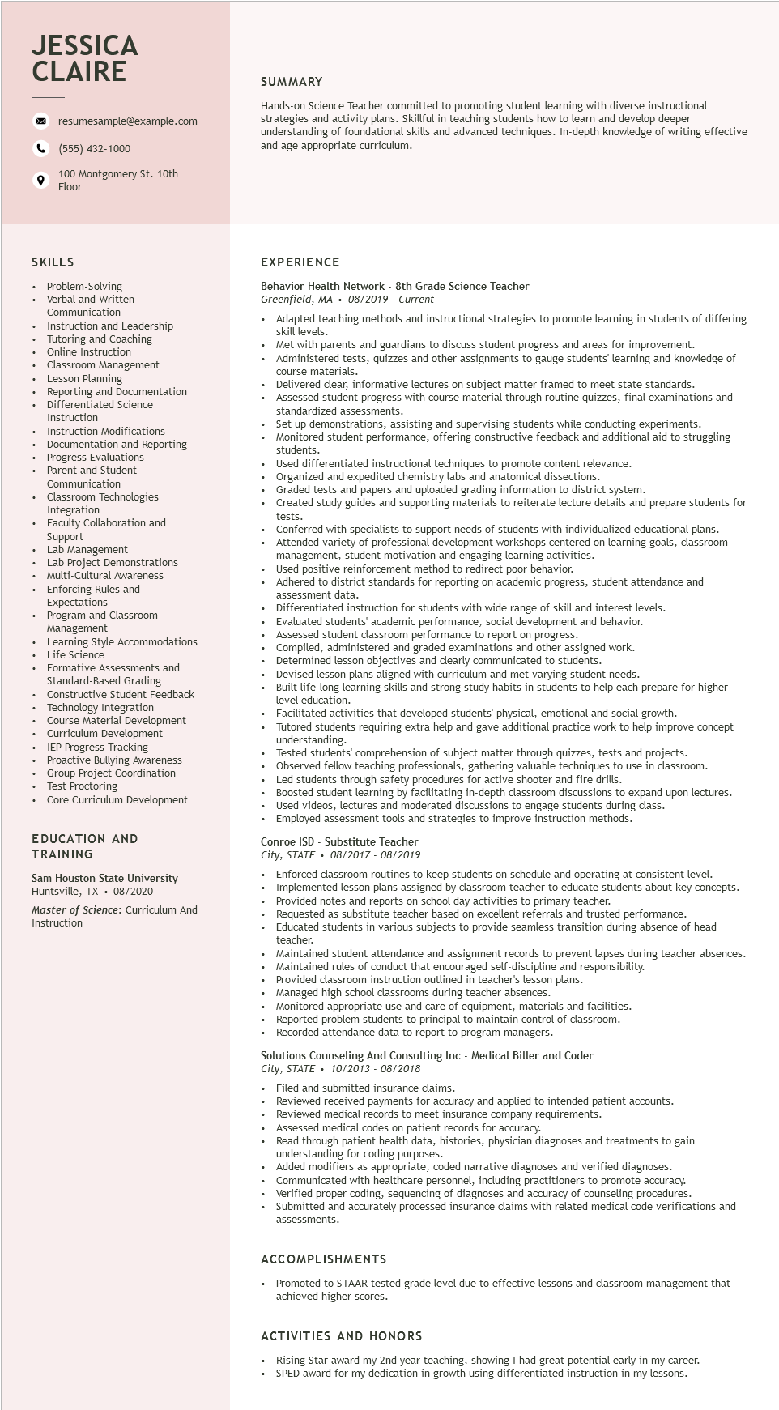

**JESSICA CLAIRE**

resumesample@example.com

(555) 432-1000

100 Montgomery St. 10th Floor

SUMMARY

Hands-on Science Teacher committed to promoting student learning with diverse instructional strategies and activity plans. Skillful in teaching students how to learn and develop deeper understanding of foundational skills and advanced techniques. In-depth knowledge of writing effective and age appropriate curriculum.

SKILLS

Problem-Solving Verbal and written Communication

Instruction and Leadership

Tutoring and Coaching

Online Instruction

Classroom Management

Lesson Planning

Reporting and Documentation

Differentiated Science Instruction

Instruction Modifications

Documentation and Reporting

Progress Evaluations Parent and Student Communication

Classroom Technologies Integration

• Faculty Collaboration and Support Lab Management

Lab Project Demonstrations

• Multi-Cultural Awareness

• Enforcing Rules and

Expectations

Program

and Classroom

Management

• Learning Style Accommodations

Life Science

Formative Assessments and Standard-Based Grading Constructive Student Feedback Technology Integration Course Material Development Curriculum Development IEP Progress Tracking

Proactive Bullying Awareness Group Project Coordination Test Proctoring

• Core Curriculum Development

EDUCATION AND TRAINING

Sam Houston State University

Huntsville, TX. 08/2020

Master of Science: Curriculum And Instruction

EXPERIENCE

Behavior Health Network - 8th Grade Science Teacher Greenfield, MA 08/2019 - Current

Adapted teaching methods and instructional strategies to promote learning in students of differing skill levels.

Met with parents and guardians to discuss student progress and areas for improvement.

• Administered tests, quizzes and other assignments to gauge students' learning and knowledge of course materials.

Delivered clear, informative lectures on subject matter framed to meet state standards.

Assessed student progress with course material through routine quizzes, final examinations and standardized assessments.

Standar

Set up demonstrations, assisting and supervising students while conducting experiments. Monitored student performance, offering constructive feedback and additional aid to struggling students.

Used differentiated instructional techniques to promote content relevance. Organized and expedited chemistry labs and anatomical dissections.

Graded tests and papers and uploaded grading information to district system.

Created study guides and supporting materials to reiterate lecture details and prepare students for tests. tests.

Conferred with specialists to support needs of students with individualized educational plans. Attended variety of professional development workshops centered on learning goals, classroom management, student motivation and engaging learning activities.

Used positive reinforcement method to redirect poor behavior.

Adhered to district standards for reporting on academic progress, student attendance and assessment data.

assessiner

Differentiated instruction for students with wide range of skill and interest levels.

Evaluated students' academic performance, social development and behavior.

Assessed student classroom performance to report on progress.

Compiled, administered and graded examinations and other assigned work.

Determined lesson objectives and clearly communicated to students.

Devised lesson plans aligned with curriculum and met varying student needs.

Built life-long learning skills and strong study habits in students to help each prepare for higher- level education.

Facilitated activities that developed students' physical, emotional and social growth.

Tutored students requiring extra help and gave additional practice work to help improve concept understanding.

Tested students' comprehension of subject matter through quizzes, tests and projects. Observed fellow teaching professionals, gathering valuable techniques to use in classroom.

Led students through safety procedures for active shooter and fire drills.

Boosted student learning by facilitating in-depth classroom discussions to expand upon lectures. Used videos, lectures and moderated discussions to engage students during class. Employed assessment tools and strategies to improve instruction methods.

Conroe ISD - Substitute Teacher

*City, STATE 08/2017-08/2019*

Enforced classroom routines to keep students on schedule and operating at consistent level. Implemented lesson plans assigned by classroom teacher to educate students about key concepts. Provided notes and reports on school day activities to primary teacher.

Requested as substitute teacher based on excellent referrals and trusted performance. Educated students in various subjects to provide seamless transition during absence of head teacher.

Maintained student attendance and assignment records to prevent lapses during teacher absences. Maintained rules of conduct that encouraged self-discipline and responsibility.

Provided classroom instruction outlined in teacher's lesson plans.

• Managed high school classrooms during teacher absences.

• Monitored appropriate use and care of equipment, materials and facilities. Reported problem students to principal to maintain control of classroom. Recorded attendance data to report to program managers.

Solutions Counseling And Consulting Inc - Medical Biller and Coder City, STATE

*10/2013 - 08/2018*

Filed and submitted insurance claims.

Reviewed received payments for accuracy and applied to intended patient accounts. Reviewed medical records to meet insurance company requirements.

Assessed medical codes on patient records for accuracy.

Read through patient health data, histories, physician diagnoses and treatments to gain understanding for coding purposes.

Added modifiers as appropriate, coded narrative diagnoses and verified diagnoses. Communicated with healthcare personnel, including practitioners to promote accuracy. Verified proper coding, sequencing of diagnoses and accuracy of counseling procedures. Submitted and accurately processed insurance claims with related medical code verifications and assessments.

**ACCOMPLISHMENTS**

Promoted to STAAR tested grade level due to effective lessons and classroom management that achieved higher scores.

ACTIVITIES AND HONORS

Rising Star award my 2nd year teaching, showing I had great potential early in my career. SPED award for my dedication in growth using differentiated instruction in my lessons.