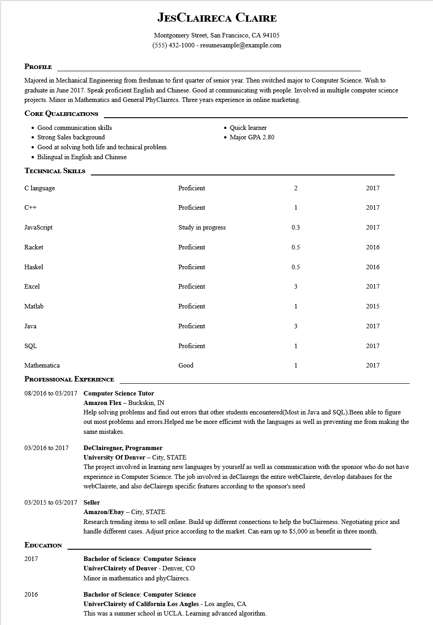

**JESCLAIRECA CLAIRE**

Montgomery Street, San Francisco, CA 94105 (555) 432-1000 - resumesample@example.com

**PROFILE**

Majored in Mechanical Engineering from freshman to first quarter of senior year. Then switched major to Computer Science. Wish to graduate in June 2017. Speak proficient English and Chinese. Good at communicating with people. Involved in multiple computer science projects. Minor in Mathematics and General PhyClairecs. Three years experience in online marketing.

**CORE QUALIFICATIONS**

• Good communication skills

• Strong Sales background

• Good at solving both life and technical problem

• Bilingual in English and Chinese

**TECHNICAL SKILLS**

C language

C++

• Quick learner

• Major GPA 2.80

2

2017

1

2017

Proficient

Proficient

JavaScript

Study in progress

0.3

2017

Racket

Proficient

Haskel

Proficient

0.5

2016

0.5

2016

Excel

Proficient

3

2017

Matlab

Java

SQL

Mathematica

**PROFESSIONAL EXPERIENCE**

**08/2016 to 03/2017 Computer Science Tutor**

Proficient

1

2015

Proficient

3

2017

Proficient

1

2017

Good

1

2017

03/2016 to 2017

Amazon Flex - Buckskin, IN

Help solving problems and find out errors that other students encountered(Most in Java and SQL).Been able to figure out most problems and errors. Helped me be more efficient with the languages as well as preventing me from making the same mistakes.

**DeClairegner, Programmer**

**University of Denver - City, STATE**

The project involved in learning new languages by yourself as well as communication with the sponsor who do not have experience in Computer Science. The job involved in deClairegn the entire webClairete, develop databases for the webClairete, and also deClairegn specific features according to the sponsor's need

03/2015 to 03/2017 Seller

**EDUCATION**

2017

2016

**Amazon/Ebay - City, STATE**

Research trending items to sell online. Build up different connections to help the buClaireness. Negotiating price and handle different cases. Adjust price according to the market. Can earn up to $5,000 in benefit in three month.

**Bachelor of Science: Computer Science**

UniverClairety of Denver - Denver, CO Minor in mathematics and phyClairecs.

**Bachelor of Science: Computer Science**

**UniverClairety of California Los Angles - Los angles, CA**

This was a summer school in UCLA. Learning advanced algorithm.