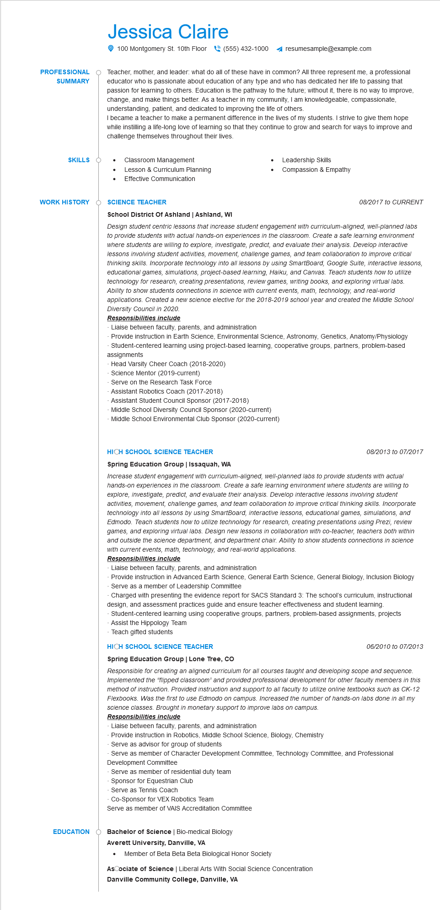

**PROFESSIONAL**

**SUMMARY**

Jessica Claire

100 Montgomery St. 10th Floor(555) 432-1000 ◄ resumesample@example.com

Teacher, mother, and leader: what do all of these have in common? All three represent me, a professional educator who is passionate about education of any type and who has dedicated her life to passing that passion for learning to others. Education is the pathway to the future; without it, there is no way to improve, change, and make things better. As a teacher in my community, I am knowledgeable, compassionate, understanding, patient, and dedicated to improving the life of others.

I became a teacher to make a permanent difference in the lives of my students. I strive to give them hope while instilling a life-long love of learning so that they continue to grow and search for ways to improve and challenge themselves throughout their lives.

Classroom Management

**SKILLS**

•

Lesson & Curriculum Planning

Leadership Skills Compassion & Empathy

Effective Communication

**WORK HISTORY**

**SCIENCE TEACHER**

**School District Of Ashland | Ashland, WI**

08/2017 to CURRENT

*Design student centric lessons that increase student engagement with curriculum-aligned, well-planned labs to provide students with actual hands-on experiences in the classroom. Create a safe learning environment where students are willing to explore, investigate, predict, and evaluate their analysis. Develop interactive lessons involving student activities, movement, challenge games, and team collaboration to improve critical thinking skills. Incorporate technology into all lessons by using SmartBoard, Google Suite, interactive lessons, educational games, simulations, project-based learning, Haiku, and Canvas. Teach students how to utilize technology for research, creating presentations, review games, writing books, and exploring virtual labs. Ability to show students connections in science with current events, math, technology, and real-world applications. Created new science elective for the 2018-2019 school year and created the Middle School Diversity Council in 2020.*

***Responsibilities include***

Liaise between faculty, parents, and administration

Provide instruction in Earth Science, Environmental Science, Astronomy, Genetics, Anatomy/Physiology Student-centered learning using project-based learning, cooperative groups, partners, problem-based assignments

Head Varsity Cheer Coach (2018-2020)

Science Mentor (2019-current)

Serve on the Research Task Force

Assistant Robotics Coach (2017-2018)

Assistant Student Council Sponsor (2017-2018)

Middle School Diversity Council Sponsor (2020-current) Middle School Environmental Club Sponsor (2020-current)

**HICH SCHOOL SCIENCE TEACHER**

**Spring Education Group | Issaquah, WA**

08/2013 to 07/2017

*Increase student engagement with curriculum-aligned, well-planned labs to provide students with actual hands-on experiences in the classroom. Create a safe learning environment where students are willing to explore, investigate, predict, and evaluate their analysis. Develop interactive lessons involving student activities, movement, challenge games, and team collaboration to improve critical thinking skills. Incorporate technology into all lessons by using SmartBoard, interactive lessons, educational games, simulations, and Edmodo. Teach students how to utilize technology for research, creating presentations using Prezi, review games, and exploring virtual labs. Design new lessons in collaboration with co-teacher, teachers both within and outside the science department, and department chair. Ability to show students connections in science with current events, math, technology, and real-world applications.*

***Responsibilities include***

Liaise between faculty, parents, and administration

Provide instruction in Advanced Earth Science, General Earth Science, General Biology, Inclusion Biology Serve as a member of Leadership Committee

Charged with presenting the evidence report for SACS Standard 3: The school's curriculum, instructional design, and assessment practices guide and ensure teacher effectiveness and student learning. Student-centered learning using cooperative groups, partners, problem-based assignments, projects Assist the Hippology Team

Teach gifted students

**HICH SCHOOL SCIENCE TEACHER**

06/2010 to 07/2013

**Spring Education Group | Lone Tree, CO**

*Responsible for creating an aligned curriculum for all courses taught and developing scope and sequence. Implemented the "flipped classroom" and provided professional development for other faculty members in this method of instruction. Provided instruction and support to all faculty to utilize online textbooks such as CK-12 Flexbooks. Was the first to use Edmodo on campus. Increased the number of hands-on labs done in all my science classes. Brought in monetary support to improve labs on campus.*

***Responsibilities include***

Liaise between faculty, parents, and administration

Provide instruction in Robotics, Middle School Science, Biology, Chemistry

Serve as advisor for group of students

Serve as member of Character Development Committee, Technology Committee, and Professional Development Committee

Serve as member of residential duty team

Sponsor for Equestrian Club

Serve as Tennis Coach

Co-Sponsor for VEX Robotics Team

Serve as member of VAIS Accreditation Committee

**EDUCATION**

**Bachelor of Science | Bio-medical Biology**

**Averett University, Danville, VA**

•

Member of Beta Beta Beta Biological Honor Society

AsCociate of Science | Liberal Arts With Social Science Concentration

**Danville Community College, Danville, VA**