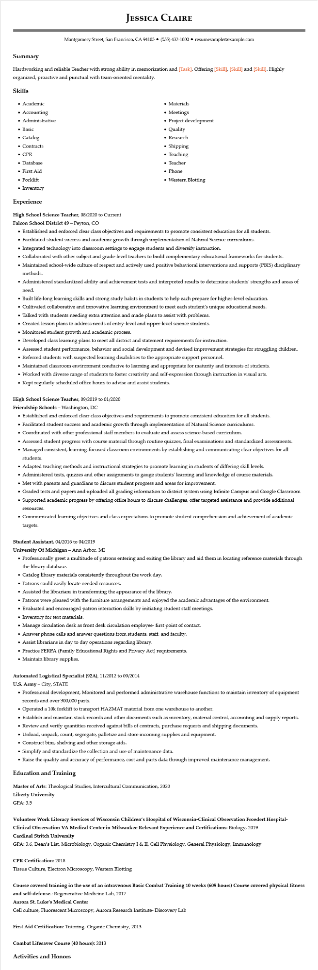

**JESSICA CLAIRE**

Montgomery Street, San Francisco, CA 94105⚫ (555) 432-1000⚫ resumesample@example.com

**Summary**

Hardworking and reliable Teacher with strong ability in memorization and [Task]. Offering [Skill], [Skill] and [Skill]. Highly organized, proactive and punctual with team-oriented mentality.

Skills

• Academic

• Accounting

• Administrative

• Basic

• Catalog

• Contracts

• CPR

• Database

• First Aid

• Forklift

• Inventory

**Experience**

High School Science Teacher, 08/2020 to Current

Falcon School District 49 - Peyton, CO

• Materials

• Meetings

• Project development

• Quality

• Research

.

Shipping

• Teaching

• Teacher

• Phone

• Western Blotting

• Established and enforced clear class objectives and requirements to promote consistent education for all students.

• Facilitated student success and academic growth through implementation of Natural Science curriculums.

• Integrated technology into classroom settings to engage students and diversify instruction.

• Collaborated with other subject and grade-level teachers to build complementary educational frameworks for students.

• Maintained school-wide culture of respect and actively used positive behavioral interventions and supports (PBIS) disciplinary methods.

• Administered standardized ability and achievement tests and interpreted results to determine students' strengths and areas of

need.

• Built life-long learning skills and strong study habits in students to help each prepare for higher-level education.

• Cultivated collaborative and innovative learning environment to meet each student's unique educational needs.

• Talked with students needing extra attention and made plans to assist with problems.

• Created lesson plans to address needs of entry-level and upper-level science students.

• Monitored student growth and academic process.

•

Developed class learning plans to meet all district and statement requirements for instruction.

• Assessed student performance, behavior and social development and devised improvement strategies for struggling children.

• Referred students with suspected learning disabilities to the appropriate support personnel.

• Maintained classroom environment conducive to learning and appropriate for maturity and interests of students.

• Worked with diverse range of students to foster creativity and self-expression through instruction in visual arts.

• Kept regularly scheduled office hours to advise and assist students.

High School Science Teacher, 09/2019 to 01/2020

**Friendship Schools - Washington, DC**

• Established and enforced clear class objectives and requirements to promote consistent education for all students.

• Facilitated student success and academic growth through implementation of Natural Science curriculums.

• Coordinated with other professional staff members to evaluate and assess science-based curriculum.

• Assessed student progress with course material through routine quizzes, final examinations and standardized assessments.

• Managed consistent, learning-focused classroom environments by establishing and communicating clear objectives for all students.

• Adapted teaching methods and instructional strategies to promote learning in students of differing skill levels.

• Administered tests, quizzes and other assignments to gauge students' learning and knowledge of course materials.

• Met with parents and guardians to discuss student progress and areas for improvement.

• Graded tests and papers and uploaded all grading information to district system using Infinite Campus and Google Classroom

• Supported academic progress by offering office hours to discuss challenges, offer targeted assistance and provide additional

resources.

• Communicated learning objectives and class expectations to promote student comprehension and achievement of academic targets.

Student Assistant, 04/2016 to 04/2019

**University of Michigan - Ann Arbor, MI**

• Professionally greet a multitude of patrons entering and exiting the library and aid them in locating reference materials through the library database.

• Catalog library materials consistently throughout the work day.

• Patrons could easily locate needed resources.

• Assisted the librarians in transforming the appearance of the library.

• Patrons were pleased with the furniture arrangements and enjoyed the academic advantages of the environment.

• Evaluated and encouraged patron interaction skills by initiating student staff meetings.

• Inventory for text materials.

• Manage circulation desk as front desk circulation employee- first point of contact.

• Answer phone calls and answer questions from students, staff, and faculty.

• Assist librarians in day to day operations regarding library.

• Practice FERPA (Family Educational Rights and Privacy Act) requirements.

• Maintain library supplies.

**Automated Logistical Specialist (92A), 11/2012 to 09/2014**

U.S. Army - City, STATE

• Professional development, Monitored and performed administrative warehouse functions to maintain inventory of equipment records and over 300,000 parts.

• Operated a 10k forklift to transport HAZMAT material from one warehouse to another.

• Establish and maintain stock records and other documents such as inventory, material control, accounting and supply reports.

• Review and verify quantities received against bills of contracts, purchase requests and shipping documents.

• Unload, unpack, count, segregate, palletize and store incoming supplies and equipment.

• Construct bins, shelving and other storage aids.

• Simplify and standardize the collection and use of maintenance data.

• Raise the quality and accuracy of performance, cost and parts data through improved maintenance management.

**Education and Training**

Master of Arts: Theological Studies, Intercultural Communication, 2020

Liberty University

GPA: 3.5

**Volunteer Work Literacy Services of Wisconsin Children's Hospital of Wisconsin-Clinical Observation Froedert Hospital- Clinical Observation VA Medical Center in Milwaukee Relevant Experience and Certifications: Biology, 2019**

**Cardinal Stritch University**

GPA: 3.6, Dean's List, Microbiology, Organic Chemistry I & II, Cell Physiology, General Physiology, Immunology

CPR Certification: 2018

Tissue Culture, Electron Microscopy, Western Blotting

**Course covered training in the use of an intravenous Basic Combat Training 10 weeks (605 hours) Course covered physical fitness and self-defense.: Regenerative Medicine Lab, 2017**

**Aurora St. Luke's Medical Center**

Cell culture, Fluorescent Microscopy, Aurora Research Institute- Discovery Lab

First Aid Certification: Tutoring- Organic Chemistry, 2013

Combat Lifesaver Course (40 hours): 2013

**Activities and Honors**