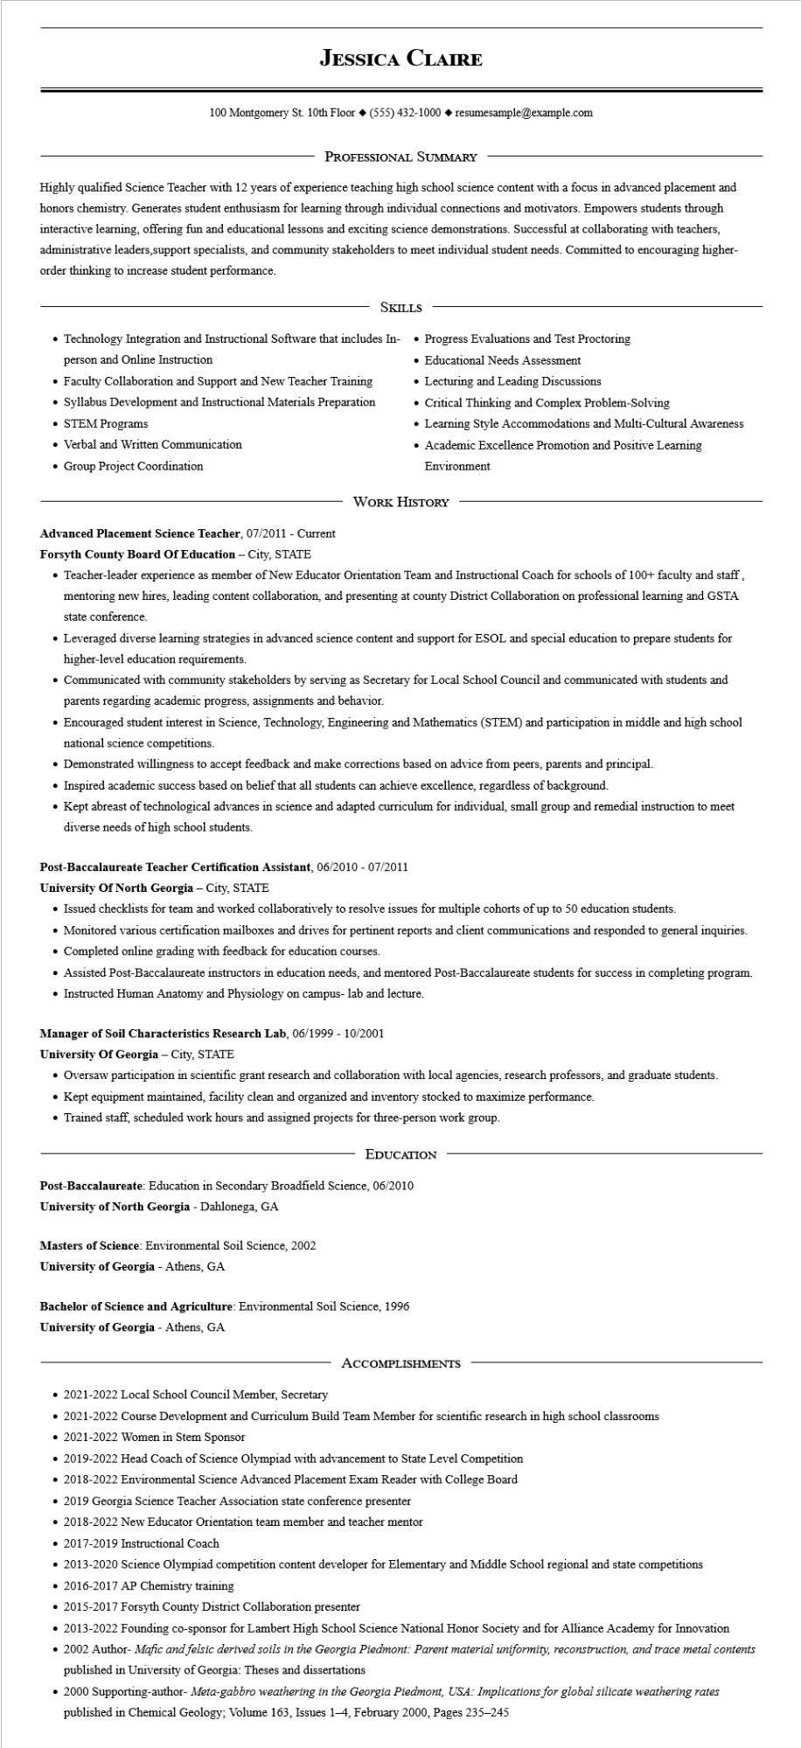

**JESSICA CLAIRE**

100 Montgomery St. 10th Floor (555) 432-1000◆ resumesample@example.com

PROFESSIONAL SUMMARY

Highly qualified Science Teacher with 12 years of experience teaching high school science content with a focus in advanced placement and honors chemistry. Generates student enthusiasm for learning through individual connections and motivators. Empowers students through interactive learning, offering fun and educational lessons and exciting science demonstrations. Successful at collaborating with teachers, administrative leaders, support specialists, and community stakeholders to meet individual student needs. Committed to encouraging higher- order thinking to increase student performance.

SKILLS

• Technology Integration and Instructional Software that includes In- person and Online Instruction

• Faculty Collaboration and Support and New Teacher Training

• Syllabus Development and Instructional Materials Preparation • STEM Programs

• Verbal and Written Communication

• Group Project Coordination

Advanced Placement Science Teacher, 07/2011 - Current

**Forsyth County Board Of Education - City, STATE**

• Progress Evaluations and Test Proctoring

• Educational Needs Assessment

• Lecturing and Leading Discussions

• Critical Thinking and Complex Problem-Solving

• Learning Style Accommodations and Multi-Cultural Awareness

• Academic Excellence Promotion and Positive Learning Environment

WORK HISTORY

• Teacher-leader experience as member of New Educator Orientation Team and Instructional Coach for schools of 100+ faculty and staff, mentoring new hires, leading content collaboration, and presenting at county District Collaboration on professional learning and GSTA state conference.

• Leveraged diverse learning strategies in advanced science content and support for ESOL and special education to prepare students for higher-level education requirements.

• Communicated with community stakeholders by serving as Secretary for Local School Council and communicated with students and parents regarding academic progress, assignments and behavior.

• Encouraged student interest in Science, Technology, Engineering and Mathematics (STEM) and participation in middle and high school national science competitions.

• Demonstrated willingness to accept feedback and make corrections based on advice from peers, parents and principal.

• Inspired academic success based on belief that all students can achieve excellence, regardless of background.

• Kept abreast of technological advances in science and adapted curriculum for individual, small group and remedial instruction to meet diverse needs of high school students.

**Post-Baccalaureate Teacher Certification Assistant, 06/2010 - 07/2011**

**University of North Georgia - City, STATE**

• Issued checklists for team and worked collaboratively to resolve issues for multiple cohorts of up to 50 education students.

• Monitored various certification mailboxes and drives for pertinent reports and client communications and responded to general inquiries.

• Completed online grading with feedback for education courses.

• Assisted Post-Baccalaureate instructors in education needs, and mentored Post-Baccalaureate students for success in completing program. • Instructed Human Anatomy and Physiology on campus- lab and lecture.

**Manager of Soil Characteristics Research Lab, 06/1999 - 10/2001**

**University of Georgia - City, STATE**

• Oversaw participation in scientific grant research and collaboration with local agencies, research professors, and graduate students.

• Kept equipment maintained, facility clean and organized and inventory stocked to maximize performance.

• Trained staff, scheduled work hours and assigned projects for three-person work group.

**EDUCATION**

Post-Baccalaureate: Education in Secondary Broadfield Science, 06/2010

**University of North Georgia - Dahlonega, GA**

Masters of Science: Environmental Soil Science, 2002

**University of Georgia - Athens, GA**

**Bachelor of Science and Agriculture: Environmental Soil Science, 1996**

**University of Georgia - Athens, GA**

ACCOMPLISHMENTS

2021-2022 Local School Council Member, Secretary

• 2021-2022 Course Development and Curriculum Build Team Member for scientific research in high school classrooms

• 2021-2022 Women in Stem Sponsor

• 2019-2022 Head Coach of Science Olympiad with advancement to State Level Competition

⚫ 2018-2022 Environmental Science Advanced Placement Exam Reader with College Board

⚫ 2019 Georgia Science Teacher Association state conference presenter

⚫ 2018-2022 New Educator Orientation team member and teacher mentor

• 2017-2019 Instructional Coach

• 2013-2020 Science Olympiad competition content developer for Elementary and Middle School regional and state competitions

• 2016-2017 AP Chemistry training

2015-2017 Forsyth County District Collaboration presenter

• 2013-2022 Founding co-sponsor for Lambert High School Science National Honor Society and for Alliance Academy for Innovation

• 2002 Author- Mafic and felsic derived soils in the Georgia Piedmont: Parent material uniformity, reconstruction, and trace metal contents published in University of Georgia: Theses and dissertations

• 2000 Supporting-author- Meta-gabbro weathering in the Georgia Piedmont, USA: Implications for global silicate weathering rates published in Chemical Geology; Volume 163, Issues 1-4, February 2000, Pages 235-245