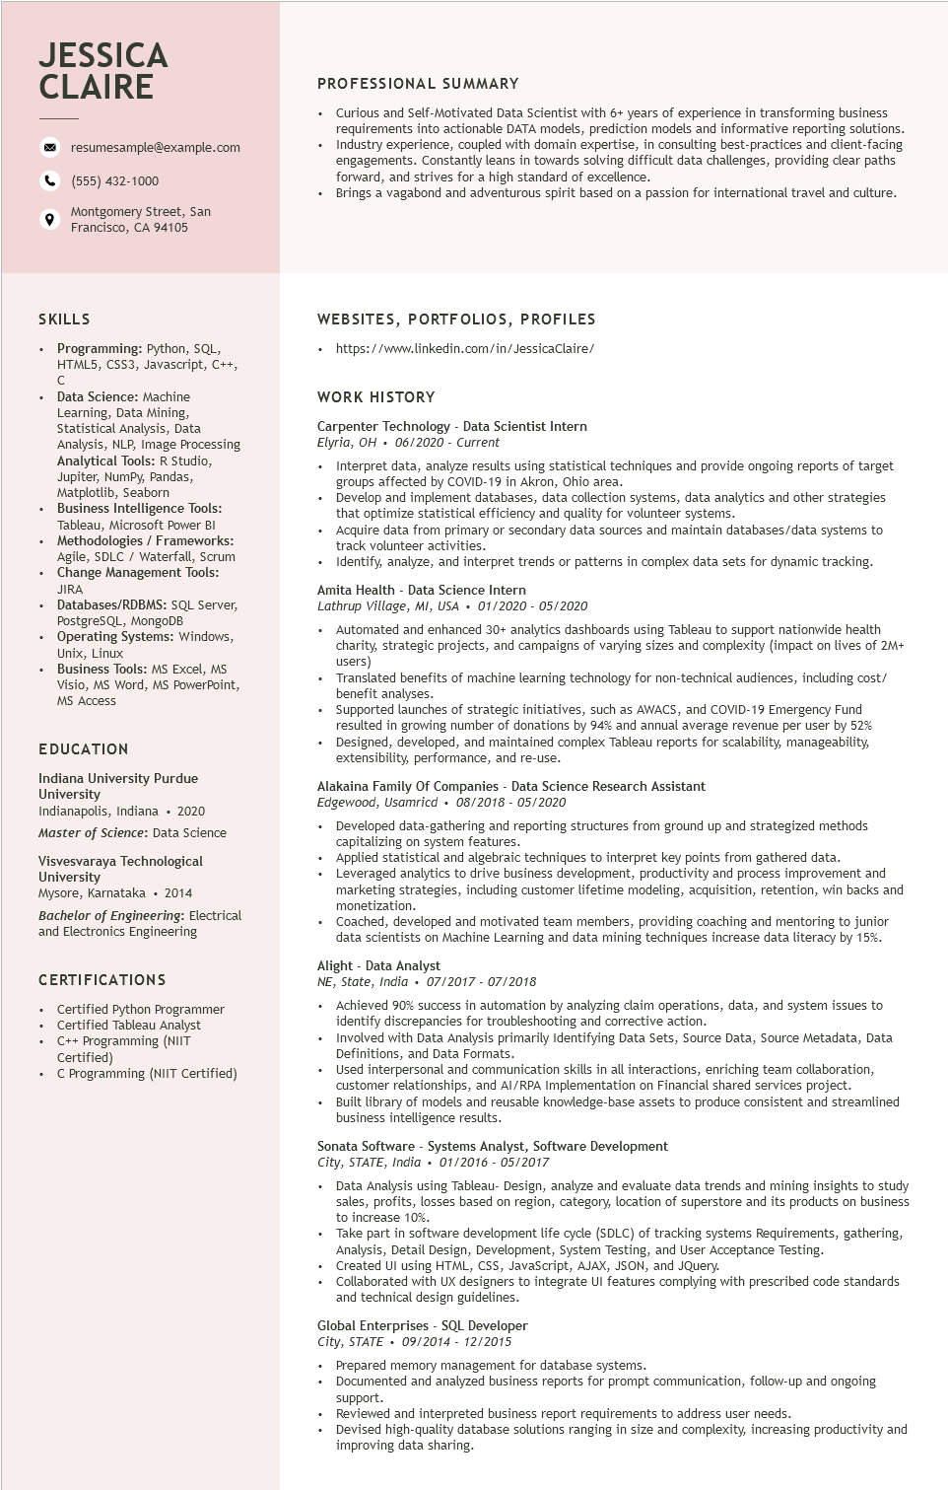

**JESSICA CLAIRE**

9

resumesample@example.com

(555) 432-1000

Montgomery Street, San Francisco, CA 94105

**PROFESSIONAL SUMMARY**

•

Curious and Self-Motivated Data Scientist with 6+ years of experience in transforming business requirements into actionable DATA models, prediction models and informative reporting solutions. Industry experience, coupled with domain expertise, in consulting best-practices and client-facing engagements. Constantly leans in towards solving difficult data challenges, providing clear paths forward, and strives for a high standard of excellence.

Brings a vagabond and adventurous spirit based on a passion for international travel and culture.

SKILLS

• Programming: Python, SQL,

HTML5, CSS3, Javascript, C++,

C

Data Science: Machine

Learning, Data Mining, Statistical Analysis, Data

Analysis, NLP, Image Processing Analytical Tools: R Studio, Jupiter, NumPy, Pandas, Matplotlib, Seaborn

Business Intelligence Tools:

Tableau, Microsoft Power BI • Methodologies / Frameworks:

Agile, SDLC / Waterfall, Scrum Agile, Change Management Tools: JIRA

Databases/RDBMS: SQL Server, PostgreSQL, MongoDB

• Operating Systems: Windows, Unix, Linux

• Business Tools: MS Excel, MS Visio, MS Word, MS PowerPoint, MS Access

EDUCATION

Indiana University Purdue University

Indianapolis, Indiana ⚫ 2020

Master of Science: Data Science

Visvesvaraya Technological University

Mysore, Karnataka ⚫ 2014

Bachelor of Engineering: Electrical and Electronics Engineering

CERTIFICATIONS

• Certified Python Programmer Certified Tableau Analyst C++ Programming (NIIT Certified)

C Programming (NIIT Certified)

WEBSITES, PORTFOLIOS, PROFILES

•

https://www.linkedin.com/in/JessicaClaire/

**WORK HISTORY**

Carpenter Technology Data Scientist Intern

Elyria, OH 06/2020 - Current

•

Interpret data, analyze results using statistical techniques and provide ongoing reports of target groups affected by COVID-19 in Akron, Ohio area.

Develop and implement databases, data collection systems, data analytics and other strategies that optimize statistical efficiency and quality for volunteer systems.

Acquire data from primary or secondary data sources and maintain databases/data systems to track volunteer activities.

Identify, analyze, and interpret trends or patterns in complex data sets for dynamic tracking. Amita Health Data Science Intern

*Lathrup Village, MI, USA. 01/2020- 05/2020*

Automated and enhanced 30+ analytics dashboards using Tableau to support nationwide health charity, strategic projects, and campaigns of varying sizes and complexity (impact on lives of 2M+ users)

Translated benefits of machine learning technology for non-technical audiences, including cost/ benefit analyses.

Supported launches of strategic initiatives, such as AWACS, and COVID-19 Emergency Fund resulted in growing number of donations by 94% and annual average revenue per user by 52% Designed, developed, and maintained complex Tableau reports for scalability, manageability, extensibility, performance, and re-use.

Alakaina Family Of Companies - Data Science Research Assistant

*Edgewood, Usamricd⚫ 08/2018 - 05/2020*

• Developed data-gathering and reporting structures from ground up and strategized methods capitalizing on system features.

Applied statistical and algebraic techniques to interpret key points from gathered data.

• Leveraged analytics to drive business development, productivity and process improvement and marketing strategies, including customer lifetime modeling, acquisition, retention, win backs and monetization.

Coached, developed and motivated team members, providing coaching and mentoring to junior data scientists on Machine Learning and data mining techniques increase data literacy by 15%.

Alight - Data Analyst

NE, State, India 07/2017- 07/2018

.

Achieved 90% success in automation by analyzing claim operations, data, and system issues to identify discrepancies for troubleshooting and corrective action.

Involved with Data Analysis primarily Identifying Data Sets, Source Data, Source Metadata, Data Definitions, and Data Formats.

Used interpersonal and communication skills in all interactions, enriching team collaboration, customer relationships, and AI/RPA Implementation on Financial shared services project. Built library of models and reusable knowledge-base assets to produce consistent and streamlined business intelligence results.

Sonata Software - Systems Analyst, Software Development

*City, STATE, India 01/2016 - 05/2017*

.

Data Analysis using Tableau- Design, analyze and evaluate data trends and mining insights to study sales, profits, losses based on region, category, location of superstore and its products on business to increase 10%.

Take part in software development life cycle (SDLC) of tracking systems Requirements, gathering, Analysis, Detail Design, Development, System Testing, and User Acceptance Testing. Created UI using HTML, CSS, JavaScript, AJAX, JSON, and JQuery.

Collaborated with UX designers to integrate UI features complying with prescribed code standards and technical design guidelines.

Global Enterprises SQL Developer

*City, STATE*

*09/2014 - 12/2015*

Prepared memory management for database systems.

Documented and analyzed business reports for prompt communication, follow-up and ongoing

support.

Reviewed and interpreted business report requirements to address user needs.

Devised high-quality database solutions ranging in size and complexity, increasing productivity and improving data sharing.