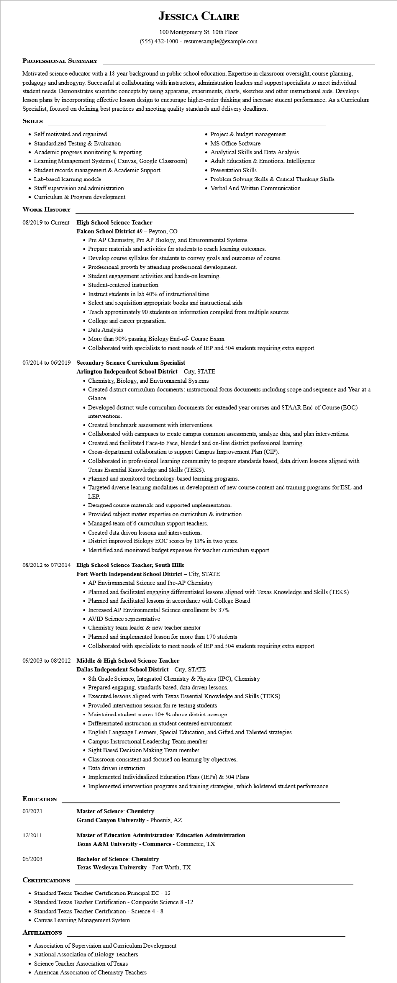

**JESSICA CLAIRE**

100 Montgomery St. 10th Floor

(555) 432-1000 - resumesample@example.com

**PROFESSIONAL SUMMARY**

Motivated science educator with a 18-year background in public school education. Expertise in classroom oversight, course planning. pedagogy and androgyny. Successful at collaborating with instructors, administration leaders and support specialists to meet individual student needs. Demonstrates scientific concepts by using apparatus, experiments, charts, sketches and other instructional aids. Develops lesson plans by incorporating effective lesson design to encourage higher-order thinking and increase student performance. As a Curriculum Specialist, focused on defining best practices and meeting quality standards and delivery deadlines.

**SKILLS**

• Self motivated and organized

• Standardized Testing & Evaluation

• Academic progress monitoring & reporting

• Learning Management Systems (Canvas, Google Classroom)

• Student records management & Academic Support

• Lab-based learning models

Staff supervision and administration

• Curriculum & Program development

**WORK HISTORY**

**08/2019 to Current High School Science Teacher**

**Falcon School District 49 - Peyton, CO**

• Project & budget management

• MS Office Software

• Analytical Skills and Data Analysis

• Adult Education & Emotional Intelligence

• Presentation Skills

• Problem Solving Skills & Critical Thinking Skills

• Verbal And Written Communication

• Pre AP Chemistry, Pre AP Biology, and Environmental Systems

• Prepare materials and activities for students to reach learning outcomes.

• Develop course syllabus for students to convey goals and outcomes of course.

• Professional growth by attending professional development.

• Student engagement activities and hands-on learning.

• Student-centered instruction

• Instruct students in lab 40% of instructional time

• Select and requisition appropriate books and instructional aids

• Teach approximately 90 students on information compiled from multiple sources

• College and career preparation.

• Data Analysis

• More than 90% passing Biology End-of- Course Exam

• Collaborated with specialists to meet needs of IEP and 504 students requiring extra support

**07/2014 to 06/2019 Secondary Science Curriculum Specialist**

**Arlington Independent School District - City, STATE**

• Chemistry, Biology, and Environmental Systems

• Created district curriculum documents: instructional focus documents including scope and sequence and Year-at-a- Glance.

• Developed district wide curriculum documents for extended year courses and STAAR End-of-Course (EOC) interventions.

• Created benchmark assessment with interventions.

• Collaborated with campuses to create campus common assessments, analyze data, and plan interventions.

• Created and facilitated Face-to Face, blended and on-line district professional learning.

• Cross-department collaboration to support Campus Improvement Plan (CIP).

• Collaborated in professional learning community to prepare standards based, data driven lessons aligned with Texas Essential Knowledge and Skills (TEKS).

• Planned and monitored technology-based learning programs.

• Targeted diverse learning modalities in development of new course content and training programs for ESL and LEP.

• Designed course materials and supported implementation.

• Provided subject matter expertise on curriculum & instruction.

• Managed team of 6 curriculum support teachers.

• Created data driven lessons and interventions.

• District improved Biology EOC scores by 18% in two years.

• Identified and monitored budget expenses for teacher curriculum support

**08/2012 to 07/2014 High School Science Teacher, South Hills**

**Fort Worth Independent School District - City, STATE**

• AP Environmental Science and Pre-AP Chemistry

• Planned and facilitated engaging differentiated lessons aligned with Texas Knowledge and Skills (TEKS)

• Planned and facilitated lessons in accordance with College Board

• Increased AP Environmental Science enrollment by 37%

• AVID Science representative

• Chemistry team leader & new teacher mentor

• Planned and implemented lesson for more than 170 students

• Collaborated with specialists to meet needs of IEP and 504 students requiring extra support

**09/2003 to 08/2012 Middle & High School Science Teacher**

**EDUCATION**

07/2021

**Dallas Independent School District - City, STATE**

• 8th Grade Science, Integrated Chemistry & Physics (IPC), Chemistry

• Prepared engaging, standards based, data driven lessons.

• Executed lessons aligned with Texas Essential Knowledge and Skills (TEKS)

• Provided intervention session for re-testing students

• Maintained student scores 10+% above district average

• Differentiated instruction in student centered environment

• English Language Learners, Special Education, and Gifted and Talented strategies

•

Campus Instructional Leadership Team member

• Sight Based Decision Making Team member

• Classroom consistent and focused on learning by objectives.

• Data driven instruction

• Implemented Individualized Education Plans (IEPs) & 504 Plans

• Implemented intervention programs and training strategies, which bolstered student performance.

**Master of Science: Chemistry**

**Grand Canyon University - Phoenix, AZ**

12/2011

05/2003

**Master of Education Administration: Education Administration**

**Texas A&M University - Commerce - Commerce, TX**

**Bachelor of Science: Chemistry**

**Texas Wesleyan University - Fort Worth, TX**

**CERTIFICATIONS**

• Standard Texas Teacher Certification Principal EC - 12

• Standard Texas Teacher Certification - Composite Science 8-12

• Standard Texas Teacher Certification - Science 4-8

• Canvas Learning Management System

**AFFILIATIONS**

• Association of Supervision and Curriculum Development

• National Association of Biology Teachers

• Science Teacher Association of Texas

• American Association of Chemistry Teachers