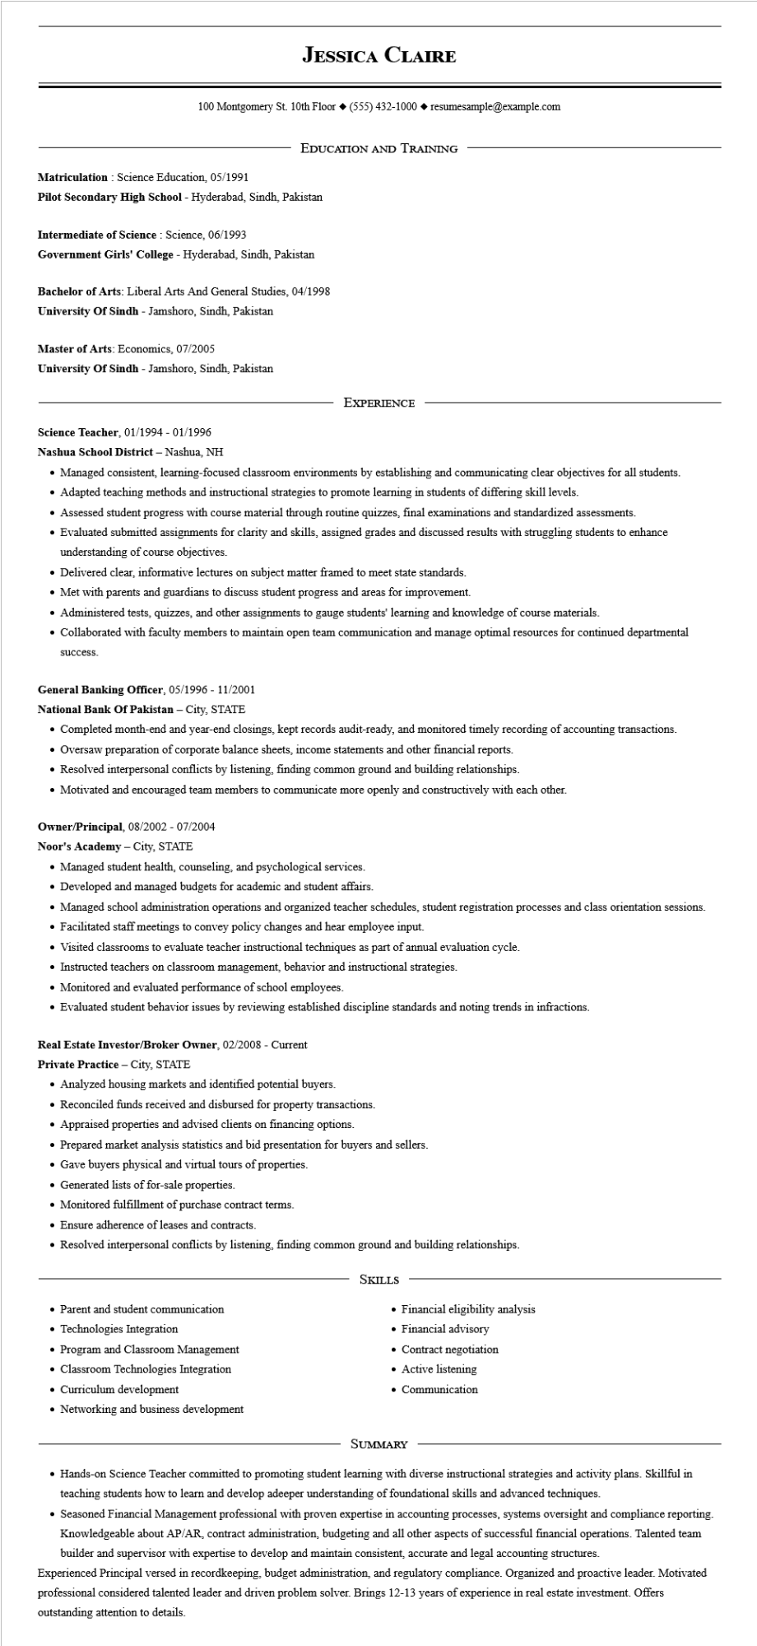

**JESSICA CLAIRE**

100 Montgomery St. 10th Floor (555) 432-1000◆ resumesample@example.com

EDUCATION AND TRAINING

**Matriculation: Science Education, 05/1991**

Pilot Secondary High School - Hyderabad, Sindh, Pakistan

**Intermediate of Science Science, 06/1993**

Government Girls' College - Hyderabad, Sindh, Pakistan

Bachelor of Arts: Liberal Arts And General Studies, 04/1998

**University of Sindh - Jamshoro, Sindh, Pakistan**

Master of Arts: Economics, 07/2005

University of Sindh - Jamshoro, Sindh, Pakistan

EXPERIENCE

**Science Teacher, 01/1994 - 01/1996**

**Nashua School District - Nashua, NH**

• Managed consistent, learning-focused classroom environments by establishing and communicating clear objectives for all students.

• Adapted teaching methods and instructional strategies to promote learning in students of differing skill levels.

• Assessed student progress with course material through routine quizzes, final examinations and standardized assessments.

• Evaluated submitted assignments for clarity and skills, assigned grades and discussed results with struggling students to enhance understanding of course objectives.

• Delivered clear, informative lectures on subject matter framed to meet state standards.

• Met with parents and guardians to discuss student progress and areas for improvement.

• Administered tests, quizzes, and other assignments to gauge students' learning and knowledge of course materials.

• Collaborated with faculty members to maintain open team communication and manage optimal resources for continued departmental

**success.**

General Banking Officer, 05/1996 - 11/2001

**National Bank Of Pakistan - City, STATE**

• Completed month-end and year-end closings, kept records audit-ready, and monitored timely recording of accounting transactions.

• Oversaw preparation of corporate balance sheets, income statements and other financial reports.

• Resolved interpersonal conflicts by listening, finding common ground and building relationships.

• Motivated and encouraged team members to communicate more openly and constructively with each other.

Owner/Principal, 08/2002 - 07/2004

Noor's Academy - City, STATE

• Managed student health, counseling, and psychological services.

• Developed and managed budgets for academic and student affairs.

• Managed school administration operations and organized teacher schedules, student registration processes and class orientation sessions.

• Facilitated staff meetings to convey policy changes and hear employee input.

• Visited classrooms to evaluate teacher instructional techniques as part of annual evaluation cycle.

• Instructed teachers on classroom management, behavior and instructional strategies.

• Monitored and evaluated performance of school employees.

• Evaluated student behavior issues by reviewing established discipline standards and noting trends in infractions.

**Real Estate Investor/Broker Owner, 02/2008 - Current**

**Private Practice - City, STATE**

• Analyzed housing markets and identified potential buyers.

• Reconciled funds received and disbursed for property transactions.

• Appraised properties and advised clients on financing options.

• Prepared market analysis statistics and bid presentation for buyers and sellers.

• Gave buyers physical and virtual tours of properties.

• Generated lists of for-sale properties.

• Monitored fulfillment of purchase contract terms.

• Ensure adherence of leases and contracts.

• Resolved interpersonal conflicts by listening, finding common ground and building relationships.

SKILLS

• Parent and student communication

• Technologies Integration

• Program and Classroom Management

• Classroom Technologies Integration

• Curriculum development

• Financial eligibility analysis

• Financial advisory

• Contract negotiation

• Active listening

• Communication

• Networking and business development

SUMMARY

• Hands-on Science Teacher committed to promoting student learning with diverse instructional strategies and activity plans. Skillful in teaching students how to learn and develop adeeper understanding of foundational skills and advanced techniques.

• Seasoned Financial Management professional with proven expertise in accounting processes, systems oversight and compliance reporting. Knowledgeable about AP/AR, contract administration, budgeting and all other aspects of successful financial operations. Talented team builder and supervisor with expertise to develop and maintain consistent, accurate and legal accounting structures.

Experienced Principal versed in recordkeeping, budget administration, and regulatory compliance. Organized and proactive leader. Motivated professional considered talented leader and driven problem solver. Brings 12-13 years of experience in real estate investment. Offers outstanding attention to details.