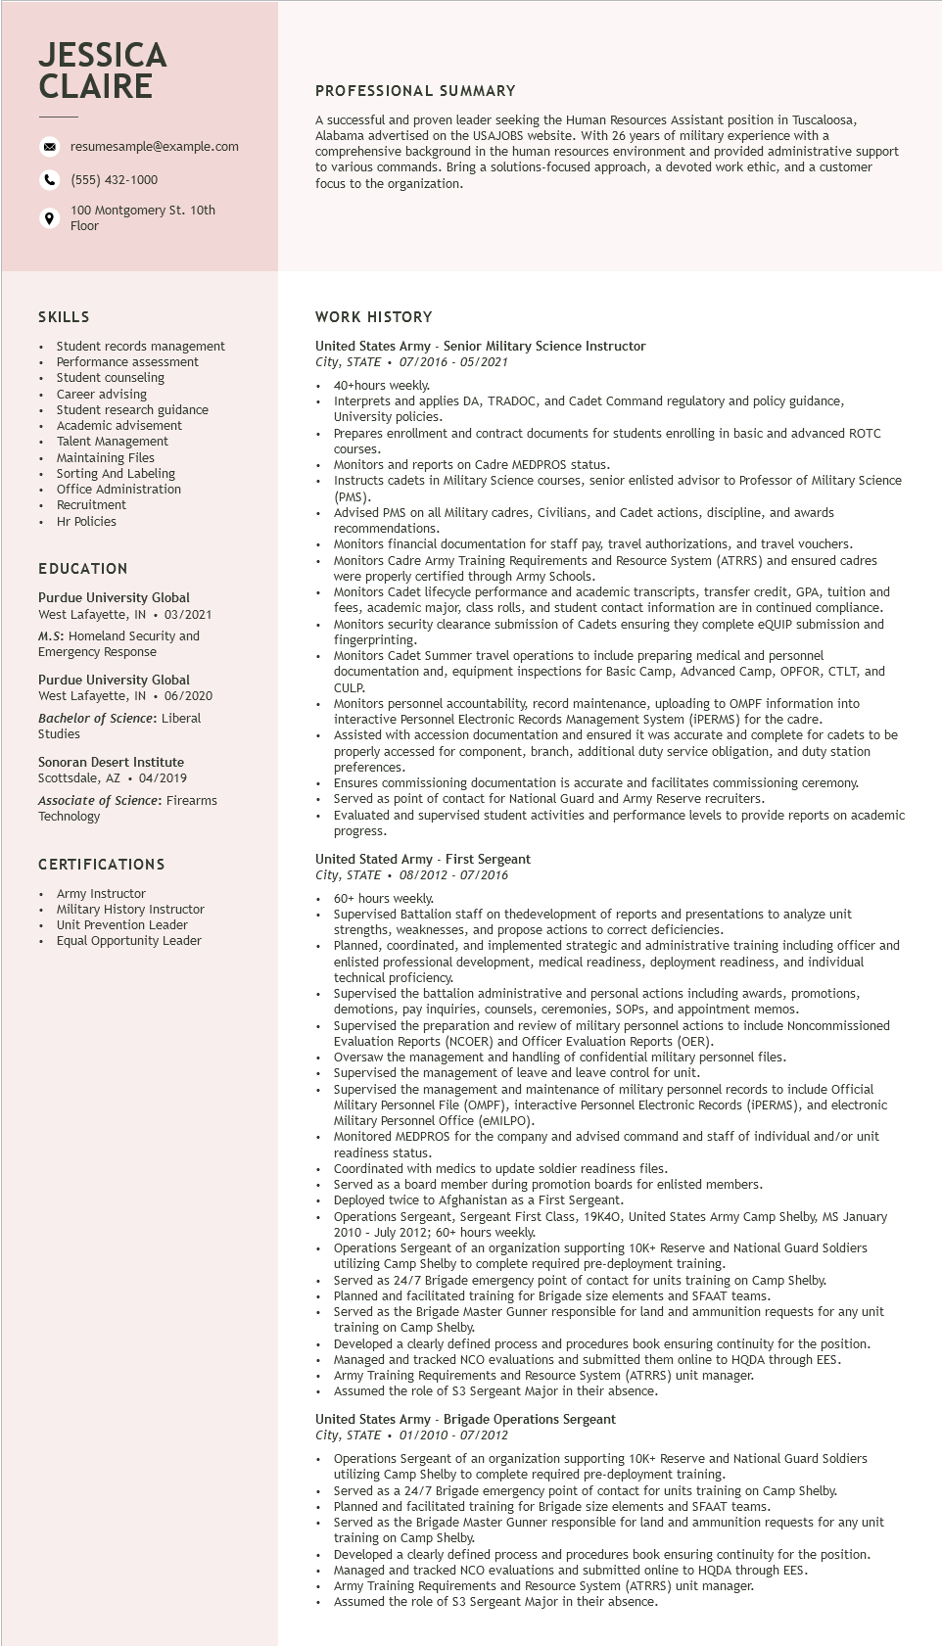

**JESSICA CLAIRE**

resumesample@example.com

(555) 432-1000

100 Montgomery St. 10th Floor

**PROFESSIONAL SUMMARY**

A successful and proven leader seeking the Human Resources Assistant position in Tuscaloosa, Alabama advertised on the USAJOBS website. With 26 years of military experience with a comprehensive background in the human resources environment and provided administrative support to various commands. Bring a solutions-focused approach, a devoted work ethic, and a customer focus to the organization.

SKILLS

Student records management

Performance assessment Student counseling

Career advising

Student research guidance advisement

Academic

Talent Management Maintaining Files

Sorting And Labeling

Office Administration

• Recruitment

Hr Policies

EDUCATION

Purdue University Global West Lafayette, IN ⚫ 03/2021 M.S: Homeland Security and Emergency Response

Purdue University Global

West Lafayette, IN ⚫ 06/2020

*Bachelor of Science: Liberal*

Studies

Sonoran Desert Institute

Scottsdale, AZ. 04/2019

Associate of Science: Firearms Technology

CERTIFICATIONS

Army Instructor

Military History Instructor Unit Prevention Leader

Equal Opportunity Leader

**WORK HISTORY**

United States Army - Senior Military Science Instructor

*City, STATE 07/2016 - 05/2021*

•

40+hours weekly.

Interprets and applies DA, TRADOC, and Cadet Command regulatory and policy guidance, University policies.

Prepares enrollment and contract documents for students enrolling in basic and advanced ROTC

courses.

Monitors and reports on Cadre MEDPROS status.

• Instructs cadets in Military Science courses, senior enlisted advisor to Professor of Military Science (PMS). (PMS).

Advised PMS on all Military cadres, Civilians, and Cadet actions, discipline, and awards recommendations.

• Monitors financial documentation for staff pay, travel authorizations, and travel vouchers. Monitors Cadre Army Training Requirements and Resource System (ATRRS) and ensured cadres were properly certified through Army Schools.

Monitors Cadet lifecycle performance and academic transcripts, transfer credit, GPA, tuition and fees, academic major, class rolls, and student contact information are in continued compliance. Monitors security clearance submission of Cadets ensuring they complete eQUIP submission and fingerprinting.

Monitors Cadet Summer travel operations to include preparing medical and personnel documentation and, equipment inspections for Basic Camp, Advanced Camp, OPFOR, CTLT, and

CULP. COLP.

Monitors personnel accountability, record maintenance, uploading to OMPF information into interactive Personnel Electronic Records Management System (iPERMS) for the cadre.

Assisted with accession documentation and ensured it was accurate and complete for cadets to be properly accessed for component, branch, additional duty service obligation, and duty station preferences.

Ensures commissioning documentation is accurate and facilitates commissioning ceremony. Served as point of contact for National Guard and Army Reserve recruiters.

Evaluated and supervised student activities and performance levels to provide reports on academic progress.

United Stated Army - First Sergeant

*City, STATE⚫ 08/2012 - 07/2016*

60+ hours weekly.

Supervised Battalion staff on thedevelopment of reports and presentations to analyze unit strengths, weaknesses, and propose actions to correct deficiencies.

Planned, coordinated, and implemented strategic and administrative training including officer and enlisted professional development, medical readiness, deployment readiness, and individual technical proficiency.

Superviseu the battalion administrative and personal actions including awards, promotions, demotions, pay inquiries, counsels, ceremonies, SOPs, and appointment memos. Supervised the the preparation and review of military personnel actions to include Noncommissioned Evaluation Reports (NCOER) and Officer Evaluation Reports (OER).

Oversaw the management and handling of confidential military personnel files.

Supervised the

the management of leave and leave control for unit.

Supervised the management and maintenance of military personnel records to include Official Military Personnel File (OMPF), interactive Personnel Electronic Records (iPERMS), and electronic Military Personnel Office (eMILPO).

Monitored MEDPROS for the company and advised command and staff of individual and/or unit readiness status.

Coordinated with medics to update soldier readiness files.

Served as a board member during promotion boards for enlisted members.

Deployed twice to Afghanistan as a First Sergeant.

Operations Sergeant, Sergeant First Class, 19K40, United States Army Camp Shelby, MS January 2010 - July 2012; 60+ hours weekly.

Operations Sergeant of an organization supporting 10K+ Reserve and National Guard Soldiers

utilizing Camp Shelby to complete required pre-deployment training.

Served as 24/7 Brigade emergency point of contact for units training on Camp Shelby.

Planned and facilitated training for Brigade size elements and SFAAT teams.

Served as the Brigade Master Gunner responsible for land and ammunition requests for any unit training on Camp Shelby.

Developed a clearly defined process and procedures book ensuring continuity for the position. Managed and tracked NCO evaluations and submitted them online to HQDA through EES. Army Training Requirements and Resource System (ATRRS) unit manager.

Assumed the role of $3 Sergeant Major in their absence.

United States Army - Brigade Operations Sergeant

*City, STATE*

*01/2010 - 07/2012*

Operations Sergeant of an organization supporting 10K+ Reserve and National Guard Soldiers utilizing Camp Shelby to complete required pre-deployment training.

Served as a 24/7 Brigade emergency point of contact for units training on Camp Shelby.

Planned and facilitated training for Brigade size elements and SFAAT teams.

Served as the Brigade Master Gunner responsible for land and ammunition requests for any unit training on Camp Shelby.

Developed a clearly defined process and procedures book ensuring continuity for the position.

Managed and tracked NCO evaluations and submitted online to HQDA through EES.

Army Training Requirements and Resource System (ATRRS) unit manager.

Assumed the role of $3 Sergeant Major in their absence.