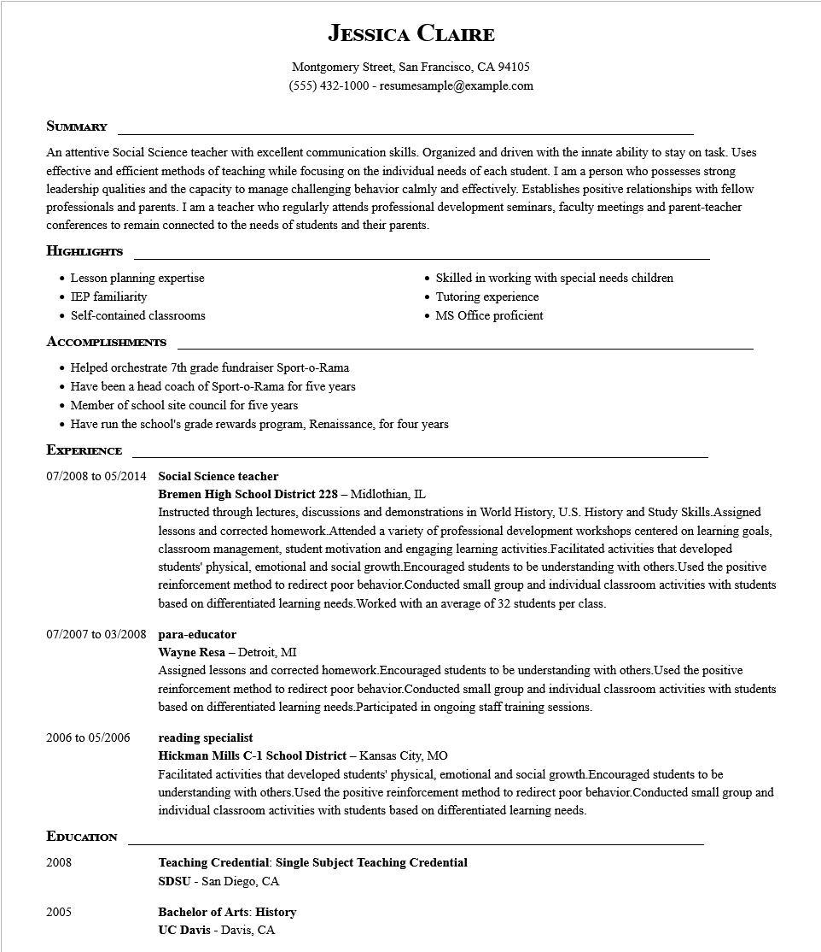

**JESSICA CLAIRE**

Montgomery Street, San Francisco, CA 94105

(555) 432-1000-resumesample@example.com

**SUMMARY**

An attentive Social Science teacher with excellent communication skills. Organized and driven with the innate ability to stay on task. Uses effective and efficient methods of teaching while focusing on the individual needs of each student. I am a person who possesses strong leadership qualities and the capacity to manage challenging behavior calmly and effectively. Establishes positive relationships with fellow professionals and parents. I am a teacher who regularly attends professional development seminars, faculty meetings and parent-teacher conferences to remain connected to the needs of students and their parents.

**HIGHLIGHTS**

• Lesson planning expertise

• IEP familiarity

• Self-contained classrooms

**ACCOMPLISHMENTS**

• Helped orchestrate 7th grade fundraiser Sport-o-Rama

• Have been a head coach of Sport-o-Rama for five years

• Member of school site council for five years

Skilled in working with special needs children Tutoring experience

• MS Office proficient

• Have run the school's grade rewards program, Renaissance, for four years

**EXPERIENCE**

**07/2008 to 05/2014 Social Science teacher**

**Bremen High School District 228 - Midlothian, IL**

Instructed through lectures, discussions and demonstrations in World History, U.S. History and Study Skills.Assigned lessons and corrected homework. Attended a variety of professional development workshops centered on learning goals, classroom management, student motivation and engaging learning activities.Facilitated activities that developed students' physical, emotional and social growth.Encouraged students to be understanding with others. Used the positive reinforcement method to redirect poor behavior.Conducted small group and individual classroom activities with students based on differentiated learning needs. Worked with an average of 32 students per class.

07/2007 to 03/2008 para-educator

Wayne Resa - Detroit, MI

Assigned lessons and corrected homework. Encouraged students to be understanding with others. Used the positive reinforcement method to redirect poor behavior. Conducted small group and individual classroom activities with students based on differentiated learning needs. Participated in ongoing staff training sessions.

2006 to 05/2006

**reading specialist**

**EDUCATION**

2008

2005

**Hickman Mills C-1 School District - Kansas City, MO**

Facilitated activities that developed students' physical, emotional and social growth. Encouraged students to be understanding with others. Used the positive reinforcement method to redirect poor behavior. Conducted small group and individual classroom activities with students based on differentiated learning needs.

**Teaching Credential: Single Subject Teaching Credential**

SDSU - San Diego, CA

**Bachelor of Arts: History UC Davis - Davis, CA**