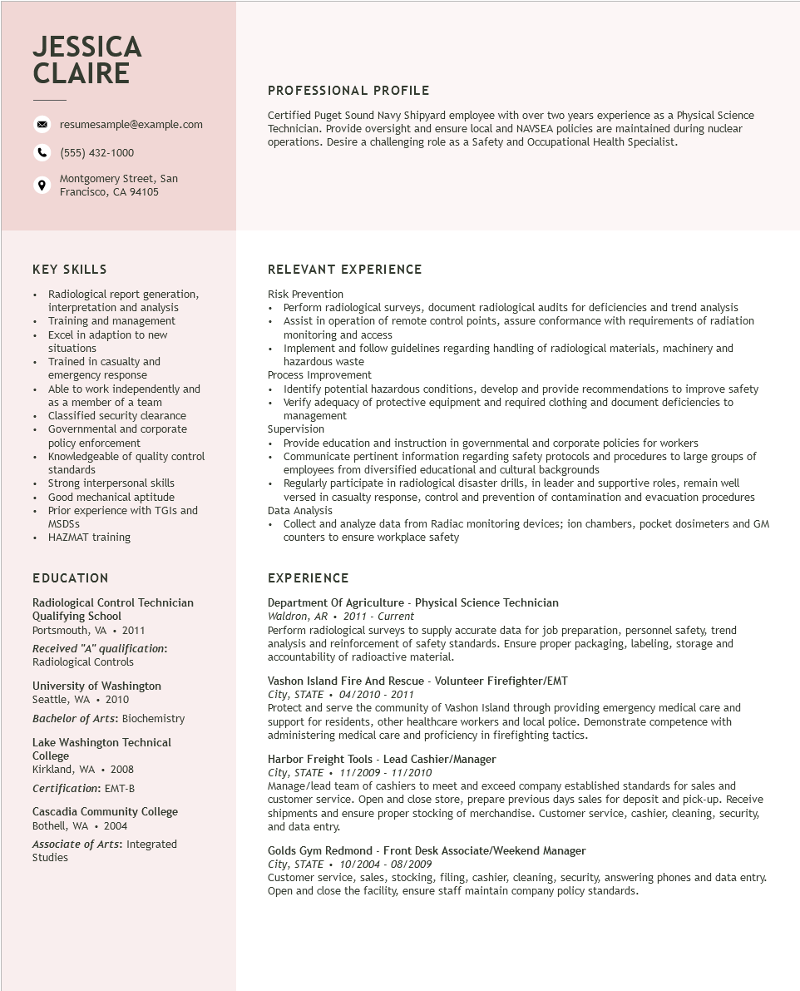

**JESSICA CLAIRE**

resumesample@example.com

(555) 432-1000

Montgomery Street, San Francisco, CA 94105

PROFESSIONAL PROFILE

Certified Puget Sound Navy Shipyard employee with over two years experience as a Physical Science Technician. Provide oversight and ensure local and NAVSEA policies are maintained during nuclear operations. Desire a challenging role as a Safety and Occupational Health Specialist.

**KEY SKILLS**

• Radiological report generation, interpretation and analysis

• Training and management

·

·

Excel in adaption to new

situations

Trained in casualty and

emergency response

Able to work independently and

as a member of a team Classified security clearance

• Governmental and corporate policy enforcement

·

Knowledgeable of quality control standards

• Strong interpersonal skills

•

•

Good mechanical aptitude

Prior experience with TGIs and MSDSS

• HAZMAT training

**EDUCATION**

Radiological Control Technician Qualifying School

Portsmouth, VA. 2011

*Received "A" qualification: Radiological Controls*

University of Washington Seattle, WA. 2010

Bachelor of Arts: Biochemistry

Lake Washington Technical College

*Kirkland, WA. 2008 Certification: EMT-B*

Cascadia Community College Bothell, WA 2004 Associate of Arts: Integrated Studies

RELEVANT EXPERIENCE

Risk Prevention

• Perform radiological surveys, document radiological audits for deficiencies and trend analysis • Assist in operation of remote control points, assure conformance with requirements of radiation monitoring and access

• Implement and follow guidelines regarding handling of radiological materials, machinery and hazardous waste

Process Improvement

• Identify potential hazardous conditions, develop and provide recommendations to improve safety

• Verify adequacy of protective equipment and required clothing and document deficiencies to management

Supervision

• Provide education and instruction in governmental and corporate policies for workers

• Communicate pertinent information regarding safety protocols and procedures to large groups of employees from diversified educational and cultural backgrounds

• Regularly participate in radiological disaster drills, in leader and supportive roles, remain well versed in casualty response, control and prevention of contamination and evacuation procedures Data Analysis

• Collect and analyze data from Radiac monitoring devices; ion chambers, pocket dosimeters and GM counters to ensure workplace safety

**EXPERIENCE**

Department Of Agriculture - Physical Science Technician Waldron, AR. 2011 - Current

Perform radiological surveys to supply accurate data for job preparation, personnel safety, trend analysis and reinforcement of safety standards. Ensure proper packaging, labeling, storage and accountability of radioactive material.

Vashon Island Fire And Rescue - Volunteer Firefighter/EMT

*City, STATE 04/2010 - 2011*

Protect and serve the community of Vashon Island through providing emergency medical care and support for residents, other healthcare workers and local police. Demonstrate competence with administering medical care and proficiency in firefighting tactics.

Harbor Freight Tools - Lead Cashier/Manager City, STATE

*11/2009 - 11/2010*

Manage/lead team of cashiers to meet and exceed company established standards for sales and customer service. Open and close store, prepare previous days sales for deposit and pick-up. Receive shipments and ensure proper stocking of merchandise. Customer service, cashier, cleaning, security, and data entry.

Golds Gym Redmond - Front Desk Associate/Weekend Manager

City, STATE 10/2004 - 08/2009

Customer service, sales, stocking, filing, cashier, cleaning, security, answering phones and data entry. Open and close the facility, ensure staff maintain company policy standards.