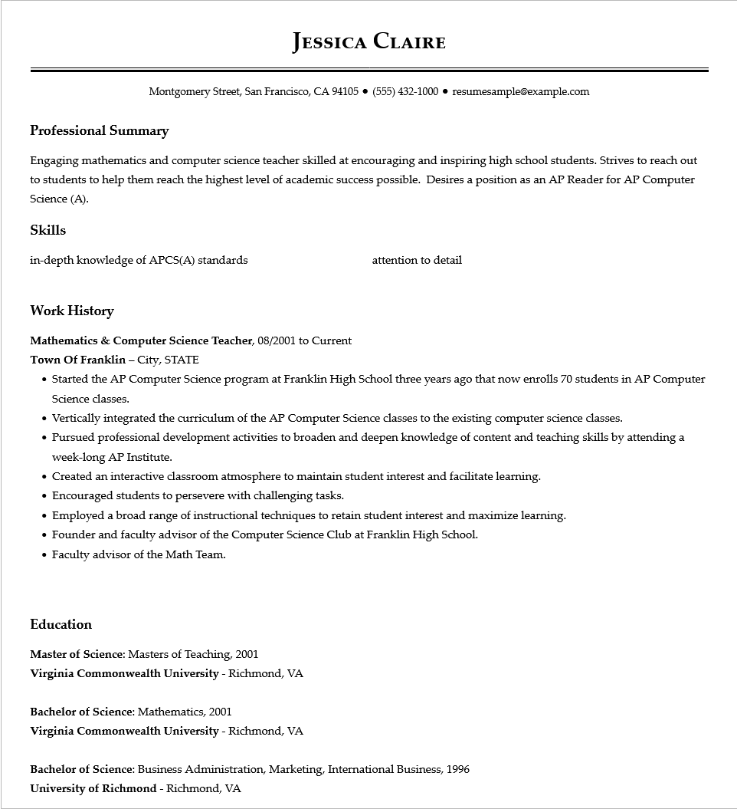

**JESSICA CLAIRE**

Montgomery Street, San Francisco, CA 94105 ● (555) 432-1000⚫ resumesample@example.com

**Professional Summary**

Engaging mathematics and computer science teacher skilled at encouraging and inspiring high school students. Strives to reach out to students to help them reach the highest level of academic success possible. Desires a position as an AP Reader for AP Computer Science (A).

Skills

in-depth knowledge of APCS(A) standards

**Work History**

**Mathematics & Computer Science Teacher, 08/2001 to Current**

**Town of Franklin - City, STATE**

attention to detail

• Started the AP Computer Science program at Franklin High School three years ago that now enrolls 70 students in AP Computer Science classes.

• Vertically integrated the curriculum of the AP Computer Science classes to the existing computer science classes.

• Pursued professional development activities to broaden and deepen knowledge of content and teaching skills by attending a week-long AP Institute.

• Created an interactive classroom atmosphere to maintain student interest and facilitate learning.

• Encouraged students to persevere with challenging tasks.

• Employed a broad range of instructional techniques to retain student interest and maximize learning.

• Founder and faculty advisor of the Computer Science Club at Franklin High School.

• Faculty advisor of the Math Team.

**Education**

Master of Science: Masters of Teaching, 2001

Virginia Commonwealth University - Richmond, VA

Bachelor of Science: Mathematics, 2001

Virginia Commonwealth University - Richmond, VA

Bachelor of Science: Business Administration, Marketing, International Business, 1996 University of Richmond - Richmond, VA