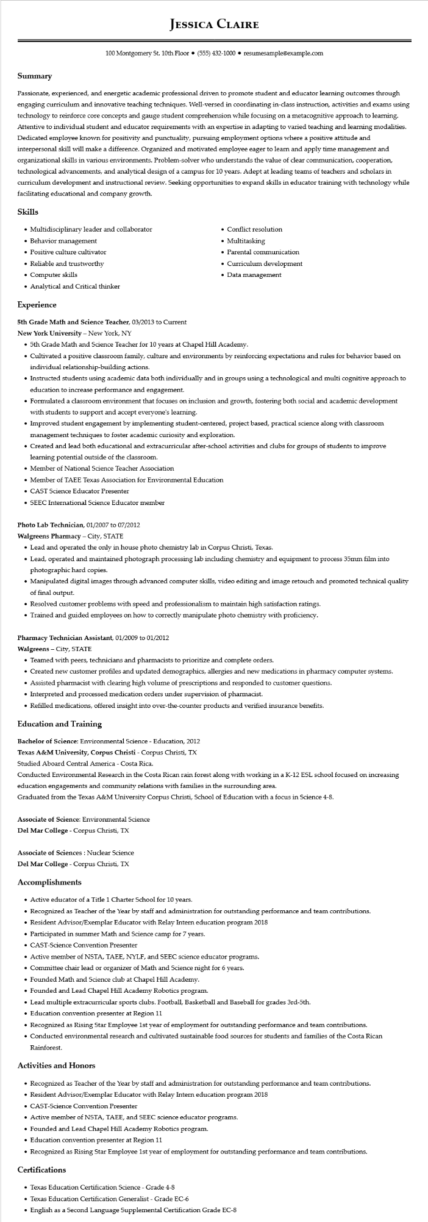

**JESSICA CLAIRE**

100 Montgomery St. 10th Floor (555) 432-1000⚫ resumesample@example.com

**Summary**

Passionate, experienced, and energetic academic professional driven to promote student and educator learning outcomes through engaging curriculum and innovative teaching techniques. Well-versed in coordinating in-class instruction, activities and exams using technology to reinforce core concepts and gauge student comprehension while focusing on a metacognitive approach to learning. Attentive to individual student and educator requirements with an expertise in adapting to varied teaching and learning modalities. Dedicated employee known for positivity and punctuality, pursuing employment options where a positive attitude and interpersonal skill will make a difference. Organized and motivated employee eager to learn and apply time management and organizational skills in various environments. Problem-solver who understands the value of clear communication, cooperation, technological advancements, and analytical design of a campus for 10 years. Adept at leading teams of teachers and scholars in curriculum development and instructional review. Seeking opportunities to expand skills in educator training with technology while facilitating educational and company growth.

Skills

• Multidisciplinary leader and collaborator

• Behavior management

• Positive culture cultivator

• Reliable and trustworthy

• Computer skills

• Analytical and Critical thinker

**Experience**

5th Grade Math and Science Teacher, 03/2013 to Current

**New York University - New York, NY**

• Conflict resolution

• Multitasking

• Parental communication

• Curriculum development • Data management

• 5th Grade Math and Science Teacher for 10 years at Chapel Hill Academy.

• Cultivated a positive classroom family, culture and environments by reinforcing expectations and rules for behavior based on individual relationship-building actions.

• Instructed students using academic data both individually and in groups using a technological and multi cognitive approach to education to increase performance and engagement.

• Formulated a classroom environment that focuses on inclusion and growth, fostering both social and academic development with students to support and accept everyone's learning.

• Improved student engagement by implementing student-centered, project based, practical science along with classroom management techniques to foster academic curiosity and exploration.

• Created and lead both educational and extracurricular after-school activities and clubs for groups of students to improve learning potential outside of the classroom.

• Member of National Science Teacher Association

• Member of TAEE Texas Association for Environmental Education

• CAST Science Educator Presenter

• SEEC International Science Educator member

**Photo Lab Technician, 01/2007 to 07/2012**

**Walgreens Pharmacy - City, STATE**

• Lead and operated the only in house photo chemistry lab in Corpus Christi, Texas.

• Lead, operated and maintained photograph processing lab including chemistry and equipment to process 35mm film into photographic hard copies.

• Manipulated digital images through advanced computer skills, video editing and image retouch and promoted technical quality of final output.

• Resolved customer problems with speed and professionalism to maintain high satisfaction ratings.

• Trained and guided employees on how to correctly manipulate photo chemistry with proficiency.

**Pharmacy Technician Assistant, 01/2009 to 01/2012**

**Walgreens - City, STATE**

• Teamed with peers, technicians and pharmacists to prioritize and complete orders.

• Created new customer profiles and updated demographics, allergies and new medications in pharmacy computer systems.

• Assisted pharmacist with clearing high volume of prescriptions and responded to customer questions.

• Interpreted and processed medication orders under supervision of pharmacist.

• Refilled medications, offered insight into over-the-counter products and verified insurance benefits.

**Education and Training**

Bachelor of Science: Environmental Science - Education, 2012

**Texas A&M University, Corpus Christi - Corpus Christi, TX**

Studied Aboard Central America - Costa Rica.

Conducted Environmental Research in the Costa Rican rain forest along with working in a K-12 ESL school focused on increasing education engagements and community relations with families in the surrounding area.

Graduated from the Texas A&M University Corpus Christi, School of Education with a focus in Science 4-8.

Associate of Science: Environmental Science

Del Mar College - Corpus Christi, TX

**Associate of Sciences: Nuclear Science**

Del Mar College - Corpus Christi, TX

**Accomplishments**

• Active educator of a Title 1 Charter School for 10 years.

• Recognized as Teacher of the Year by staff and administration for outstanding performance and team contributions.

• Resident Advisor/Exemplar Educator with Relay Intern education program 2018

• Participated in summer Math and Science camp for 7 years.

• CAST-Science Convention Presenter

• Active member of NSTA, TAEE, NYLF, and SEEC science educator programs.

• Committee chair lead or organizer of Math and Science night for 6 years.

• Founded Math and Science club at Chapel Hill Academy.

• Founded and Lead Chapel Hill Academy Robotics program.

• Lead multiple extracurricular sports clubs. Football, Basketball and Baseball for grades 3rd-5th.

• Education convention presenter at Region 11

• Recognized as Rising Star Employee 1st year of employment for outstanding performance and team contributions.

• Conducted environmental research and cultivated sustainable food sources for students and families of the Costa Rican Rainforest.

**Activities and Honors**

• Recognized as Teacher of the Year by staff and administration for outstanding performance and team contributions.

• Resident Advisor/Exemplar Educator with Relay Intern education program 2018

• CAST-Science Convention Presenter

• Active member of NSTA, TAEE, and SEEC science educator programs.

• Founded and Lead Chapel Hill Academy Robotics program.

• Education convention presenter at Region 11

• Recognized as Rising Star Employee 1st year of employment for outstanding performance and team contributions.

**Certifications**

• Texas Education Certification Science - Grade 4-8

• Texas Education Certification Generalist - Grade EC-6

• English as a Second Language Supplemental Certification Grade EC-8