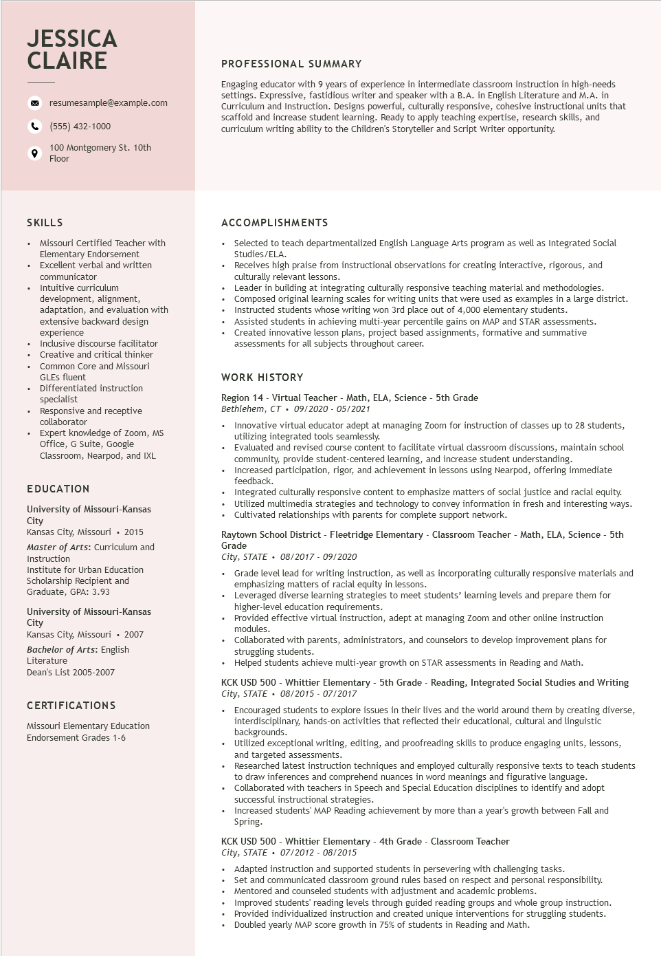

**JESSICA CLAIRE**

resumesample@example.com

(555) 432-1000

100 Montgomery St. 10th Floor

PROFESSIONAL SUMMARY

Engaging educator with 9 years of experience in intermediate classroom instruction in high-needs settings. Expressive, fastidious writer and speaker with a B.A. in English Literature and M.A. in Curriculum and Instruction. Designs powerful, culturally responsive, cohesive instructional units that scaffold and increase student learning. Ready to apply teaching expertise, research skills, and curriculum writing ability to the Children's Storyteller and Script Writer opportunity.

SKILLS

•

Missouri Certified Teacher with Elementary Endorsement

• Excellent verbal and written

•

communicator

Intuitive curriculum

development, alignment,

adaptation, and evaluation with

extensive backward design experience

Inclusive discourse facilitator Creative and critical thinker

• Common Core and Missouri

•

•

•

GLES fluent

Differentiated instruction specialist

Responsive and receptive collaborator

Expert knowledge of Zoom, MS

Office, G Suite, Google Classroom, Nearpod, and IXL

**EDUCATION**

University of Missouri-Kansas City

Kansas City, Missouri. 2015

Master of Arts: Curriculum and

Instruction

Institute for Urban Education

Scholarship Recipient and

Graduate, GPA: 3.93

University of Missouri-Kansas City

Kansas City, Missouri. 2007

Bachelor of Arts: English Literature

Dean's List 2005-2007

**CERTIFICATIONS**

Missouri Elementary Education

Endorsement Grades 1-6

**ACCOMPLISHMENTS**

• Selected to teach departmentalized English Language Arts program as well as Integrated Social Studies/ELA.

• Receives high praise from instructional observations for creating interactive, rigorous, and culturally relevant lessons.

• Leader in building at integrating culturally responsive teaching material and methodologies. Composed original learning scales for writing units that were used as examples in a large district. Instructed students whose writing won 3rd place out of 4,000 elementary students.

• Assisted students in achieving multi-year percentile gains on MAP and STAR assessments.

• Created innovative lesson plans, project based assignments, formative and summative assessments for all subjects throughout career.

**WORK HISTORY**

Region 14 - Virtual Teacher - Math, ELA, Science - 5th Grade

*Bethlehem, CT⚫ 09/2020-05/2021*

⚫ Innovative virtual educator adept at managing Zoom for instruction of classes up to 28 students, utilizing integrated tools seamlessly.

• Evaluated and revised course content to facilitate virtual classroom discussions, maintain school community, provide student-centered learning, and increase student understanding.

• Increased participation, rigor, and achievement in lessons using Nearpod, offering immediate feedback.

Integrated culturally responsive content to emphasize matters of social justice and racial equity. • Utilized multimedia strategies and technology to convey information in fresh and interesting ways. • Cultivated relationships with parents for complete support network.

Raytown School District - Fleetridge Elementary - Classroom Teacher - Math, ELA, Science - 5th Grade

*City, STATE. 08/2017 - 09/2020*

• Grade level lead for writing instruction, as well as incorporating culturally responsive materials and emphasizing matters of racial equity in lessons.

.

Leveraged diverse learning strategies to meet students' learning levels and prepare them for higher-level education requirements.

Provided effective virtual instruction, adept at managing Zoom and other online instruction modules.

• Collaborated with parents, administrators, and counselors to develop improvement plans for struggling students.

• Helped students achieve multi-year growth on STAR assessments in Reading and Math.

KCK USD 500 - Whittier Elementary - 5th Grade - Reading, Integrated Social Studies and Writing City, STATE⚫ 08/2015 - 07/2017

Encouraged students to explore issues in their lives and the world around them by creating diverse, interdisciplinary, hands-on activities that reflected their educational, cultural and linguistic backgrounds.

• Utilized exceptional writing, editing, and proofreading skills to produce engaging units, lessons, and targeted assessments.

• Researched latest instruction techniques and employed culturally responsive texts to teach students to draw inferences and comprehend nuances in word meanings and figurative language.

• Collaborated with teachers in Speech and Special Education disciplines to identify and adopt successful instructional strategies.

• Increased students' MAP Reading achievement by more than a year's growth between Fall and Spring.

KCK USD 500 - Whittier Elementary - 4th Grade - Classroom Teacher

*City, STATE⚫ 07/2012 - 08/2015*

• Adapted instruction and supported students in persevering with challenging tasks.

• Set and communicated classroom ground rules based on respect and personal responsibility.

• Mentored and counseled students with adjustment and academic problems. Improved students' reading levels through guided reading groups and whole group instruction. • Provided individualized instruction and created unique interventions for struggling students. Doubled yearly MAP score growth in 75% of students in Reading and Math.