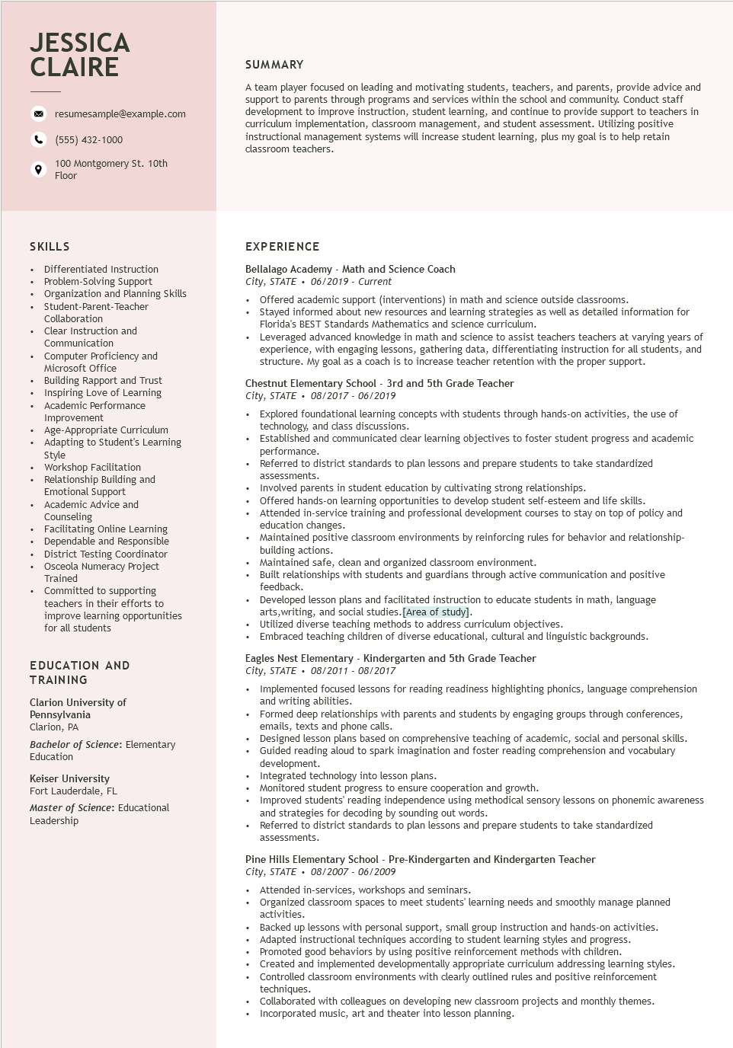

**JESSICA CLAIRE**

resumesample@example.com

(555) 432-1000

100 Montgomery St. 10th Floor

**SUMMARY**

A team player focused on leading and motivating students, teachers, and parents, provide advice and support to parents through programs and services within the school and community. Conduct staff development to improve instruction, student learning, and continue to provide support to teachers in curriculum implementation, classroom management, and student assessment. Utilizing positive instructional management systems will increase student learning, plus my goal is to help retain classroom teachers.

SKILLS

•

•

•

·

.

.

+

.

·

Differentiated Instruction Problem-Solving Support

Organization and Planning Skills

Student-Parent-Teacher

Collaboration

Clear Instruction and Communication

Computer Proficiency and Microsoft Office

Building Rapport and Trust

Inspiring Love of Learning

Academic Performance

Improvement

Age-Appropriate Curriculum

Adapting to Student's Learning

Style

Workshop Facilitation

Relationship Building and

Emotional Support

• Academic Advice and

.

•

Counseling

Facilitating Online Learning

Dependable and Responsible

District Testing Coordinator Osceola Numeracy Project Trained

Committed to supporting

teachers in their efforts to improve learning opportunities for all students

**EDUCATION AND**

TRAINING

Clarion University of

Pennsylvania

Clarion, PA

Bachelor of Science: Elementary Education

Keiser University Fort Lauderdale, FL

Master of Science: Educational Leadership

EXPERIENCE

Bellalago Academy - Math and Science Coach

*City, STATE. 06/2019 - Current*

• Offered academic support (interventions) in math and science outside classrooms.

Stayed informed about new resources and learning strategies as well as detailed information for Florida's BEST Standards Mathematics and science curriculum.

• Leveraged advanced knowledge in math and science to assist teachers teachers at varying years of experience, with engaging lessons, gathering data, differentiating instruction for all students, and structure. My goal as a coach is to increase teacher retention with the proper support.

Chestnut Elementary School - 3rd and 5th Grade Teacher

*City, STATE⚫ 08/2017 - 06/2019*

• Explored foundational learning concepts with students through hands-on activities, the use of technology, and class discussions.

• Established and communicated clear learning objectives to foster student progress and academic performance.

Referred to district standards to plan lessons and prepare students to take standardized assessments.

Involved parents in student education by cultivating strong relationships.

⚫ Offered hands-on learning opportunities to develop student self-esteem and life skills.

• Attended in-service training and professional development courses to stay on top of policy and education changes.

• Maintained positive classroom environments by reinforcing rules for behavior and relationship- building actions.

• Maintained safe, clean and organized classroom environment.

• Built relationships with students and guardians through active communication and positive feedback.

Developed lesson plans and facilitated instruction to educate students in math, language arts, writing, and social studies. [Area of study].

Utilized diverse teaching methods to address curriculum objectives.

• Embraced teaching children of diverse educational, cultural and linguistic backgrounds.

Eagles Nest Elementary - Kindergarten and 5th Grade Teacher

*City, STATE⚫ 08/2011-08/2017*

• Implemented focused lessons for reading readiness highlighting phonics, language comprehension and writing abilities.

• Formed deep relationships with parents and students by engaging groups through conferences, emails, texts and phone calls.

• Designed lesson plans based on comprehensive teaching of academic, social and personal skills.

• Guided reading aloud to spark imagination and foster reading comprehension and vocabulary development.

• Integrated technology into lesson plans.

• Monitored student progress to ensure cooperation and growth.

Improved students' reading independence using methodical sensory lessons on phonemic awareness and strategies for decoding by sounding out words.

• Referred to district standards to plan lessons and prepare students to take standardized assessments.

Pine Hills Elementary School - Pre-Kindergarten and Kindergarten Teacher City, STATE 08/2007 - 06/2009

• Attended in-services, workshops and seminars.

.

Organized classroom spaces to meet students' learning needs and smoothly manage planned activities.

Backed up lessons with personal support, small group instruction and hands-on activities. Adapted instructional techniques according to student learning styles and progress.

• Promoted good behaviors by using positive reinforcement methods with children.

• Created and implemented developmentally appropriate curriculum addressing learning styles.

• Controlled classroom environments with clearly outlined rules and positive reinforcement techniques.

Collaborated with colleagues on developing new classroom projects and monthly themes. Incorporated music, art and theater into lesson planning.