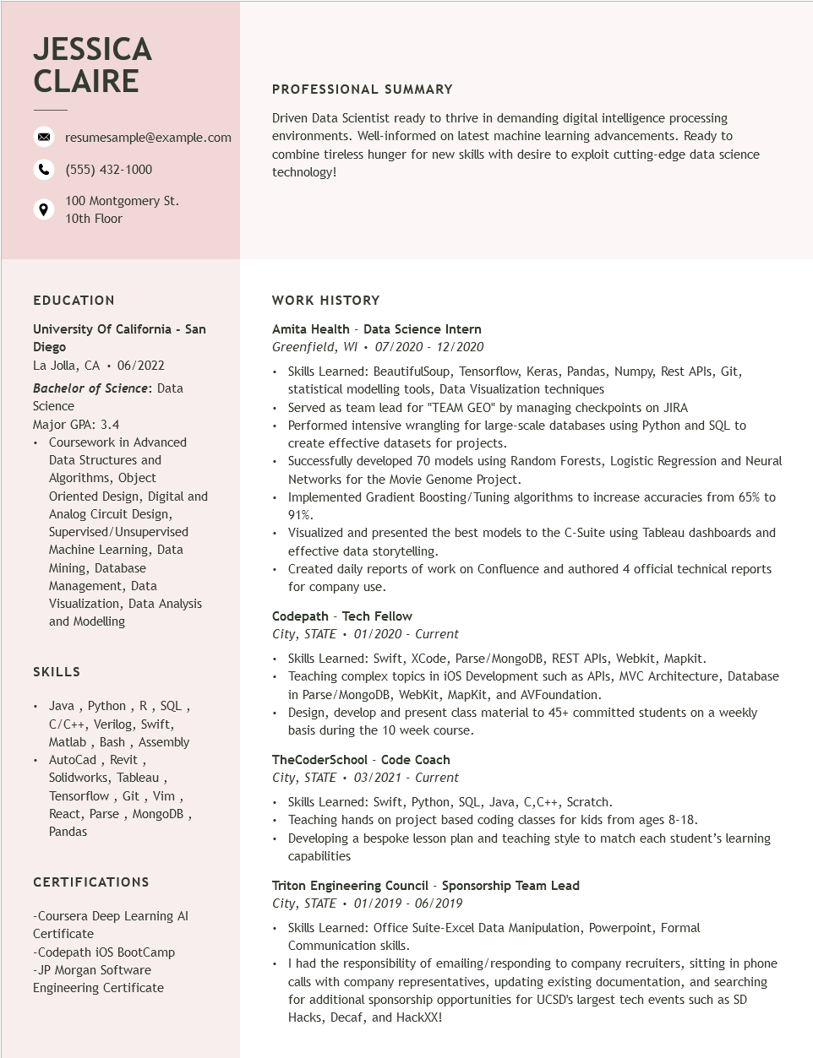

**JESSICA CLAIRE**

resumesample@example.com

(555) 432-1000

100 Montgomery St. 10th Floor

**PROFESSIONAL SUMMARY**

Driven Data Scientist ready to thrive in demanding digital intelligence processing environments. Well-informed on latest machine learning advancements. Ready to combine tireless hunger for new skills with desire to exploit cutting-edge data science technology!

EDUCATION

**University of California - San Diego**

La Jolla, CA 06/2022

**Bachelor of Science: Data Science**

Major GPA: 3.4

• Coursework in Advanced

Data Structures and Algorithms, Object

Oriented Design, Digital and Analog Circuit Design, Supervised/Unsupervised Machine Learning, Data Mining, Database Management, Data

Visualization, Data Analysis and Modelling

**SKILLS**

Java, Python, R, SQL, C/C++, Verilog, Swift, Matlab, Bash, Assembly AutoCad, Revit, Solidworks, Tableau,

Tensorflow, Git, Vim,

React, Parse, MongoDB, Pandas

CERTIFICATIONS

-Coursera Deep Learning Al

Certificate

-Codepath iOS BootCamp -JP Morgan Software

Engineering Certificate

**WORK HISTORY**

**Amita Health - Data Science Intern Greenfield, WI 07/2020 - 12/2020**

• Skills Learned: BeautifulSoup, Tensorflow, Keras, Pandas, Numpy, Rest APIs, Git, statistical modelling tools, Data Visualization techniques

Served as team lead for "TEAM GEO" by managing checkpoints on JIRA

• Performed intensive wrangling for large-scale databases using Python and SQL to create effective datasets for projects.

• Successfully developed 70 models using Random Forests, Logistic Regression and Neural Networks for the Movie Genome Project.

Implemented Gradient Boosting/Tuning algorithms to increase accuracies from 65% to 91%.

• Visualized and presented the best models to the C-Suite using Tableau dashboards and effective data storytelling.

• Created daily reports of work on Confluence and authored 4 official technical reports for company use.

**Codepath - Tech Fellow**

*City, STATE 01/2020 - Current*

• Skills Learned: Swift, XCode, Parse/MongoDB, REST APIs, Webkit, Mapkit.

Teaching complex topics in iOS Development such as APIs, MVC Architecture, Database in Parse/MongoDB, WebKit, MapKit, and AVFoundation.

• Design, develop and present class material to 45+ committed students on a weekly basis during the 10 week course.

**TheCoderSchool - Code Coach City, STATE 03/2021 - Current**

• Skills Learned: Swift, Python, SQL, Java, C, C++, Scratch.

Teaching hands on project based coding classes for kids from ages 8-18.

• Developing a bespoke lesson plan and teaching style to match each student's learning capabilities

**Triton Engineering Council - Sponsorship Team Lead**

*City, STATE. 01/2019 - 06/2019*

• Skills Learned: Office Suite-Excel Data Manipulation, Powerpoint, Formal Communication skills.

⚫ I had the responsibility of emailing/responding to company recruiters, sitting in phone calls with company representatives, updating existing documentation, and searching for additional sponsorship opportunities for UCSD's largest tech events such as SD Hacks, Decaf, and HackXX!