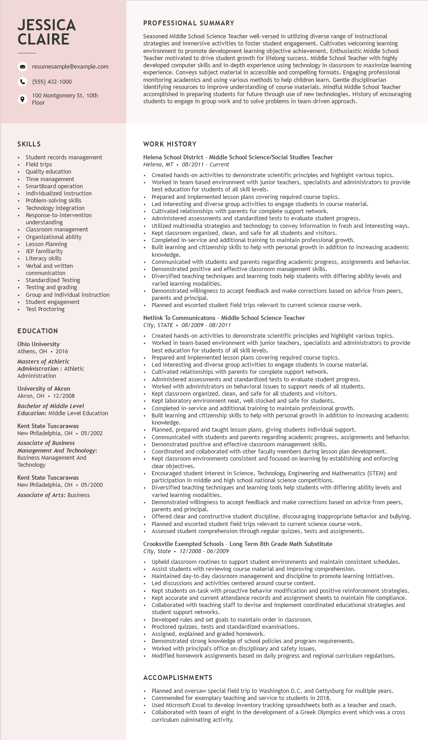

**JESSICA CLAIRE**

resumesample@example.com

(555) 432-1000

100 Montgomery St. 10th Floor

PROFESSIONAL SUMMARY

Seasoned Middle School Science Teacher well-versed in utilizing diverse range of instructional strategies and immersive activities to foster student engagement. Cultivates welcoming learning environment to promote development learning objective achievement. Enthusiastic Middle School Teacher motivated to drive student growth for lifelong success. Middle School Teacher with highly developed computer skills and in-depth experience using technology in classroom to maximize learning experience. Conveys subject material in accessible and compelling formats. Engaging professional monitoring academics and using various methods to help children learn. Gentle disciplinarian identifying resources to improve understanding of course materials. Mindful Middle School Teacher accomplished in preparing students for future through use of new technologies. History of encouraging students to engage in group work and to solve problems in team-driven approach.

SKILLS

Student records management

Field trips

Quality education

Time

management

SmartBoard operation Individualized instruction Problem-solving skills Technology integration Response-to-intervention understanding Classroom management Organizational ability Planning

Lesson

IEP familiarity Literacy skills

Verbal and written

communication

• Standardized Testing

• Testing and grading

• Group and individual instruction

• Student engagement

•

Test Proctoring

**EDUCATION**

Ohio University Athens, OH 2016

Masters of Athletic

Administration: Athletic Administration

University of Akron

Akron, OH. 12/2008

*Bachelor of Middle Level*

Education: Middle Level Education

Kent State Tuscarawas

New Philadelphia, OH 05/2002 Associate of Business Management And Technology: Business Management And Technology

Kent State Tuscarawas

New Philadelphia, OH 05/2000

*Associate of Arts: Business*

**WORK HISTORY**

Helena School District - Middle School Science/Social Studies Teacher Helena, MT. 08/2011- Current

.

Created hands-on activities to demonstrate scientific principles and highlight various topics. Worked in team-based environment with junior teachers, specialists and administrators to provide best education for students of all skill levels.

• Prepared and implemented lesson plans covering required course topics.

Led interesting and diverse group activities to engage students in course material. Cultivated relationships with parents for complete support network.

⚫ Administered I assessments and standardized tests to evaluate student progress.

.

Utilized multimedia strategies and technology to convey information in fresh and interesting ways. Kept classroom organized, clean, and safe for all students and visitors. Completed in-service and additional training to maintain professional growth.

Built learning and citizenship skills to help with personal growth in addition to increasing academic knowledge.

Communicated with students and parents regarding academic progress, assignments and behavior. Demonstrated positive and effective classroom management skills.

Diversified teaching techniques and learning tools help students with differing ability levels and varied learning modalities.

Demonstrated willingness to accept feedback and make corrections based on advice from peers, parents and principal.

Planned and escorted student field trips relevant to current science course work.

Netlink To Communicatons - Middle School Science Teacher

*City, STATE. 08/2009 - 08/2011*

Created hands-on activities to demonstrate scientific principles and highlight various topics. Worked in team-based environment with junior teachers, specialists and administrators to provide best education for students of all skill levels.

Prepared and implemented lesson plans covering required course topics.

and diverse

Led interesting and diverse group activities to engage students in course material. Cultivated relationships with parents for complete support network.

Prelationships

Administered assessments and standardized tests to evaluate student progress. Worked with administrators on behavioral issues to support needs of all students.

Kept classroom organized, clean, and safe for all students and visitors.

Kept laboratory environment neat, well-stocked and safe for students.

Completed in-service and additional training to maintain professional growth.

Built learning and citizenship skills to help with personal growth in addition to increasing academic knowledge.

Planned, prepared and taught lesson plans, giving students individual support.

Communicated with students and parents regarding academic progress, assignments and behavior. Demonstrated positive and effective classroom management skills.

Coordinated and collaborated with other faculty members during lesson plan development. classroom environments consistent and focused on learning by establishing and enforcing clear objectives.

Kept clas

Encouraged student interest in Science, Technology, Engineering and Mathematics (STEM) and participation in middle and high school national science competitions.

Diversified teaching techniques and learning tools help students with differing ability levels and varied learning modalities.

Demonstrated willingness to accept feedback and make corrections based on advice from peers, parents and principal.

Offered clear and constructive student discipline, discouraging inappropriate behavior and bullying.

•

Planned and escorted student field trips relevant to current science course work.

•

Assessed student comprehension through regular quizzes, tests and assignments.

Crooksville Exempted Schools - Long Term 8th Grade Math Substitute

City, State 12/2008 - 06/2009

Upheld classroom routines to support student environments and maintain consistent schedules. Assist students with reviewing course material and improving comprehension.

Maintained day-to-day classroom management and discipline to promote learning initiatives. Led discussions and activities centered around course content.

Kept students on-task with proactive behavior modification and positive reinforcement strategies. Kept accurate and current attendance records and assignment sheets to maintain file compliance. Collaborated with teaching staff to devise and implement coordinated educational strategies and student support networks.

Developed rules and set goals to maintain order in classroom.

Proctored quizzes, tests and standardized examinations.

Assigned, explained and graded homework.

Demonstrated strong knowledge of school policies and program requirements.

Worked with principal's office on disciplinary and safety issues.

Modified homework assignments based on daily progress and regional curriculum regulations.

**ACCOMPLISHMENTS**

Planned and oversaw special field trip to Washington D.C. and Gettysburg for multiple years. Commended for exemplary teaching and service to students in 2018.

Used Microsoft Excel to develop inventory tracking spreadsheets both as a teacher and coach. Collaborated with team of eight in the development of a Greek Olympics event which was a cross curriculum culminating activity.