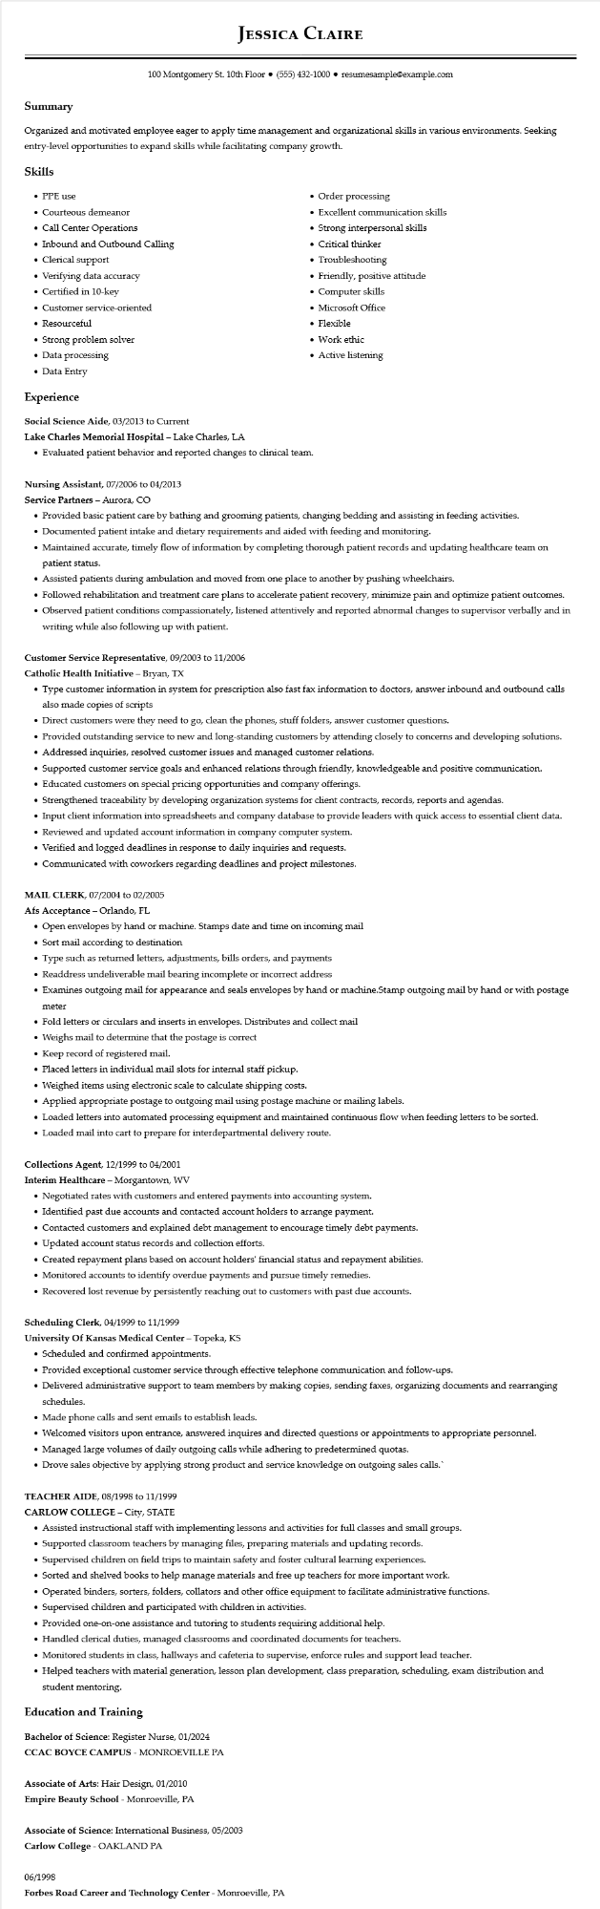

**JESSICA CLAIRE**

100 Montgomery St. 10th Floor⚫ (555) 432-1000⚫ resumesample@example.com

**Summary**

Organized and motivated employee eager to apply time management and organizational skills in various environments. Seeking entry-level opportunities to expand skills while facilitating company growth.

Skills

• PPE use

• Courteous demeanor

• Call Center Operations

• Inbound and Outbound Calling

• Clerical support

• Verifying data accuracy

• Certified in 10-key

• Customer service-oriented

• Resourceful

• Strong problem solver

• Data processing

• Data Entry

**Experience**

Social Science Aide, 03/2013 to Current

**Lake Charles Memorial Hospital - Lake Charles, LA**

• Order processing

• Excellent communication skills

• Strong interpersonal skills

• Critical thinker

• Troubleshooting

• Friendly, positive attitude

•

• Evaluated patient behavior and reported changes to clinical team.

**Nursing Assistant, 07/2006 to 04/2013**

Service Partners - Aurora, CO

Computer skills

• Microsoft Office

• Flexible

• Work ethic

• Active listening

• Provided basic patient care by bathing and grooming patients, changing bedding and assisting in feeding activities.

• Documented patient intake and dietary requirements and aided with feeding and monitoring.

• Maintained accurate, timely flow of information by completing thorough patient records and updating healthcare team on patient status.

• Assisted patients during ambulation and moved from one place to another by pushing wheelchairs.

• Followed rehabilitation and treatment care plans to accelerate patient recovery, minimize pain and optimize patient outcomes.

• Observed patient conditions compassionately, listened attentively and reported abnormal changes to supervisor verbally and in writing while also following up with patient.

Customer Service Representative, 09/2003 to 11/2006

Catholic Health Initiative - Bryan, TX

• Type customer information in system for prescription also fast fax information to doctors, answer inbound and outbound calls also made copies of scripts

• Direct customers were they need to go, clean the phones, stuff folders, answer customer questions.

• Provided outstanding service to new and long-standing customers by attending closely to concerns and developing solutions.

• Addressed inquiries, resolved customer issues and managed customer relations.

•

Supported customer service goals and enhanced relations through friendly, knowledgeable and positive communication.

• Educated customers on special pricing opportunities and company offerings.

• Strengthened traceability by developing organization systems for client contracts, records, reports and agendas.

• Input client information into spreadsheets and company database to provide leaders with quick access to essential client data.

• Reviewed and updated account information in company computer system.

• Verified and logged deadlines in response to daily inquiries and requests.

• Communicated with coworkers regarding deadlines and project milestones.

MAIL CLERK, 07/2004 to 02/2005

Afs Acceptance - Orlando, FL

•

Open envelopes by hand or machine. Stamps date and time on incoming mail

• Sort mail according to destination

• Type such as returned letters, adjustments, bills orders, and payments

• Readdress undeliverable mail bearing incomplete or incorrect address

• Examines outgoing mail for appearance and seals envelopes by hand or machine.Stamp outgoing mail by hand or with postage

meter

• Fold letters or circulars and inserts in envelopes. Distributes and collect mail

• Weighs mail to determine that the postage is correct

• Keep record of registered mail.

• Placed letters in individual mail slots for internal staff pickup.

• Weighed items using electronic scale to calculate shipping costs.

• Applied appropriate postage to outgoing mail using postage machine or mailing labels.

• Loaded letters into automated processing equipment and maintained continuous flow when feeding letters to be sorted.

• Loaded mail into cart to prepare for interdepartmental delivery route.

**Collections Agent, 12/1999 to 04/2001**

Interim Healthcare - Morgantown, WV

• Negotiated rates with customers and entered payments into accounting system.

• Identified past due accounts and contacted account holders to arrange payment.

• Contacted customers and explained debt management to encourage timely debt payments. • Updated account status records and collection efforts.

• Created repayment plans based on account holders' financial status and repayment abilities.

• Monitored accounts to identify overdue payments and pursue timely remedies.

• Recovered lost revenue by persistently reaching out to customers with past due accounts.

**Scheduling Clerk, 04/1999 to 11/1999**

**University of Kansas Medical Center - Topeka, KS**

• Scheduled and confirmed appointments.

• Provided exceptional customer service through effective telephone communication and follow-ups.

• Delivered administrative support to team members by making copies, sending faxes, organizing documents and rearranging schedules.

• Made phone calls and sent emails to establish leads.

• Welcomed visitors upon entrance, answered inquires and directed questions or appointments to appropriate personnel.

• Managed large volumes of daily outgoing calls while adhering to predetermined quotas.

• Drove sales objective by applying strong product and service knowledge on outgoing sales calls.`

TEACHER AIDE, 08/1998 to 11/1999

**CARLOW COLLEGE - City, STATE**

• Assisted instructional staff with implementing lessons and activities for full classes and small groups.

• Supported classroom teachers by managing files, preparing materials and updating records.

• Supervised children on field trips to maintain safety and foster cultural learning experiences.

• Sorted and shelved books to help manage materials and free up teachers for more important work.

•

·

Operated binders, sorters, folders, collators and other office equipment to facilitate administrative functions.

Supervised children and participated with children in activities.

• Provided one-on-one assistance and tutoring to students requiring additional help.

• Handled clerical duties, managed classrooms and coordinated documents for teachers.

• Monitored students in class, hallways and cafeteria to supervise, enforce rules and support lead teacher.

• Helped teachers with material generation, lesson plan development, class preparation, scheduling, exam distribution and

student mentoring.

**Education and Training**

Bachelor of Science: Register Nurse, 01/2024

CCAC BOYCE CAMPUS - MONROEVILLE PA

Associate of Arts: Hair Design, 01/2010

Empire Beauty School - Monroeville, PA

Associate of Science: International Business, 05/2003

**Carlow College - OAKLAND PA**

06/1998

**Forbes Road Career and Technology Center - Monroeville, PA**