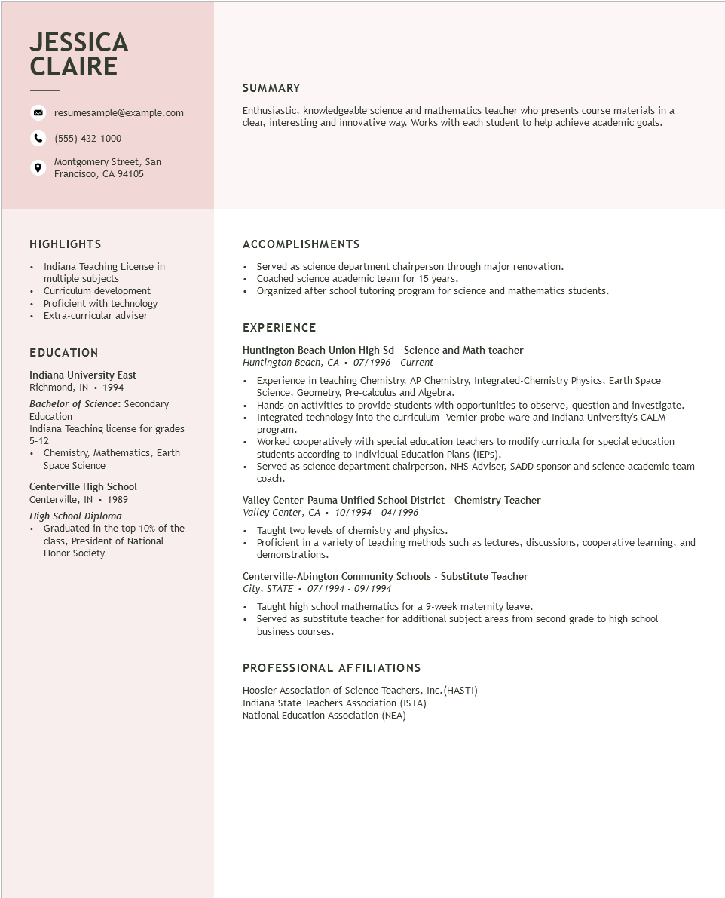

**JESSICA CLAIRE**

resumesample@example.com

(555) 432-1000

Montgomery Street, San Francisco, CA 94105

**SUMMARY**

Enthusiastic, knowledgeable science and mathematics teacher who presents course materials in a clear, interesting and innovative way. Works with each student to help achieve academic goals.

**HIGHLIGHTS**

•

Indiana Teaching License in multiple subjects

• Curriculum development • Proficient with technology

• Extra-curricular adviser

**EDUCATION**

Indiana University East

Richmond, IN 1994

*Bachelor of Science: Secondary Education*

Indiana Teaching license for grades 5-12

• Chemistry, Mathematics, Earth

Space Science

Centerville High School

Centerville, IN 1989

*High School Diploma*

• Graduated in the top 10% of the

class, President of National Honor Society

**ACCOMPLISHMENTS**

Served as science department chairperson through major renovation.

• Coached science academic team for 15 years.

• Organized after school tutoring program for science and mathematics students.

EXPERIENCE

Huntington Beach Union High Sd - Science and Math teacher

Huntington Beach, CA 07/1996 - Current

Experience in teaching Chemistry, AP Chemistry, Integrated-Chemistry Physics, Earth Space Science, Geometry, Pre-calculus and Algebra.

• Hands-on activities to provide students with opportunities to observe, question and investigate. Integrated technology into the curriculum -Vernier probe-ware and Indiana University's CALM program.

Worked cooperatively with special education teachers to modify curricula for special education students according to Individual Education Plans (IEPs).

• Served as science department chairperson, NHS Adviser, SADD sponsor and science academic team coach.

Valley Center-Pauma Unified School District - Chemistry Teacher

*Valley Center, CA⚫ 10/1994 - 04/1996*

• Taught two levels of chemistry and physics.

• Proficient in a variety of teaching methods such as lectures, discussions, cooperative learning, and demonstrations.

Centerville-Abington Community Schools - Substitute Teacher

City, STATE⚫ 07/1994 - 09/1994

• Taught high school mathematics for a 9-week maternity leave.

• Served as substitute teacher for additional subject areas from second grade to high school business courses.

PROFESSIONAL AFFILIATIONS

Hoosier Association of Science Teachers, Inc. (HASTI)

Indiana State Teachers Association (ISTA)

National Education Association (NEA)