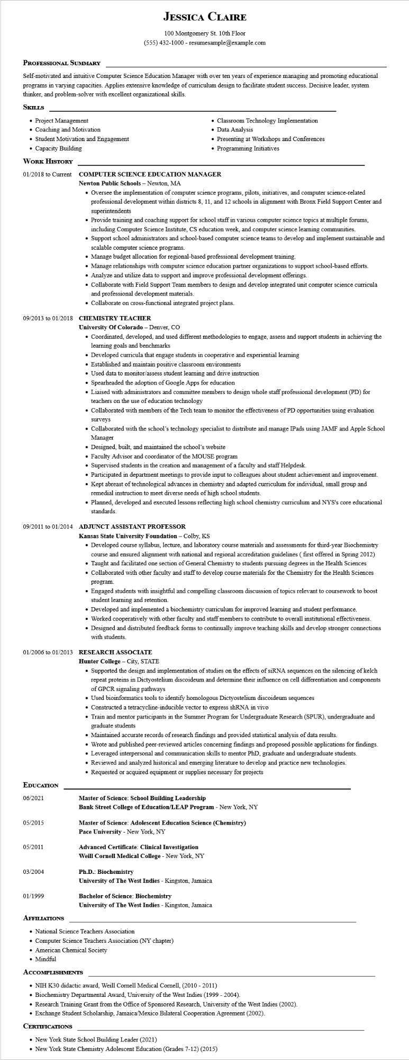

**JESSICA CLAIRE**

100 Montgomery St. 10th Floor (555) 432-1000 - resumesample@example.com

**PROFESSIONAL SUMMARY**

Self-motivated and intuitive Computer Science Education Manager with over ten years of experience managing and promoting educational programs in varying capacities. Applies extensive knowledge of curriculum design to facilitate student success. Decisive leader, system thinker, and problem-solver with excellent organizational skills.

**SKILLS**

• Project Management

• Coaching and Motivation

• Student Motivation and Engagement

• Capacity Building

**WORK HISTORY**

01/2018 to Current

• Classroom Technology Implementation • Data Analysis

• Presenting at Workshops and Conferences • Programming Initiatives

**COMPUTER SCIENCE EDUCATION MANAGER**

**Newton Public Schools - Newton, MA**

• Oversee the implementation of computer science programs, pilots, initiatives, and computer science-related professional development within districts 8, 11, and 12 schools in alignment with Bronx Field Support Center and superintendents

• Provide training and coaching support for school staff in various computer science topics at multiple forums, including Computer Science Institute, CS education week, and computer science learning communities.

• Support school administrators and school-based computer science teams to develop and implement sustainable and scalable computer science programs.

• Manage budget allocation for regional-based professional development training.

• Manage relationships with computer science education partner organizations to support school-based efforts.

• Analyze and utilize data to support and improve professional development offerings.

• Collaborate with Field Support Team members to design and develop integrated unit computer science curricula and professional development materials.

• Collaborate on cross-functional integrated project plans.

**09/2013 to 01/2018 CHEMISTRY TEACHER**

**University of Colorado - Denver, CO**

• Coordinated, developed, and used different methodologies to engage, assess and support students in achieving the learning goals and benchmarks

• Developed curricula that engage students in cooperative and experiential learning

• Established and maintain positive classroom environments

• Used data to monitor/assess student learning and drive instruction

• Spearheaded the adoption of Google Apps for education

• Liaised with administrators and committee members to design whole staff professional development (PD) for teachers on the use of education technology

• Collaborated with members of the Tech team to monitor the effectiveness of PD opportunities using evaluation surveys

• Collaborated with the school's technology specialist to distribute and manage IPads using JAMF and Apple School Manager

• Designed, built, and maintained the school's website

• Faculty Advisor and coordinator of the MOUSE program

• Supervised students in the creation and management of a faculty and staff Helpdesk.

• Participated in department meetings to provide input to colleagues about student achievement and improvement.

• Kept abreast of technological advances in chemistry and adapted curriculum for individual, small group and remedial instruction to meet diverse needs of high school students.

• Planned, developed and executed lessons reflecting high school chemistry curriculum and NYS's core educational standards.

**09/2011 to 01/2014 ADJUNCT ASSISTANT PROFESSOR**

**Kansas State University Foundation - Colby, KS**

• Developed course syllabus, lecture, and laboratory course materials and assessments for third-year Biochemistry course and ensured alignment with national and regional accreditation guidelines (first offered in Spring 2012)

• Taught and facilitated one section of General Chemistry to students pursuing degrees in the Health Sciences

• Collaborated with other faculty and staff to develop course materials for the Chemistry for the Health Sciences program.

• Engaged students with insightful and compelling classroom discussion of topics relevant to coursework to boost student learning and retention.

• Developed and implemented a biochemistry curriculum for improved learning and student performance.

• Worked cooperatively with other faculty and staff members to contribute to overall institutional effectiveness.

• Designed and distributed feedback forms to continually improve teaching skills and develop stronger connections with students.

**01/2006 to 01/2013 RESEARCH ASSOCIATE**

**EDUCATION**

06/2021

05/2015

Hunter College - City, STATE

• Supported the design and implementation of studies on the effects of siRNA sequences on the silencing of kelch repeat proteins in Dictyostelium discoideum and determine their influence on cell differentiation and components of GPCR signaling pathways

• Used bioinformatics tools to identify homologous Dictyostelium discoideum sequences

• Constructed a tetracycline-inducible vector to express shRNA in vivo

• Train and mentor participants in the Summer Program for Undergraduate Research (SPUR), undergraduate and graduate students

• Maintained accurate records of research findings and provided statistical analysis of data results.

• Wrote and published peer-reviewed articles concerning findings and proposed possible applications for findings.

• Leveraged interpersonal and communication skills to mentor PhD, graduate and undergraduate students.

• Reviewed and analyzed historical and emerging literature to develop and practice new technologies.

• Requested or acquired equipment or supplies necessary for projects

**Master of Science: School Building Leadership**

**Bank Street College of Education/LEAP Program - New York, NY**

**Master of Science: Adolescent Education Science (Chemistry) Pace University - New York, NY**

**Advanced Certificate: Clinical Investigation**

05/2011

**Weill Cornell Medical College - New York, NY**

03/2004

**Ph.D.: Biochemistry**

University of The West Indies - Kingston, Jamaica

01/1999

**Bachelor of Science: Biochemistry**

University of The West Indies - Kingston, Jamaica

**AFFILIATIONS**

• National Science Teachers Association

• Computer Science Teachers Association (NY chapter)

• American Chemical Society

• Mindful

**ACCOMPLISHMENTS**

• NIH K30 didactic award, Weill Cornell Medical Cornell, (2010 - 2011)

• Biochemistry Departmental Award, University of the West Indies (1999 - 2004).

• Research Training Grant from the Office of Sponsored Research, University of the West Indies (2002).

• Exchange Student Scholarship, Jamaica/Mexico Bilateral Cooperation Agreement (2002).

**CERTIFICATIONS**

New York State School Building Leader (2021)

• New York State Chemistry Adolescent Education (Grades 7-12) (2015)