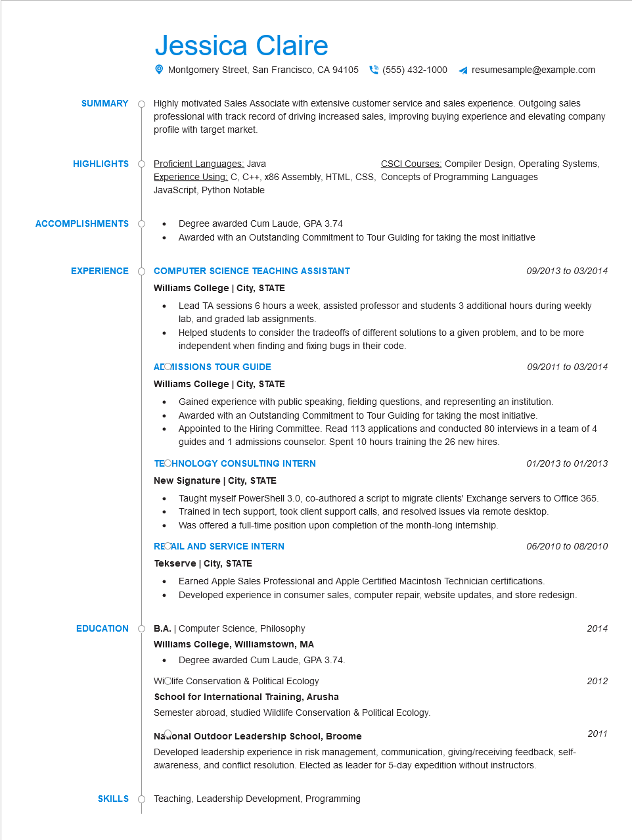

**SUMMARY**

Jessica Claire

Montgomery Street, San Francisco, CA 94105 (555) 432-1000

resumesample@example.com

Highly motivated Sales Associate with extensive customer service and sales experience. Outgoing sales professional with track record of driving increased sales, improving buying experience and elevating company profile with target market.

**HIGHLIGHTS**

Proficient Languages: Java

**ACCOMPLISHMENTS**

CSCI Courses: Compiler Design, Operating Systems,

Experience Using: C, C++, x86 Assembly, HTML, CSS, Concepts of Programming Languages JavaScript, Python Notable

Degree awarded Cum Laude, GPA 3.74

· Awarded with an Outstanding Commitment to Tour Guiding for taking the most initiative

**EXPERIENCE**

**COMPUTER SCIENCE TEACHING ASSISTANT Williams College | City, STATE**

**EDUCATION**

*09/2013 to 03/2014*

• Lead TA sessions 6 hours a week, assisted professor and students 3 additional hours during weekly lab, and graded lab assignments.

• Helped students to consider the tradeoffs of different solutions to a given problem, and to be more independent when finding and fixing bugs in their code.

**ACOMISSIONS TOUR GUIDE**

**Williams College | City, STATE**

*09/2011 to 03/2014*

Gained experience with public speaking, fielding questions, and representing an institution. Awarded with an Outstanding Commitment to Tour Guiding for taking the most initiative. Appointed to the Hiring Committee. Read 113 applications and conducted 80 interviews in a team of 4 guides and 1 admissions counselor. Spent 10 hours training the 26 new hires.

**TECHNOLOGY CONSULTING INTERN**

**New Signature | City, STATE**

*01/2013 to 01/2013*

Taught myself PowerShell 3.0, co-authored a script to migrate clients' Exchange servers to Office 365.

• Trained in tech support, took client support calls, and resolved issues via remote desktop. Was offered a full-time position upon completion of the month-long internship.

**RECAIL AND SERVICE INTERN**

**Tekserve | City, STATE**

•

*06/2010 to 08/2010*

Earned Apple Sales Professional and Apple Certified Macintosh Technician certifications. Developed experience in consumer sales, computer repair, website updates, and store redesign.

B.A. | Computer Science, Philosophy

**Williams College, Williamstown, MA**

Degree awarded Cum Laude, GPA 3.74.

2014

Widlife Conservation & Political Ecology

2012

**School for International Training, Arusha**

Semester abroad, studied Wildlife Conservation & Political Ecology.

**Nasonal Outdoor Leadership School, Broome**

2011

Developed leadership experience in risk management, communication, giving/receiving feedback, self- awareness, and conflict resolution. Elected as leader for 5-day expedition without instructors.

SKILLS Teaching, Leadership Development, Programming