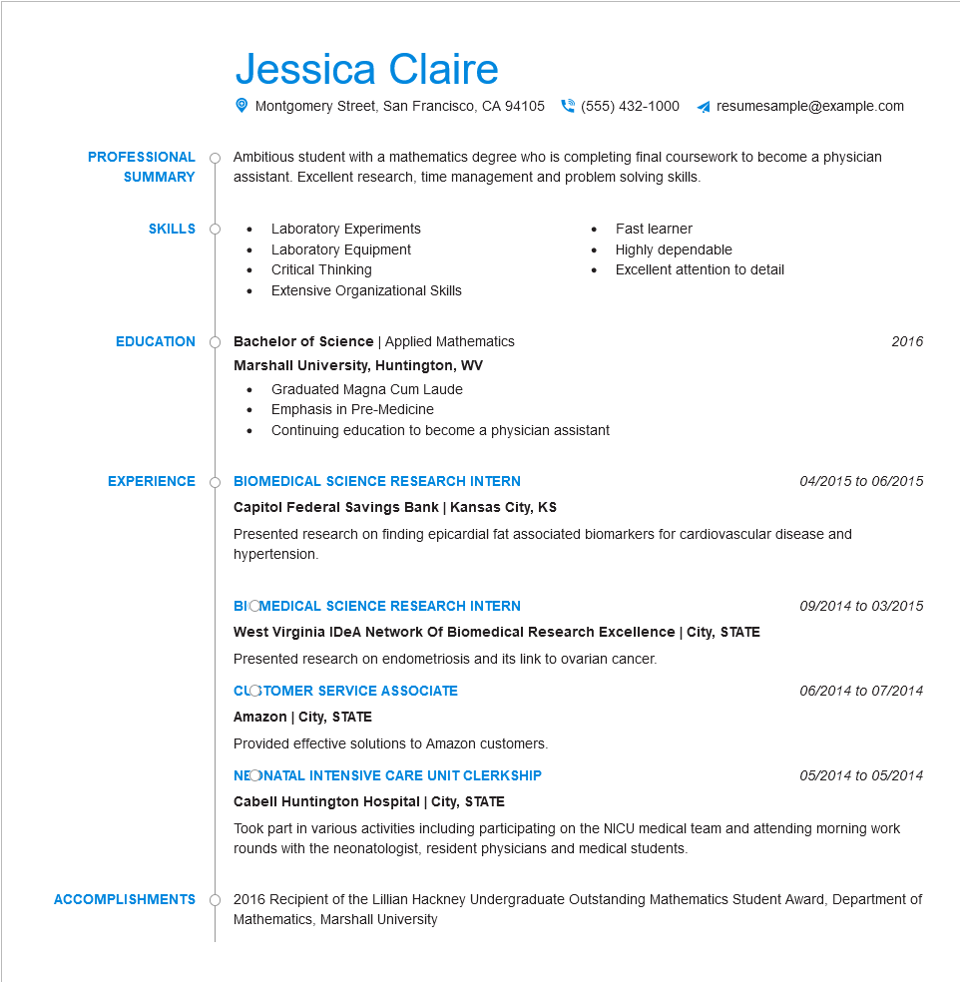

**PROFESSIONAL**

**SUMMARY**

Jessica Claire

Montgomery Street, San Francisco, CA 94105

(555) 432-1000

resumesample@example.com

Ambitious student with a mathematics degree who is completing final coursework to become a physician assistant. Excellent research, time management and problem solving skills.

• Laboratory Experiments

**SKILLS**

•

Fast learner

Laboratory Equipment

•

Highly dependable

Critical Thinking

•

Excellent attention to detail

Extensive Organizational Skills

**EDUCATION**

Bachelor of Science | Applied Mathematics

**Marshall University, Huntington, WV**

•

Graduated Magna Cum Laude

• Emphasis in Pre-Medicine

Continuing education to become a physician assistant

**EXPERIENCE**

**BIOMEDICAL SCIENCE RESEARCH INTERN**

**Capitol Federal Savings Bank | Kansas City, KS**

2016

04/2015 to 06/2015

Presented research on finding epicardial fat associated biomarkers for cardiovascular disease and hypertension.

**ACCOMPLISHMENTS**

**BIOMEDICAL SCIENCE RESEARCH INTERN**

**West Virginia IDeA Network Of Biomedical Research Excellence | City, STATE Presented research on endometriosis and its link to ovarian cancer.**

**CLOTOMER SERVICE ASSOCIATE**

**Amazon | City, STATE**

Provided effective solutions to Amazon customers.

**NEONATAL INTENSIVE CARE UNIT CLERKSHIP**

**Cabell Huntington Hospital | City, STATE**

*09/2014 to 03/2015*

06/2014 to 07/2014

05/2014 to 05/2014

Took part in various activities including participating on the NICU medical team and attending morning work rounds with the neonatologist, resident physicians and medical students.

2016 Recipient of the Lillian Hackney Undergraduate Outstanding Mathematics Student Award, Department of Mathematics, Marshall University