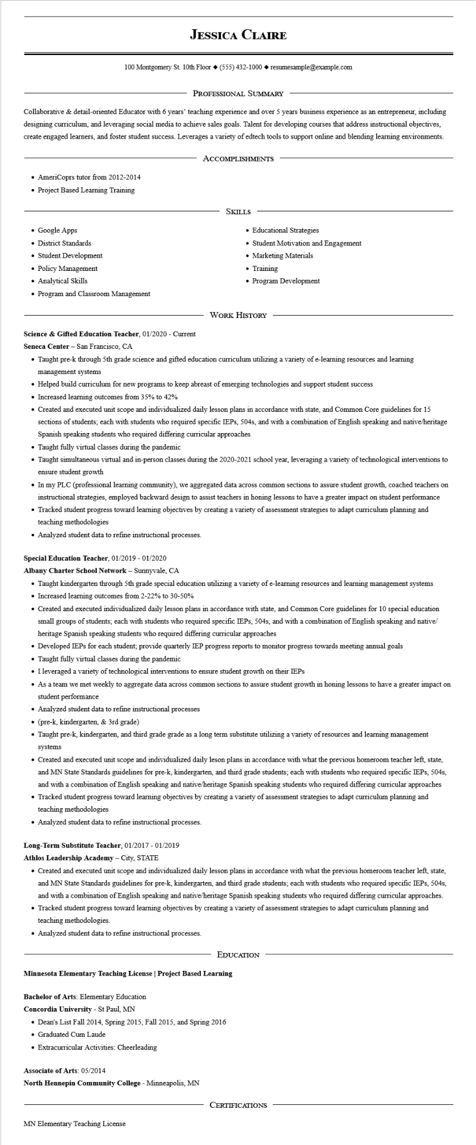

**JESSICA CLAIRE**

100 Montgomery St. 10th Floor (555) 432-1000◆ resumesample@example.com

PROFESSIONAL SUMMARY

Collaborative & detail-oriented Educator with 6 years' teaching experience and over 5 years business experience as an entrepreneur, including designing curriculum, and leveraging social media to achieve sales goals. Talent for developing courses that address instructional objectives, create engaged learners, and foster student success. Leverages a variety of edtech tools to support online and blending learning environments.

ACCOMPLISHMENTS

• AmeriCoprs tutor from 2012-2014

• Project Based Learning Training

• Google Apps

• District Standards

• Student Development

• Policy Management

• Analytical Skills

• Program and Classroom Management

SKILLS

• Educational Strategies

• Student Motivation and Engagement

• Marketing Materials

• Training

• Program Development

WORK HISTORY

**Science & Gifted Education Teacher, 01/2020 - Current**

Seneca Center - San Francisco, CA

• Taught pre-k through 5th grade science and gifted education curriculum utilizing a variety of e-learning resources and learning management systems

• Helped build curriculum for new programs to keep abreast of emerging technologies and support student success

• Increased learning outcomes from 35% to 42%

• Created and executed unit scope and individualized daily lesson plans in accordance with state, and Common Core guidelines for 15 sections of students; each with students who required specific IEPs, 504s, and with a combination of English speaking and native/heritage Spanish speaking students who required differing curricular approaches

• Taught fully virtual classes during the pandemic

• Taught simultaneous virtual and in-person classes during the 2020-2021 school year, leveraging a variety of technological interventions to ensure student growth

• In my PLC (professional learning community), we aggregated data across common sections to assure student growth, coached teachers on instructional strategies, employed backward design to assist teachers in honing lessons to have a greater impact on student performance

• Tracked student progress toward learning objectives by creating a variety of assessment strategies to adapt curriculum planning and teaching methodologies

• Analyzed student data to refine instructional processes.

**Special Education Teacher, 01/2019 - 01/2020**

**Albany Charter School Network - Sunnyvale, CA**

• Taught kindergarten through 5th grade special education utilizing a variety of e-learning resources and learning management systems • Increased learning outcomes from 2-22% to 30-50%

• Created and executed individualized daily lesson plans in accordance with state, and Common Core guidelines for 10 special education small groups of students; each with students who required specific IEPs, 504s, and with a combination of English speaking and native/ heritage Spanish speaking students who required differing curricular approaches

• Developed IEPs for each student; provide quarterly IEP progress reports to monitor progress towards meeting annual goals

• Taught fully virtual classes during the pandemic

⚫ I leveraged a variety of technological interventions to ensure student growth on their IEPs

• As a team we met weekly to aggregate data across common sections to assure student growth in honing lessons to have a greater impact on student performance

• Analyzed student data to refine instructional processes

• (pre-k, kindergarten, & 3rd grade)

• Taught pre-k, kindergarten, and third grade grade as a long term substitute utilizing a variety of resources and learning management systems

• Created and executed unit scope and individualized daily leson plans in accordance with what the previous homeroom teacher left, state, and MN State Standards guidelines for pre-k, kindergarten, and third grade students; each with students who required specific IEPs, 504s, and with a combination of English speaking and native/heritage Spanish speaking students who required differing curricular approaches • Tracked student progress toward learning objectives by creating a variety of assessment strategies to adapt curriculum planning and teaching methodologies

• Analyzed student data to refine instructional processes.

**Long-Term Substitute Teacher, 01/2017 - 01/2019**

**Athlos Leadership Academy - City, STATE**

• Created and executed unit scope and individualized daily lesson plans in accordance with what the previous homeroom teacher left, state, and MN State Standards guidelines for pre-k, kindergarten, and third grade students; each with students who required specific IEPs, 504s, and with a combination of English speaking and native/heritage Spanish speaking students who required differing curricular approaches. • Tracked student progress toward learning objectives by creating a variety of assessment strategies to adapt curriculum planning and teaching methodologies.

• Analyzed student data to refine instructional processes.

EDUCATION

**Minnesota Elementary Teaching License | Project Based Learning**

Bachelor of Arts: Elementary Education

**Concordia University - St Paul, MN**

• Dean's List Fall 2014, Spring 2015, Fall 2015, and Spring 2016

• Graduated Cum Laude

• Extracurricular Activities: Cheerleading

**Associate of Arts: 05/2014**

**North Hennepin Community College - Minneapolis, MN**

MN Elementary Teaching License

CERTIFICATIONS